Application File Vrije Universiteit Amsterdam
Master International Crimes, Conflict and Criminology

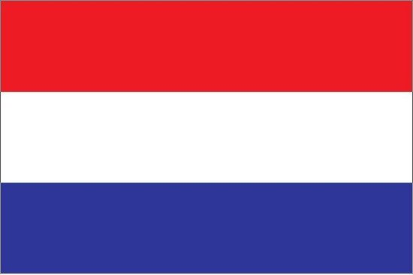 For Dutch Degree Holders (= Dutch or international students applying with a bachelor from a Dutch University, including VU-students)
The application deadline is 31 March.

Instructions: Please put all the required documents in this format. Read the instructions first, then delete the text and paste the requested document onto the page. When you have finished adding all documents, please save the complete file in .PDF format and upload it in the Complete Registration section of Your personal dashboard on vu.nl. Only submit an application file that includes all required documents in this template.
After submitting your application, we will check all documents. If one or more documents are rejected, you will receive a message informing you what to change. Please replace the document(s) and submit a complete application file again.

Your name
Your VU student number
Details regarding your previous or current education
If you have completed multiple degrees at HBO and/or university level (bachelor, premaster, master), make sure to mention all of them and number them accordingly.

Name of the programme and name of the university or higher education institution
Title of the degree(s) (Bachelor, master, etc.)
The (expected) date of graduation
Your current or final GPA (Grade Point Average), also include the maximum possible GPA in your university’s system (for example: 8/10, 3.27/4, etc.)

Letter of Motivation
Include a 1-2 page letter (maximum 1500 words) stating your reasons for applying to the programme.

Proof of academic writing in English
Please provide us with a proof of your academic writing in English. This can be a paper or shorter written assignment (not a thesis) in English from your previous studies.
If you do not have such an assignment, please write a short essay answering the following question (maximum 1000 words including references):
An armed group that fights government over political power hides in the jungle. It regularly kidnaps children and trains them as fighters. The group also sells cocaine to fund its activities. Would you qualify the crimes committed by this group as international crimes or (transnational) organized crime?

Curriculum Vitae (CV)
Please include a curriculum vitae that includes your personal details and lists your previous education and relevant work experience.

Transcript of records
Please place a copy of your official transcript of records here, i.e. a transcript of the grades obtained during your previous higher education (Bachelor’s and Master’s programme). The transcript should contain your name and the name of the institution, and preferably the GPA. Please include all relevant transcripts if you have multiple bachelor's and/or (pre)master's diplomas.
If you did not graduate yet, please send us an official transcript listing the grades you have obtained so far.

