Anti Money Laundering 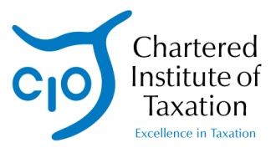
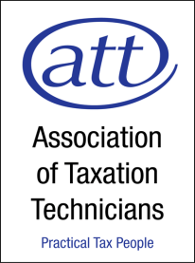
Newsletter –
Issue Thirteen

March 2013

4th Anti-Money Laundering Directive

The European Commission released its proposals for a 4th Anti-Money Laundering Directive last month. Please see their press release for further details:
http://europa.eu/rapid/press-release_IP-13-87_en.htm?locale=en

We will keep you updated of any developments on this and any subsequent changes to UK law.

Submitting a SAR and consent guidance

SOCA has asked us to draw two new documents to our supervised members’ attention:

- Submitting a SAR within the Regulated Sector
- Obtaining Consent from SOCA

Both of these documents have been through consultation with industry representatives of the SAR Regime Committee and have just been published on the UKFIU Publication section of the SOCA website at:

http://www.soca.gov.uk/about-soca/library/doc_download/465-submitting-a-sar

and

http://www.soca.gov.uk/about-soca/library/doc_download/467-obtaining-consent-from-soca

