Ukraine – risk of corrupt asset flight
The recent political unrest in the Ukraine has highlighted the need for firms to remain vigilant to the risk of corrupt asset flight. Members are therefore reminded of their duties under the Money Laundering Regulations and the Proceeds of Crime Act in light of these developments. Corrupt asset flight may be facilitated through companies and other legal arrangements, or other transactions designed to quickly liquidate assets held in the UK. Robust beneficial ownership checks by firms are therefore vital. Firms who have clients with links to the Ukraine should consider whether they have appropriate systems and controls in place for this potential increased risk when performing due diligence and PEP/beneficial ownership checks, ongoing monitoring and reporting of suspicious transactions. The FCA press release can be viewed here.
HM Treasury updated Sanctions List released
HM Treasury has this month released an updated list of financial sanctions targets for the UK which can be found here.

Fourth Money Laundering Directive
The Commission published its draft legislative proposal for the new directive in February last year. Key points included ultimate beneficial owners of companies and trusts to be listed in public registers and domestic "PEPs" (politically exposed persons) to be subject to enhanced due diligence. A number of amendments to the draft Directive have been proposed and committees in Brussels are working through their differences to reach agreement. However, negotiations between the European Parliament, the Council and the Commission have been postponed and will now take place after the European elections in May 2014. The final European Parliament vote to adopt the Directive is expected to be later this year and implementation in member states is unlikely to be before late 2015/early 2016.
Outcomes from the meeting of the FATF Plenary
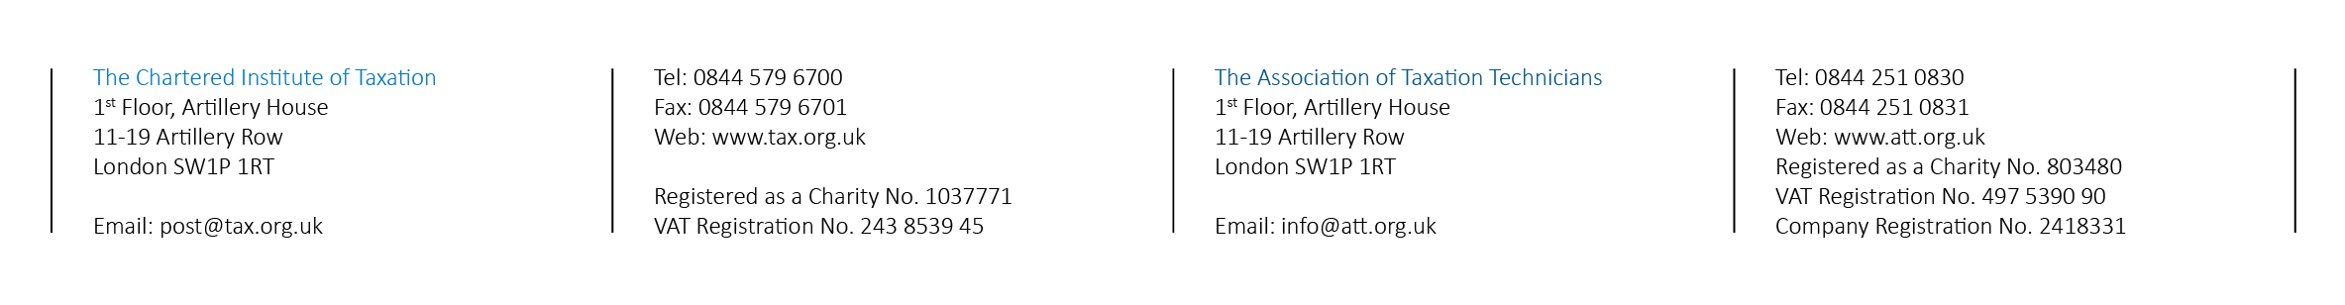
The Financial Action Task Force (FATF) had a Plenary meeting in Paris in February where main issues included an updated version of its public statement issued in October 2013 (which identifies jurisdictions with strategic anti-money laundering and countering the financing of terrorism deficiencies) and reviewing voluntary tax compliance programmes in several jurisdictions. Further details can be found here.
The National Crime Agency
The National Crime Agency (NCA) replaced the Serious Organised Crime Agency in October 2013 - www.nationalcrimeagency.gov.uk. The SAR Online service has been rebranded to reflect the new NCA identity, though the functionality and layout remain the same. The NCA has released its annual guidance note on consent requests in the Accountancy/Tax sector. This publication gives some useful insight into the main issues around consent and what reporters should be aware of when applying for consent. The guidance can be viewed here.
National Risk Assessment (NRA) of money laundering and terrorist financing
As you will all be aware tackling illicit finance is a key priority for the UK and has been a cornerstone of the UK’s Presidency of the G8. The Prime Minister has committed to lead from the front in implementation of the Financial Action Task Force Standards, and, in particular, to conducting the UK’s first NRA by the end of 2014.
The NRA will be the first systematic assessment of threats and vulnerabilities in the UK. It will co-ordinate action to assess risks, apply resources and mitigate those risks, as required by the Financial Action Task Force Standards. Led by HM Treasury and the Home Office, it will provide an evidence base to help Government assess the effectiveness and proportionality of current requirements and the application of the risk-based approach by supervisors and firms. It will also help ensure that we have the right level of expertise and resources targeted at these risks across Government and law enforcement agencies, and support further policy development.
Furthermore, the NRA should also provide you with an up to date picture of the risks we collectively face, and help you target your resources at the right areas and ensure more risk-based, effective and proportionate measures.
CIOT/ATT participated in workshops with HMT and the Home Office to help scope their approach to the NRA, and identify some of the key domestic and international risk areas as viewed by industry.
The UK is also engaging closely with other countries in the FATF to share lessons learned and best practice on conducting NRAs. To date, Australia, Serbia and New Zealand & Singapore have published their first NRAs. The FATF guidance on the NRA can be found here.

