Anti Money Laundering 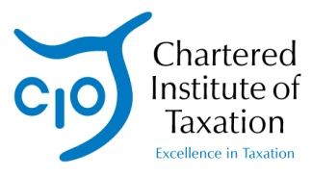
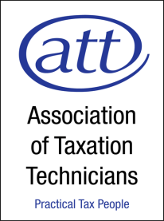
Newsletter –
Issue Fourteen

October 2013

AML Training – Webinar
Our 2013 series of webinars for CIOT & ATT members continues with an annual update on professional standards matters. Although not purely on AML issues, there will be a section that covers the 4th Directive and the opportunity for you to send in any AML queries to be answered live during the webinar. This proved popular last year as a means of updating members on developments.
The Standards webinar will be on Monday 21 October at our usual time of 4:00 – 5:00 pm. The webinar will feature:
- John Whiting (chair)
- Heather Brehcist (Head of Professional Standards for CIOT) and Charlotte Ali (Head of Professional Standards for ATT)
- Tracy Easman (vice-chair of Professional Standards committee)
We plan to cover:
- Anti-Money Laundering and 4th AML Directive
- Updated Professional Conduct in relation to Taxation guidance
- Professional Indemnity Insurance
- Engagement Letters
- Mortgage lenders - recognition of CTA and ATT by lenders
...plus anything else viewers ask about: as always, there will be plenty of time to pose questions to the panel!
To view the webinar, click here
The webinar will be live there on Monday and will be accessible via the same link afterwards. If you haven't watched one of our webinars before, do check the links and make sure your system works beforehand. You may wish to test your system in advance of the webinar; please click here.
If you are unable to view the webinar live, as noted it will be available for viewing on the Lexis Nexis site for 12 months. The slides will be available on the CIOT & ATT websites in the members’ section, with a link to the webinar. All our webinars count for your non-reading CPD.

