Instruction Microsoft Forms
To use the formats with evaluation questions, the following steps are necessary.

Copy template
Click on the link of the desired format.
Click ‘dupliceren’ (duplicate) at the top of the form.
You will be redirected to your Microsoft account (UMC Utrecht), and the document will be automatically opened and saved to your account.

Customize template
Open the form and consider which questions are relevant to your education. Make adjustments if needed.

2a. Add description
Click on: “write an explanation to the students”:
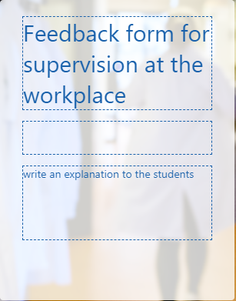
Adjust the text.

2b. Add questions and items
Click on the question where you want to add a new question.
Click on “add”:
You have the following options:
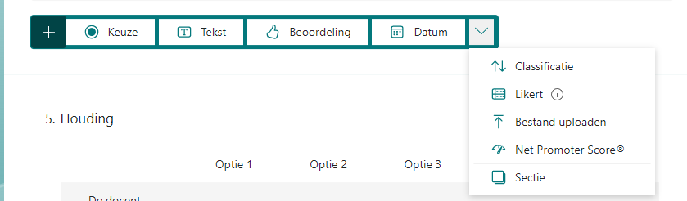
- Keuze: multiple choice question
- Tekst: open question
- Beoordeling: scale question
- Classificatie: arrange the questions
- Likert: rating questions
- Sectie: New section, you can make a new page in the questionaire
Add Item:
Click on the question where you want to add a new item and click add instruction:

2c. Copy questions
Click on the following button:
The question will be placed under the current question. Use the arrows at the right side to move the question up or down.

2d. Delete questions or items
Select the question or item you want to delete.
Click on the bin next to the question or item.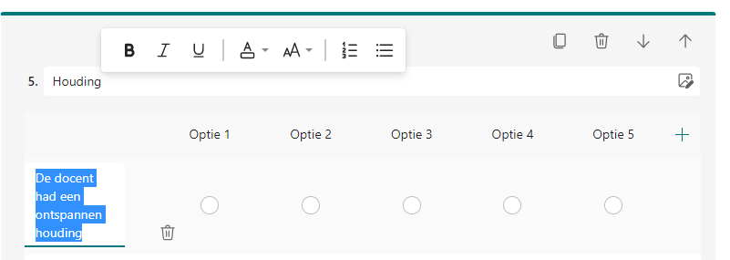
The form will be saved automatically.

Share or use the form.
The top right corner offers several options:
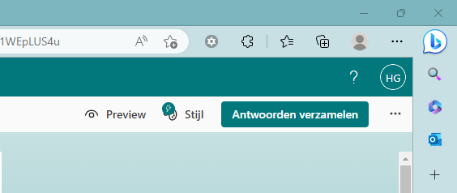
Preview: see how the document will look when shared with others
Stijl: In this section you can change the lay-out
Antwoorden verzamelen: In this section you can share a hyperlink to the participants to collect your answers
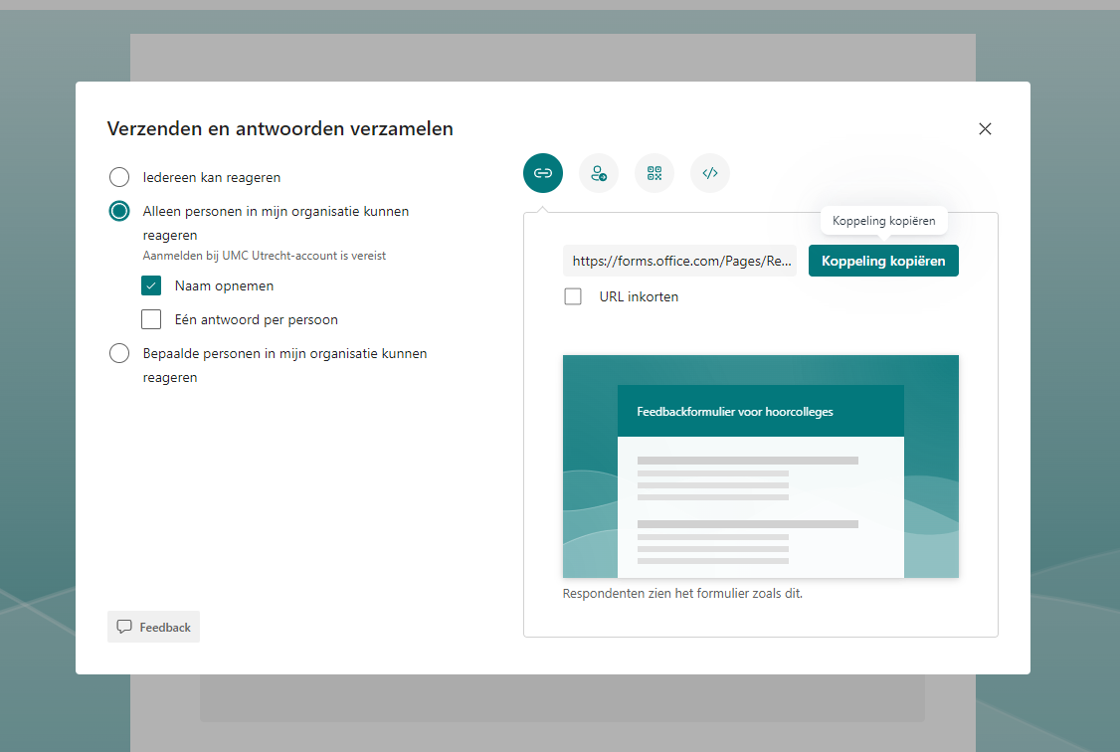
Choose the relevant options. The part: ‘alleen personen in mijn organisatie kunnen reageren’ means only participant working at UMC Utrecht can participate in the questionair. When you want to include participants of Utrecht University, you select the option: ‘iedereen kan reageren’.
On the right side, choose how you want to share the form, such as using a hyperlink or QR-code.
In case you would like to print the form, follow these steps:
Click on the three dots next to ‘antwoorden verzamelen’ (Collect answers)
Select ‘formulier afdrukken’ and choose a printer
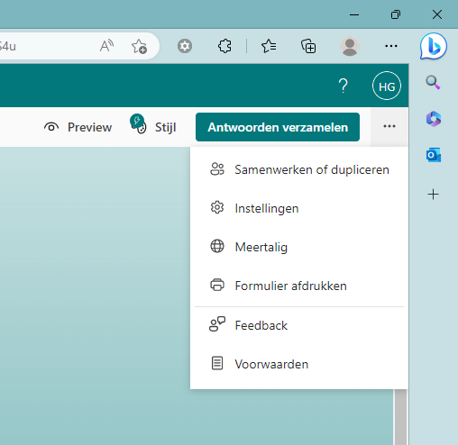

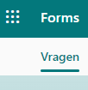
Find your form
Go to https://forms.office.com or click on:
This will provide an overview of all your forms.
Click on the form you want to analyze or adjust.
This is also the place where you can make a new form.

Collect and analyse answers
Once the questionnaire has been completed digitally, you can find the answers here.
Click on answers at the top left of the screen
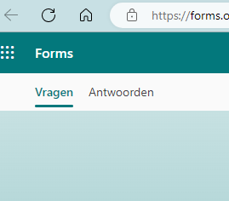
You can find some data:
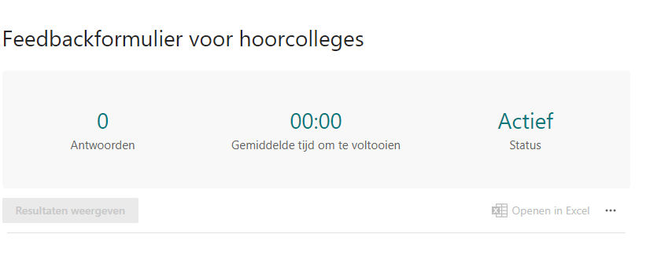
By selecting ‘antwoorden’ (Answers), you can see how many respondents have answered your questionnaire and the average time spent filling in the form.
‘actief’(active) indicates that the questionnaire is still available by participants to answer. You can set it to inactive in settings.
Below this screen, you see the results per question, per individual respondent (by clicking on show results)
You can download the answers by opening them in Excel.

