**FUNCTIONAL SKILLS**

English Level 2 - Reading

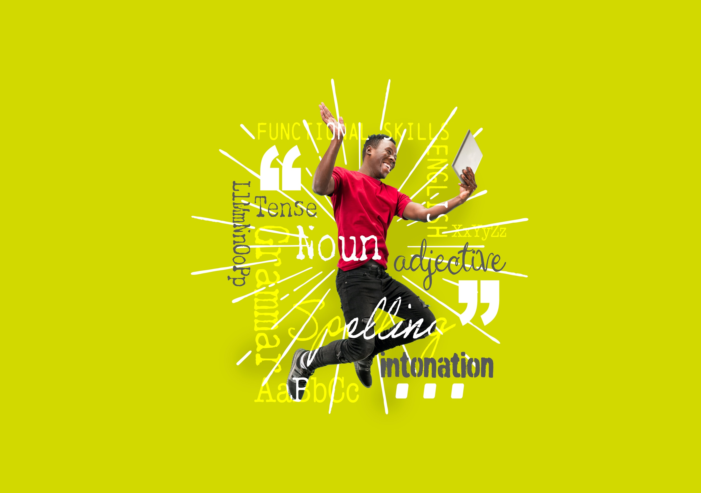



**12. Compare information, ideas and opinions in different texts, including how they are conveyed.**

This workbook will focus on the first part of the subject content; comparing information, ideas and opinions in different texts.

Below is an example question on comparing information that will form part of your reading level 2 functional skills exam.

1. Using Text A and Text B, compare the information given on healthy living.

Provide two similarities or differences from the texts. (2 marks)

**Comparing Information**

Comparing information becomes easier when you break it into smaller sections. Here are some tips to help you:

* read the question carefully. If the question asks for similarities or differences on healthy living, you should focus on where healthy living is discussed in the text.
* look at the first text and identify the main points about healthy living.
* look at the second text and identify the main points about healthy living.
* compare the information – do the writers of the texts agree with each other? Do they have similar ideas or are they on opposite sides?

**Conjunctions**

Conjunctions are words that join sentences or ideas together. They can clearly and quickly show if you think the comparison is a similarity or a difference.

By using conjunctions in your answer, you are showing that you have made a **comparison** between Text A and Text B and understand the **similarities** or **differences.**



**See below for example conjunctions to use for similarities:**

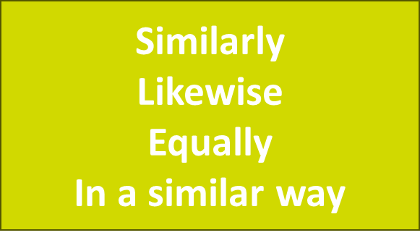

**See below for example conjunctions to use for differences:**

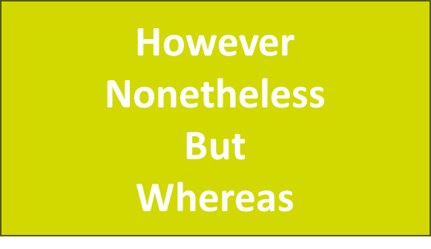

**Using conjunctions**

**Question 1**

Use the following conjunctions to complete the sentences below and state whether they are a similarity or a difference.

**However**

Likewise

Similarly

Whereas

But

An example has been provided for you:

John likes strawberry ice cream. **However**, Mary likes chocolate ice cream.

This is a **difference**.

1. Catie thinks that exercise is important. ____________, Mark says you should do at least 30 minutes of exercise a day.

This is a _______________.

1. Tim states that you need a balanced diet, ___________ Julie does not eat fruit or vegetables.

This is a _______________.

1. Megan says that running can damage your knees, ____________ Lee says that running is good for your joints.

This is a ________________.

1. Steve thinks that smoking is bad for you. __________, Dee says that smoking can take 10 years off your life expectancy.

This is a ________________.

**Comparing similarities and differences**

Read both texts very carefully before you start. Identify and highlight specific words and phrases in the text and make a comparison.

Highlighting large paragraphs can make it more difficult to pick out a comparison.

Let’s look at the example question again.

1. Using Text A and Text B, compare the information given on healthy living.

Provide two similarities or differences from the texts.

The following information has been highlighted in Text A.

**Text A**

**Text B**

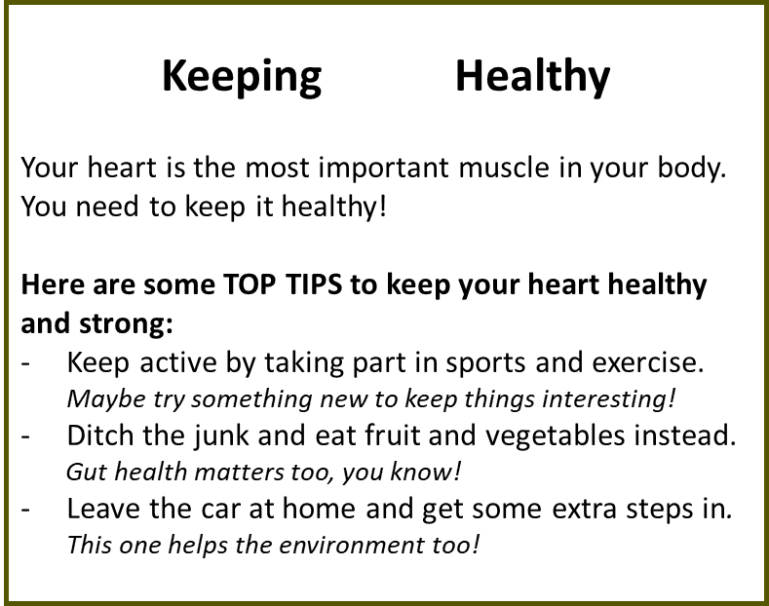

**Question 2.**

Find a statement in Text B that is **similar** to the statement highlighted in Text A.

The first has been completed for you.

1. Text A: health issues such as heart disease

Text B: You need to keep it healthy!

1. Text A: Adults should eat a minimum of five different fruits and vegetables a day

Text B: __________________________________________________

1. Text A: People should also aim to complete around 30 minutes of exercise every day

Text B: __________________________________________________

**Let’s look at how we can write this as an answer to the exam question.**

Exam question:

Using Text A and Text B, compare the information given on healthy living.

Provide **two** similarities or differences from the texts.

**Comparison 1:** *Text A says that in order to keep fit and healthy “People should also aim to complete around 30 minutes of exercise every day”. Similarly, Text B suggests that to improve heart health people should “Keep active by taking part in sports and exercise.”*

**Comparison 2:** *Text A states that people who do not look after themselves might get sick for example “people are at a much higher risk of severe health issues such as heart disease”. Likewise, Text B mentions the importance of looking after the heart to be healthy for example “Your heart is the most important muscle in your body. You need to keep it healthy!”*

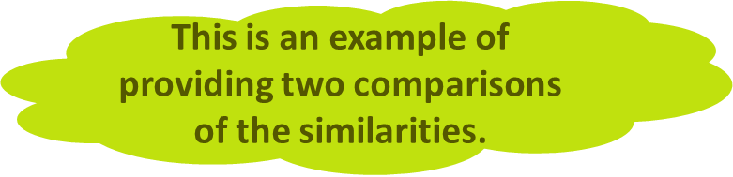

**Question 3.**

Write the following statements as an answer to the exam question.

Remember to use a conjunction.

Text A: Adults should eat a minimum of five different fruits and vegetables a day.

Text B: Ditch the junk and eat fruit and vegetables instead.

**Exam tips when asked to compare information in texts.**

* Say whether the information you are providing is from Text A or Text B
* Ensure you mention both Text A and Text B in each comparison
* Use small pieces of the text in your comparison, rather than large paragraphs
* Use conjunctions to make the comparisons clear
* Make sure you include two separate comparisons

**Exam Question**

Carefully read Texts A and B and then answer the questions about the texts.

**Text A**

**Text B**

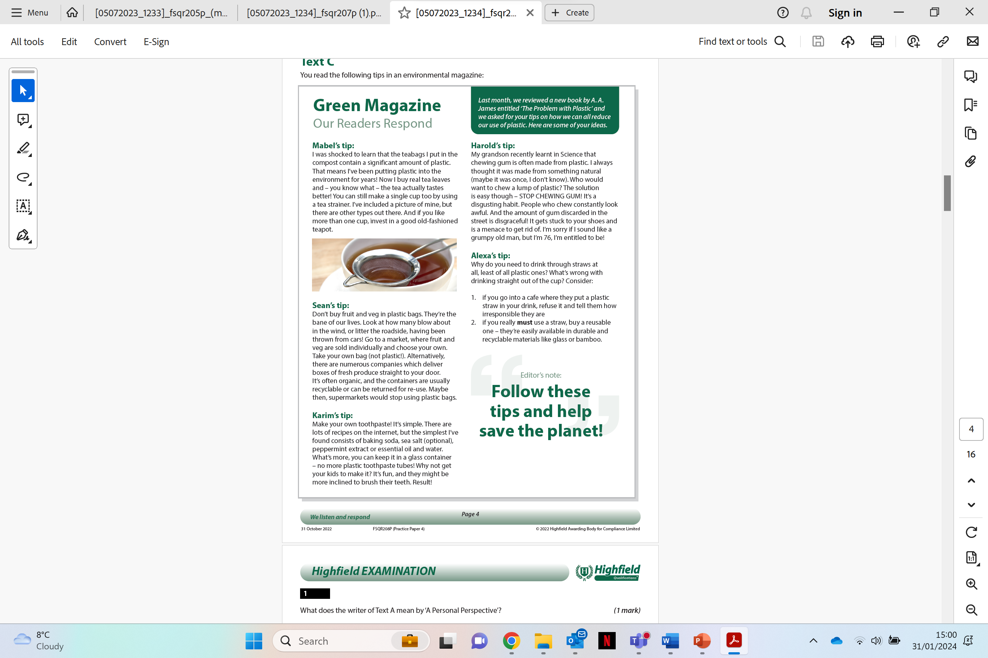

1. Using Text A and Text B, compare the writers’ ideas and opinions on hidden plastics.

Provide **two** similarities or differences from the texts. (2 marks)

Comparison 1:

Comparison 2:

**Your functional skills exam**

Your functional skills exams will consist of 2 papers.   
These papers will take place over the following time periods:

* Reading exam – 60 minutes
* Writing exam – 60 minutes

Further information on the format that your test will take can be obtained from your training provider.

**Hints and tips for reading**

* Find out what format your exam will be in. It may be paper-based or   
  on-screen.
* Plan what you are going to revise in advance. Do not leave it until the last minute.
* Do as many mock papers as you can so you are prepared for the day. If possible, try to complete the mock papers following the same format as the actual exam.
* Find a quiet place to study and revise. It helps to sit at a table or a desk.   
  Do not revise in bed.
* Do not stay up all night revising the night before your exam. It is important to have a good rest, so you feel refreshed and ready to go.
* Read the question 3 times. The first time to ensure you understand what is being asked, the second time to get an understanding of what you need to do and a third time to figure out exactly which English techniques you should be applying.
* If you are struggling with a question, skip it and come back to it later. Try not to sit getting stressed about a difficult question, it will only waste exam time. Move on and come back to it after you have answered the other questions.
* Take note of the number of marks available. This will give you an indication of how much information you should give in your answer.
* When you have finished the exam, go back and check your answers. If you still have time remaining, use it to check your answers and when you have checked your answers check them again.