**FUNCTIONAL SKILLS**

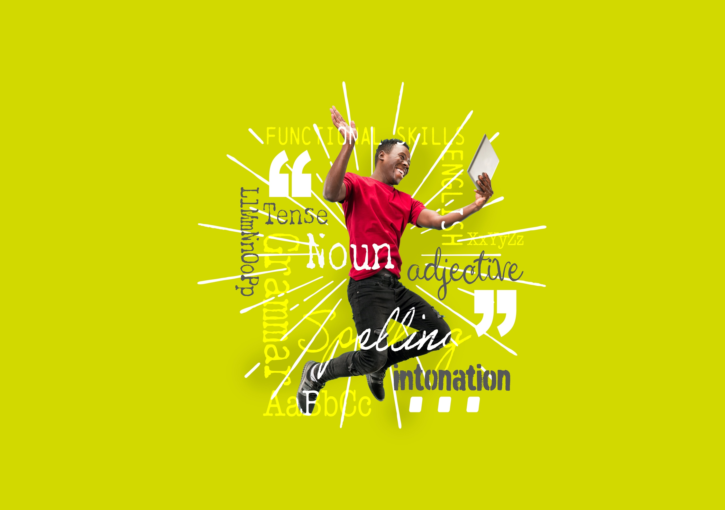English Level 2



**Area: Writing**

Criterion: 28. Construct complex sentences consistently and accurately, using paragraphs where appropriate

**Simple, compound and complex sentences**

An **independent clause** has a subject and a verb and makes sense on its own.

A **dependent clause** has a subject and verb but cannot be read alone. It needs an independent clause to help it make sense.

**Simple sentences**

A simple sentence contains one independent clause, meaning it has a subject and a verb and expresses a complete thought.

For example, ‘I am going to the park.’

**Compound sentences**

A compound sentence uses a co-ordinating conjunction to join two independent clauses.

|  |
| --- |
| Co-ordinating conjunctions  and  but  or |

For example, ‘I will go to the park and you can go to the shop.’

*Please note that ‘and’ and ‘or’ can be used in lists. In this instance, they are not   
co-ordinating conjunctions.*

**Complex sentences**

A complex sentence is made up of at least one dependent clause and one independent clause. They are joined by a subordinating conjunction.

|  |
| --- |
| Subordinating conjunctions  if  since  although  when  as  while  after  before  until  because |

For example, ‘After we have gone shopping, we can go to the park.’

Please note that the sentence above includes a comma. When the dependent clause comes first, a comma is needed to separate it from the independent clause.

If the dependent clause is the second clause, a comma is not needed.

For example, ‘I was excited because we could go to the park.’

**Using the information provided above, answer the following questions.**

**Task 1**

|  |
| --- |
| Co-ordinating conjunctions  and  but  or |

|  |
| --- |
| Subordinating conjunctions  if  since  although  when  as  while  after  before  until  because |

Look at the sentences below. Each sentence has a blank space.

Complete the sentences using the conjunctions above.

1. I want ice cream ___ Josie wants pancakes.
2. ___ the party is over, we should get some food.
3. Can you get some bread ___ you go to the shop?
4. We could go to the swimming pool ___ the theatre.
5. You should wash your hands ____ this stops germs from spreading.
6. Jerry made a roast dinner ____ Sherry set the table.

**Task 2**

State whether the following sentences are **compound** or **complex**.

Tip: identifying whether a conjunction is co-ordinating or subordinating will help you.

|  |
| --- |
| 1. I wanted to go for a run, but it was raining.   Sentence type:   1. Tom has sugar in his tea because it tastes better.   Sentence type:   1. Mia listens to music while she does her workout.   Sentence type:   1. The bakery sells cake and the butcher sells meat.   Sentence type:   1. When we go to the beach, we can make a sandcastle.   Sentence type:   1. We can go to the park or stay home in the garden.   Sentence type: |

**Using paragraphs**

Paragraphs are sections of text. You can show you are starting a new paragraph by moving to a new line, using an indent (a space between the margin and the first word) or using a line break (leaving a full line between the paragraphs).

Each paragraph should contain a different idea. The first sentence should introduce this idea and the following sentences should provide supporting details to explain or expand on the idea.

When you move onto a different idea, you should start a new paragraph. Because each paragraph should cover a different idea, transition words (however, furthermore, on the other hand) can be used to link paragraphs to a main topic.

Below is an example of a text using paragraphs.

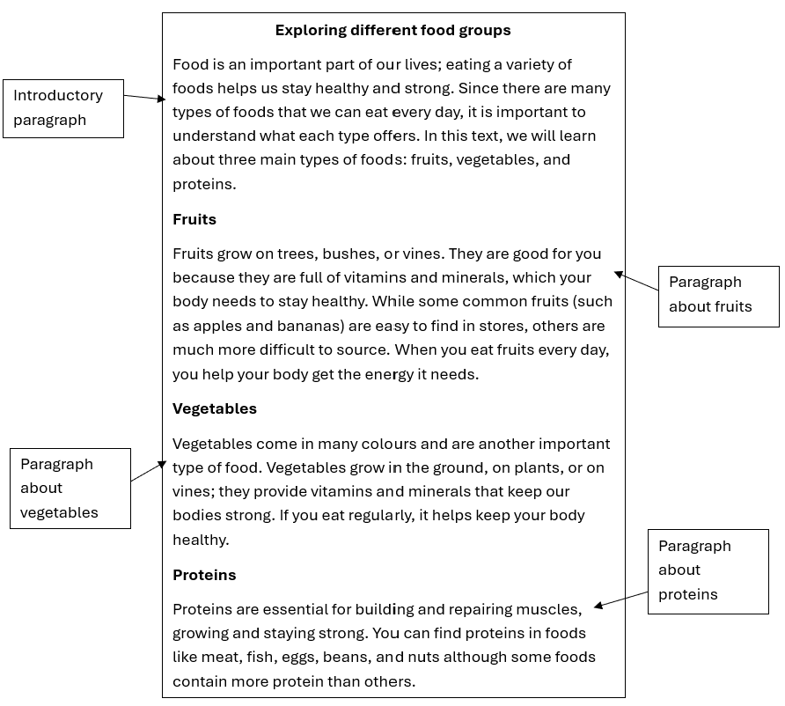

After you have written a paragraph, it is good practice to read it again to make sure that it makes sense and everything in it is related to the starting idea.

There is no set rule for how long a paragraph should be, but 3 to 6 sentences generally works well for examination purposes. If a response starts a new line for every new sentence, a mark for paragraphs will **not** be awarded.

**Task 3**

Paragraphs should have a main idea. Read the paragraphs below and decide what the main idea is.

|  |
| --- |
| 1. Cardboard is a strong, thick type of paper made from wood pulp. Wood pulp is a wet mixture and can easily be formed to make materials. Cardboard is commonly used for boxes, toilet paper tubes and egg cartons. |

|  |
| --- |
| **The main idea is:** |

|  |
| --- |
| 1. After it has been used, cardboard can be recycled. At the recycling plant, the cardboard is shredded and mixed with water to make a pulp mixture. It can then be made into other items, such as paper, plant pots or even building materials. |

|  |
| --- |
| **The main idea is:** |

|  |
| --- |
| 1. It is important to recycle as it reduces the number of trees we need to cut down. Trees produce oxygen and we need oxygen to breathe, so by protecting the trees we are protecting our future. Recycling also stops things going to landfill sites. Landfill sites take up valuable space and produce harmful gases, so we should avoid sending things there. |

|  |
| --- |
| **The main idea is:** |

**Task 4**

Read the text below and decide where the sections should be separated into paragraphs.

|  |
| --- |
| My dog, Bess, is a sheepdog. This means she needs around 2 hours of exercise every day to keep her fit. We go for one walk in the morning, then another walk shortly after dinner. In addition to this, we usually spend an hour playing fetch in the garden. Bess likes the tennis ball best, but I think the frisbee is pretty fun too. She never seems to get tired of playing fetch, although there are times when she doesn’t want to bring the ball back. It’s also important to give Bess healthy food and make sure she has enough to drink throughout the day. Dogs should have a balanced diet of meat and vegetables. Carbohydrates like rice and potatoes are good for them in small portions and make the meal more interesting for Bess. Just like people, dogs appreciate variety. |

|  |
| --- |
|  |

**Exam practice 1**

Your friend has shown an interest in one of your hobbies. They have asked you to write them instructions telling them what they will need and how to get involved in the hobby.

Ensure you use paragraphs and complex sentences consistently.

|  |
| --- |
|  |

**Answers**

**Complex sentences**

**Task 1**

1. I want ice cream **___** Josie wants pancakes.

**Co-ordinating subjunction – and, but**

1. ___ the party is over, we should get some food.

**Subordinating conjunction – after, when, before, since**

1. Can you get some bread ___ you go to the shop?

**Subordinating conjunction – when, if**

1. We could go to the swimming pool ___ the theatre.

**Co-ordinating conjunction – or, and**

1. You should wash your hands ____ this stops germs from spreading. **Subordinating conjunction – because, as, since**
2. Jerry made a roast dinner ____ Sherry set the table.

**Co-ordinating conjunction – and, but**

**Task 2**

1. I wanted to go for a run, but it was raining.

Sentence type: **Compound**

1. Tom has sugar in his tea because it tastes better.

Sentence type: **Complex**

1. Mia listens to music while she does her workout.

Sentence type: **Complex**

1. The bakery sells cake and the butcher sells meat.

Sentence type: **Compound**

1. When we go to the beach, we can make a sandcastle.

Sentence type: **Complex**

1. We can go to the park or stay home in the garden.

Sentence type: **Compound**

**Paragraphs**

**Task 3**

|  |
| --- |
| Cardboard is a strong, thick type of paper made from wood pulp. Wood pulp is a wet mixture and can easily be formed to make materials. Cardboard is commonly used for boxes, toilet paper tubes and egg cartons. |

|  |
| --- |
| This paragraph tells the reader what cardboard is. |

|  |
| --- |
| After it has been used, cardboard can be recycled. At the recycling plant, the cardboard is shredded and mixed with water to make a pulp mixture. It can then be made into other items, such as paper, plant pots or even building materials. |

|  |
| --- |
| This paragraph tells the reader how cardboard can be recycled. |

|  |
| --- |
| It is important to recycle as it reduces the number of trees we need to cut down. Trees produce oxygen and we need oxygen to breathe, so by protecting the trees we are protecting our future. Recycling also stops things going to landfill sites. Landfill sites take up valuable space and produce harmful gases, so we should avoid sending things there. |

|  |
| --- |
| This paragraph tells the reader why recycling cardboard is important. |

**Task 4**

|  |
| --- |
| My dog, Bess, is a sheepdog. This means she needs around 2 hours of exercise every day to keep her fit. We go for one walk in the morning, then another walk shortly after dinner.  In addition to this, we usually spend an hour playing fetch in the garden. Bess likes the tennis ball best, but I think the frisbee is pretty fun too. She never seems to get tired of playing fetch, although there are times when she doesn’t want to bring the ball back.  It’s also important to give Bess healthy food and make sure she has enough to drink throughout the day. Dogs should have a balanced diet of meat and vegetables. Carbohydrates like rice and potatoes are good for them in small portions and make the meal more interesting for Bess. Just like people, dogs appreciate variety. |

**Exam practice**

**Exam practice 1**

*Please note that this is an example answer and learner responses will vary.*

The complex sentences have been highlighted and the writer has used line breaks to demonstrate paragraphs.

|  |
| --- |
| **Kickboxing instructions for Sarah**  Introduction  Kickboxing is a sport that mixes traditional boxing with kicking techniques from martial arts: it helps you to gain strength, speed and coordination. Before you start, there’s a few things you will need.  You will need:   * comfy workout clothes * boxing gloves * hand wraps * a mouthguard * shin guards * a punching bag or pads   If you don’t own these things, you’ll probably be able to borrow some from your local gym. When you are first starting out, it’s also a good idea to have an experienced coach on hand to help you.  Rules  There are different styles of kickboxing. While my favourite style is called Muay Thai, you’ll probably find your own style in time. The rules can be slightly different depending on which style you want to do but here are some of the basics.  Since this is a combat sport, you’ll need to hit or strike your opponent. However, there are ‘legal’ and ‘illegal’ strikes. A legal strike includes punches, kicks and must hit the opponent’s body or head. (You might be able to see why you need a mouthguard!) You must not hit below the belt and you’re not allowed to grab onto your opponent.  A match of kickboxing usually lasts three to five rounds, with each round lasting two to three minutes. A round ends when a fighter is knocked down for 10 seconds or longer. If the fighter can’t get back up, the match ends and the person left standing is the winner. If no one is knocked down, then the winner is decided by a points system. Points are awarded when you strike your opponent or for a good defence. Points can also be taken away from you if you make an illegal strike. |

**Your functional skills exam**

Your functional skills exams will consist of 2 papers.  
These papers will take place over the following time periods:

* Reading – 60 minutes
* Writing – 60 minutes

Further information on the format that your test will take can be obtained from your training provider.

**Hints and tips**

* Find out what format your exam will be in. It may be paper-based   
  or on-screen.
* Plan what you are going to revise in advance. Don’t leave it until the last minute.
* Do as many past papers as you can so you are prepared for the day. If possible, try to complete the past papers following the same format as the actual exam.
* Find a quiet place to study and revise. It helps to sit at a table or a desk, don’t revise in bed.
* Don’t stay up all night revising the night before your exam. It’s important to have a good rest so you feel refreshed and ready to go.
* Read the question 3 times. The first time to ensure you understand what is being asked, the second time to get an understanding of what you need to do, and a third time to figure out exactly what maths techniques you should be applying.
* If you are struggling with a question, skip it and come back to it later. Try not to sit getting worked up about a difficult question, it will only waste exam time. Move on and come back to it after you have answered the other questions.
* Take note of the number of marks available. This will give you an indication of how much working out you must show. For example, 1 mark will need an answer only and more marks will need you to show your working out.
* When you’ve finished the exam, go back and check your answers. If you still have time remaining, use it to check your answers and when you have checked your answers check them again.