**FUNCTIONAL SKILLS**

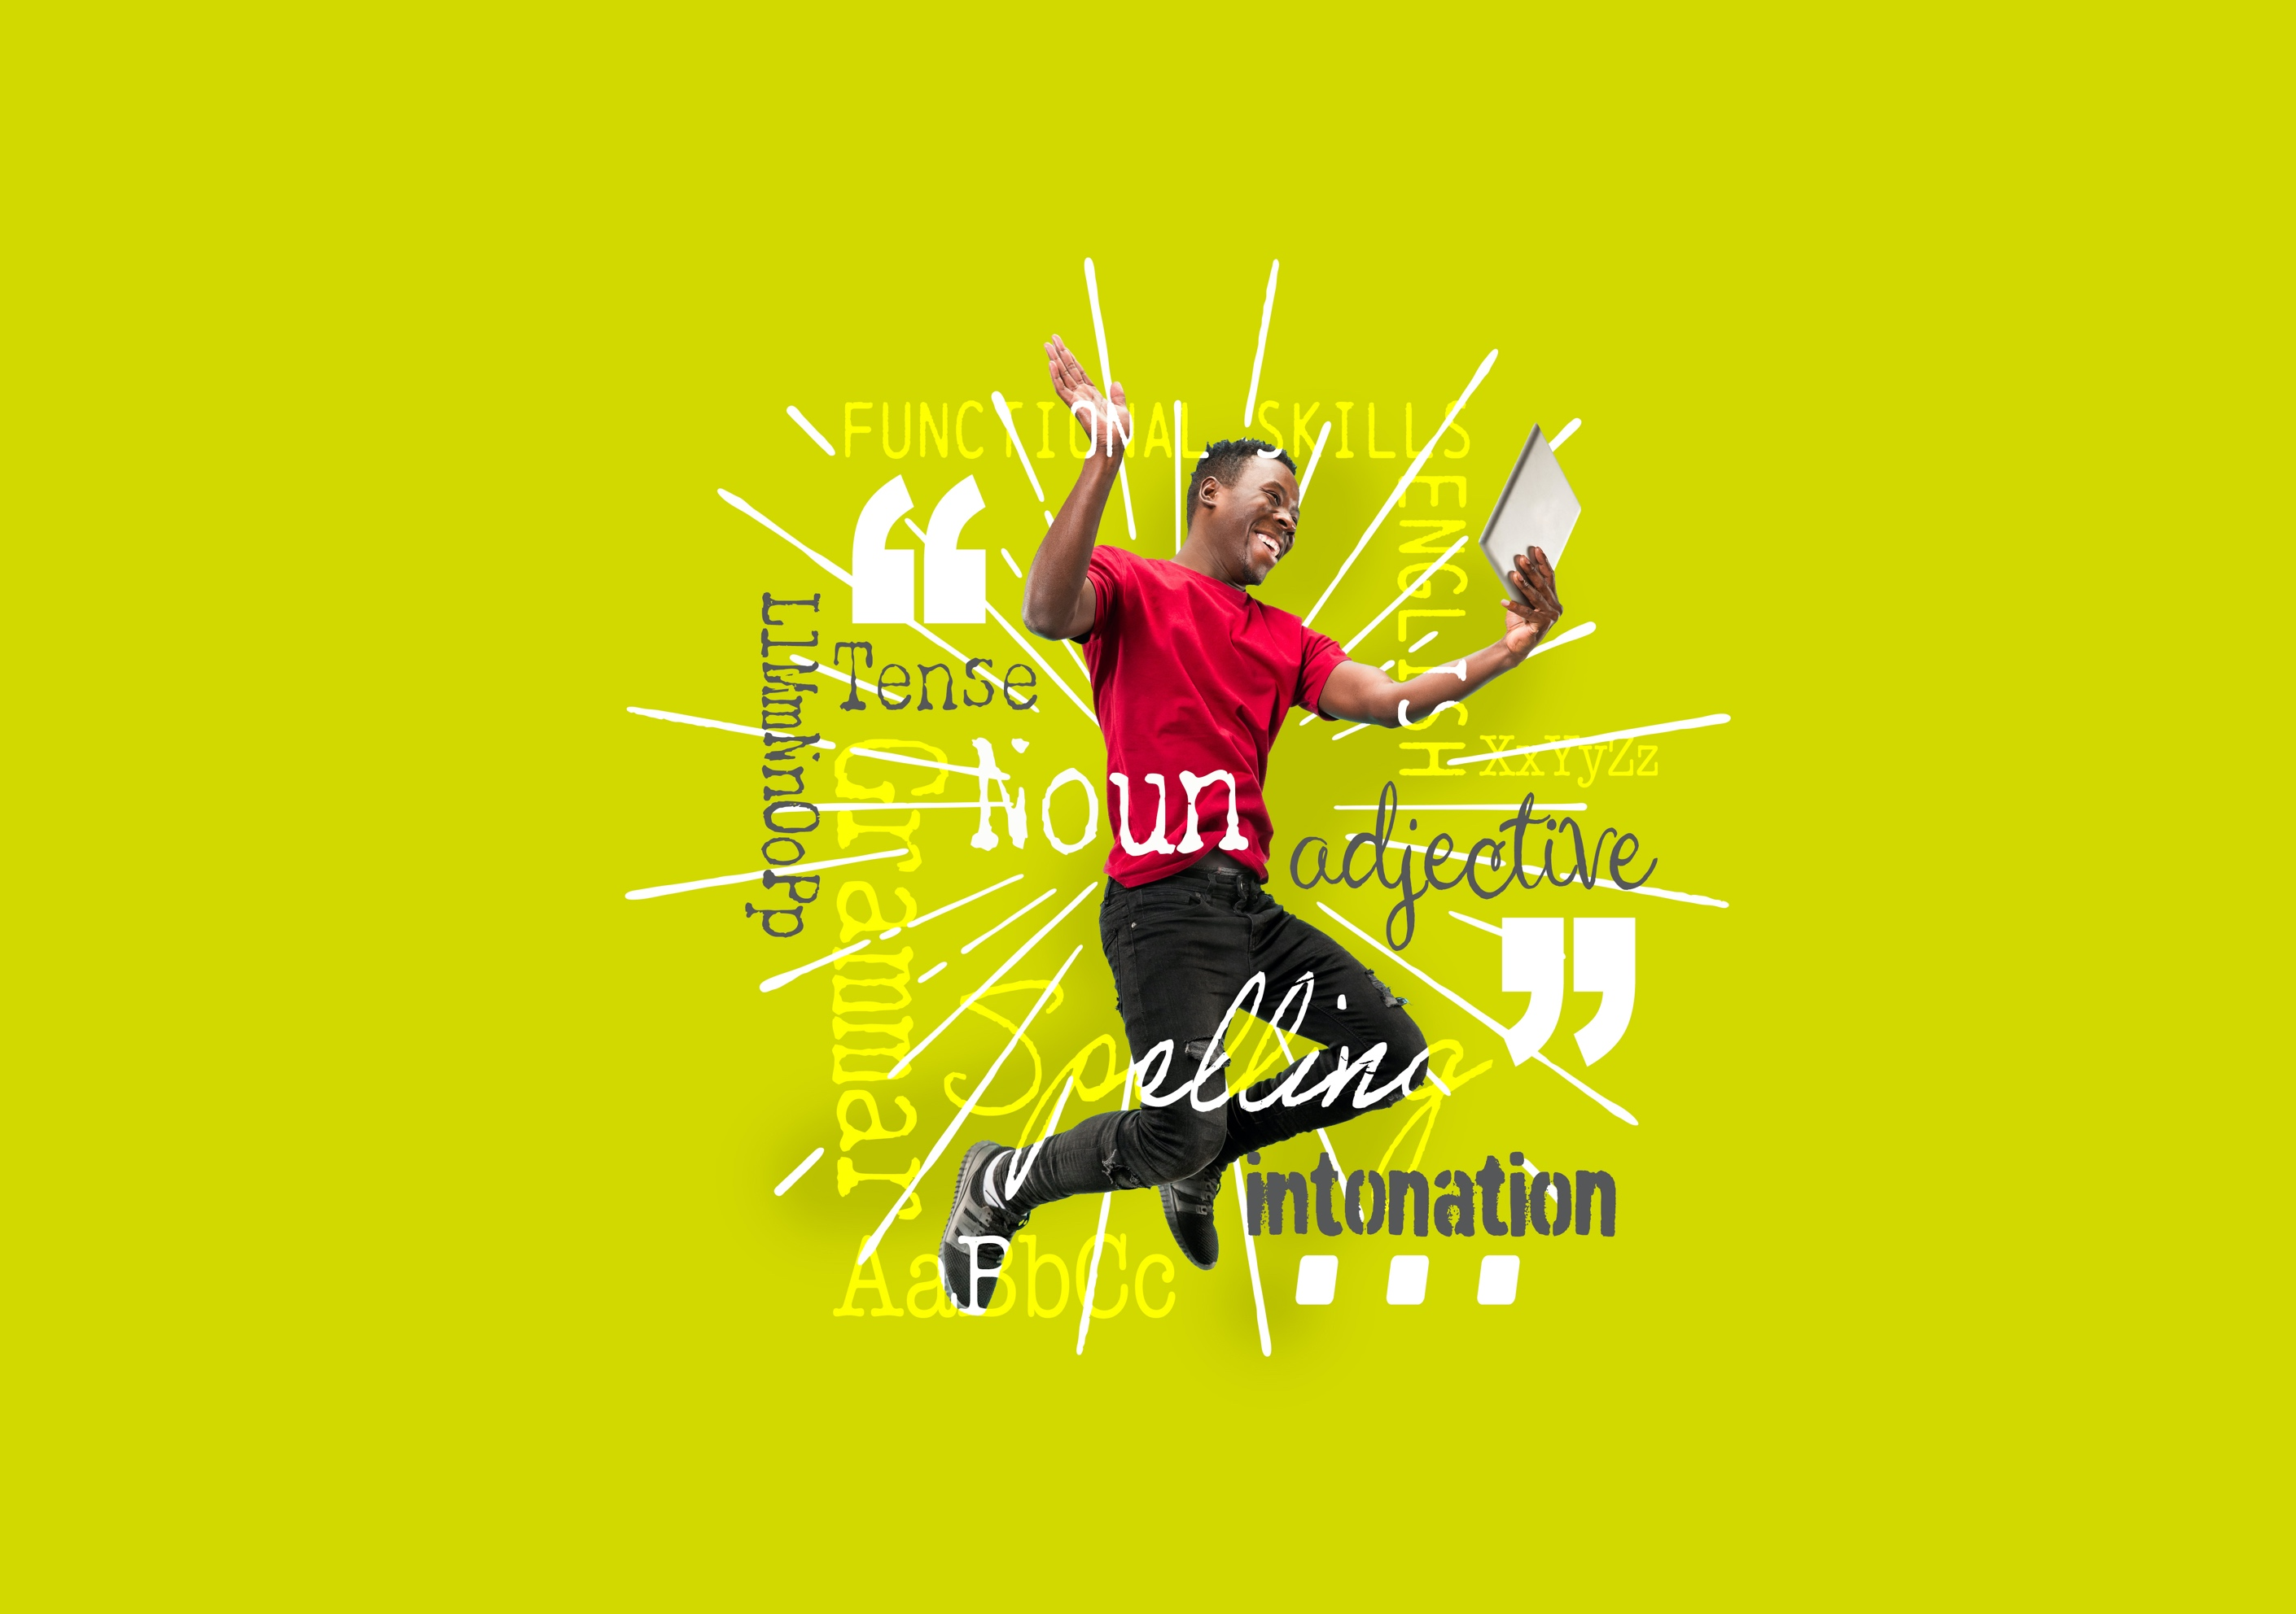English Level 1



**Area: Reading**

Criterion: 10. Compare information, ideas and opinions in different texts.

**Information, ideas and opinions**

**Information**

Information is usually a fact.

This could include factual statements, such as ‘The building has ten windows’.

Someone could look at the building and check this fact.

It could also include statistics or numbers.

For example, ‘This car is 25% more efficient’.

**Ideas**

Ideas and opinions are similar. However, they can be separated.

An idea can be seen as the writer’s thoughts or suggestions. For example, ‘You could write to the council’ or ‘You should try the chocolate cake!’.

**Opinions**

An opinion is how the writer feels about something. For example, ‘Raspberry jam is the best flavour’. This is phrased as a factual statement, but others may not like raspberry or think another flavour tastes better.

**Using the information provided above, answer the following questions.**

**Question 1**

Pick out **one** piece of information, **one** idea and **one** opinion from the text below.

|  |
| --- |
| Balancing work and life: why it matters  Finding the right balance between work and personal life is important for everyone. Many people feel pressure to work long hours, especially in today’s fast-paced world. However, taking time for yourself is just as crucial. Studies show that overworking can lead to stress, burnout and even health problems. On the other hand, having hobbies, spending time with family and resting can improve your well-being and make you more productive at work.  To improve your work/life balance, you could try setting clear boundaries. For example, avoid checking work emails after working hours or take regular breaks throughout the day. I find that planning my week helps me to manage my time better, leaving space for both work and leisure.  While some believe that hard work is the only way to get ahead, it’s important to remember that your health and happiness come first. Everyone deserves time to relax and enjoy life and finding that balance can lead to greater success in the long run. |

|  |
| --- |
| **Information:**  **Idea:**  **Opinion:** |

**Forming comparisons**

A comparison usually highlights a **similarity** or a **difference**.

To have **one** complete comparison, you must reference **both** texts and have a clear connecting theme. You must have **two** comparisons to get **both** marks.

**Conjunctions**

An easy way to format a comparison is to use conjunctions. Conjunctions are words that join two ideas together.

You can use different conjunctions for similarities and differences.

|  |  |
| --- | --- |
| Similarities | Differences |
| And | But |
| Likewise | However |
| Similarly | Whereas |

Example comparison:

‘In Text A, Ted says that breakfast is the most important meal of the day. However, in Text B, Roz says that she doesn’t eat breakfast as it makes her feel too full’.

This is **one** comparison. Here the connecting theme is the writer’s opinions on breakfast. Ted and Roz have **different** opinions.

**Using the information provided above, answer the following questions.**

**Question 2**

Use these conjunctions to write 4 comparisons.

These can be on a subject of your choice.

|  |  |
| --- | --- |
| Similarities | Differences |
| And | But |
| Likewise | However |
| Similarly | Whereas |

|  |
| --- |
| 1.  2.  3.  4. |

**Exam practice**

|  |
| --- |
| **Text A**  The joy of mountain climbing  Mountain climbing is an exciting way to explore nature and challenge yourself. It offers a full-body workout and helps improve both physical and mental health. Climbers often find a deep sense of happiness when reaching the top after a difficult climb. Whether you’re a beginner or experienced, there are various routes that can match your skill level.  One idea for those new to mountain climbing is to start with shorter, less challenging climbs. This allows you to build strength and confidence before attempting more difficult routes. It’s also important to invest in the right gear, such as sturdy boots and weather-appropriate clothing, to ensure safety during your climb.  Some people believe that mountain climbing isn’t worth the risk, citing potential dangers like falls or weather changes. However, with proper preparation and training, many feel the rewards far outweigh the risks. |

|  |
| --- |
| **Text B**  Is mountain climbing too risky?  Mountain climbing might seem like an exciting adventure, but it comes with significant risks. Every year, climbers face accidents due to unpredictable weather or accidents like falling. Even experienced climbers can be caught off guard by rapidly changing conditions or lack of proper equipment.  One idea to reduce these risks is to always climb with a partner and ensure you check weather reports beforehand. Beginners should avoid going on climbs that are too challenging, as it increases the risk of injury.  Some people argue that mountain climbing is worth the risk for the sense of achievement and connection with nature. However, others feel that the danger involved makes it not worth the effort. |

**Exam practice 1**

Compare Text A and Text B.

Identify **two** similarities or differences on **mountain climbing**.

(2 marks)

|  |
| --- |
| **Comparison 1:**  **Comparison 2:** |

**Answers**

**Information, ideas and opinions**

**Question 1**

*Please note that there may be other correct answers. These answers are examples.*

|  |
| --- |
| **Information:**  Studies show that overworking can lead to stress, burnout and even health problems.  **Idea:**  To improve your work/life balance, you could try setting clear boundaries.  **Opinion:**  I find that planning my week helps me to manage my time better, leaving space for both work and leisure. |

**Comparisons**

**Question 2**

*Please note that there may be other correct answers. These answers are examples.*

Bob says the kitchen door needs painting. Similarly, Rachel says the door paint is cracking and looks old.

Jessica says it’s cold outside and Ross says you will need a coat if you go outside.

Andy likes rollercoasters but Libby thinks they are dangerous.

Penny wants to go to Spain for a holiday, whereas Spencer wants to go to Italy.

**Exam practice**

**Exam practice 1**

**Similarities**

Text A says that mountain climbing is ‘an exciting way to explore nature’. Likewise, Text B says that it seems like ‘an exciting adventure’.

Text A states that new climbers should ‘start with shorter, less challenging climbs’. Similarly, Text B states that beginners should avoid going on climbs that are too challenging’.

Text A says ‘the rewards far outweigh the risks’ and Text B says ‘Some people argue that mountain climbing is worth the risk for the sense of achievement’.

Both Text A and Text B say that mountain climbing come with risks such as falls and unpredictable weather.

**Differences**

Text A says that mountain climbing is a way to challenge yourself. However, Text B says you should avoid climbs that are too challenging.

Text B states that even experienced climbers can be caught off guard by rapidly changing conditions, but Text A says you should have the right gear, such as sturdy boots and weather-appropriate clothing.

In Text A it says ‘with proper preparation and training, many feel the rewards far outweighs the risks’ whereas in Text B it says ‘others feel that the danger involved makes it not worth the effort’.

**Your functional skills exam**

Your functional skills exams will consist of 2 papers.  
These papers will take place over the following time periods:

* Reading – 60 minutes
* Writing – 60 minutes

Further information on the format that your test will take can be obtained from your training provider.

**Hints and tips**

* Find out what format your exam will be in. It may be paper-based   
  or on-screen.
* Plan what you are going to revise in advance. Don’t leave it until the last minute.
* Do as many past papers as you can so you are prepared for the day. If possible, try to complete the past papers following the same format as the actual exam.
* Find a quiet place to study and revise. It helps to sit at a table or a desk, don’t revise in bed.
* Don’t stay up all night revising the night before your exam. It’s important to have a good rest so you feel refreshed and ready to go.
* Read the question 3 times. The first time to ensure you understand what is being asked, the second time to get an understanding of what you need to do, and a third time to figure out exactly what maths techniques you should be applying.
* If you are struggling with a question, skip it and come back to it later. Try not to sit getting worked up about a difficult question, it will only waste exam time. Move on and come back to it after you have answered the other questions.
* Take note of the number of marks available. This will give you an indication of how much working out you must show. For example, 1 mark will need an answer only and more marks will need you to show your working out.
* When you’ve finished the exam, go back and check your answers. If you still have time remaining, use it to check your answers and when you have checked your answers check them again.