**FUNCTIONAL SKILLS**

English Level 2 - Writing



**26. Convey clear meaning and establish cohesion using organisational markers effectively**

So, what does this mean?

Let’s look at some definitions:

**Convey** – to put forward or communicate an idea or information.

**Cohesion** – linking ideas or information together within a text to give it a clear meaning.

Simply put, organisational markers can be used to make your writing clear and easy to read.

The table on the next page provides some examples of common organisational markers.

**Organisational markers**

|  |  |  |
| --- | --- | --- |
| **Organisational marker** | **Example** | **Effect** |
| **Straplines** | *‘Because you’re worth it’* | Straplines are usually found in articles and adverts. They give the reader a clue as to what the article or advert will be about, as well as setting the tone of the text. |
| **Bullet Points** | *You will need:*   * *eggs* * *flour* * *milk* | Bullet points are an excellent way to break up information, making it more manageable for the reader. |
| **Subheadings** | *Introduction*  *The start of this text…* | Subheadings help to separate a text into logical parts and also make specific information easier to find. |
| **Tables** | |  |  |  |  | | --- | --- | --- | --- | | *Age range* | *18-25*​ | *26-30*​ | *31+*​ | | *Amount* | *122*​ | *856*​ | *15*​ | | Tables help to display data in a clear and concise way for the reader**.** |
| **Text boxes** | *“It’s absolutely ridiculous”* | Text boxes allow specific chunks of information to stand out. They are often used to help highlight an opinion or viewpoint. |
| **Illustrations** | **Agriculture outline** | Illustrations draw a reader in but also help to aid understanding and support an idea or viewpoint. |
| **Footnotes** | *\*Main = The most important or biggest.* | Footnotes support a reader’s understanding of text-specific vocabulary. |
| **Numbered lists** | *Here’s what you need to do:*   1. *email the manager* 2. *attach the file* 3. *copy in HR* | Numbered lists allow information or processes to be displayed in a clear order. They are commonly used in instructional leaflets or reports. |
| **Photo captions** |   *Man (above) cuddles cat.* | Photo captions help to give more context to an image used in a text. This can help the reader gain a wider understanding of the text as a whole. |

Using organisational markers in an on-screen exam may look a little different. You can show that you would like to include an illustration or a caption by using brackets.

For example: (Include a photo of a man cuddling a cat. Caption: Man cuddles cat).

**Examples of different types of texts and organisational markers**

**Articles**

The magazine article below is titled ‘The Aging Population’. Let’s see how the writer has used organisational markers to make it easier for the reader to find the information.

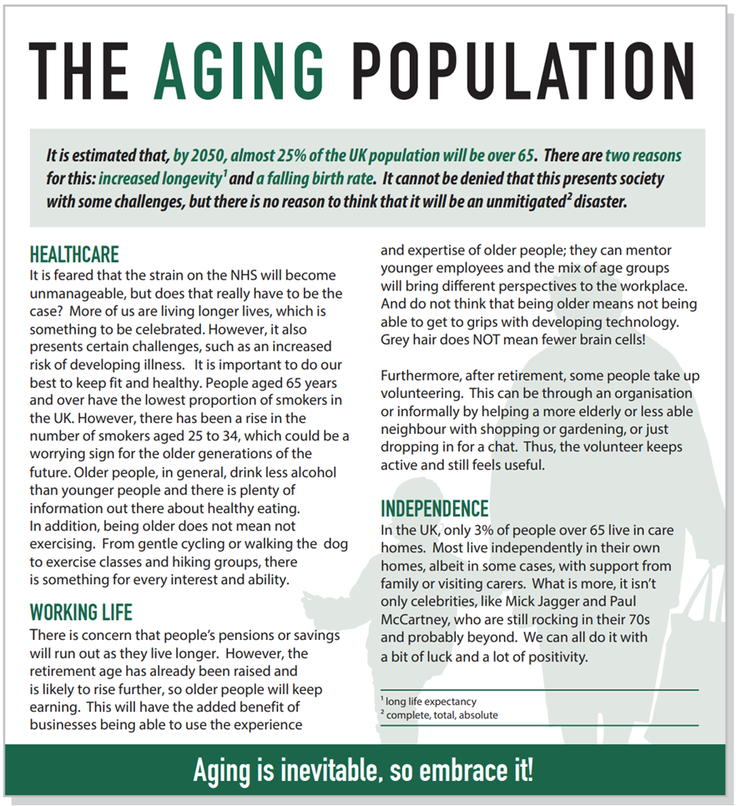

Footnotes

Subheadings

Text Box

**Examples of different types of text and organisational markers**

**Reports**

The report below is about the proposal for a distribution centre in Highfield Town. Organisational markers have been used to make it easier for the reader to locate the information they need. They also make each point clearer.

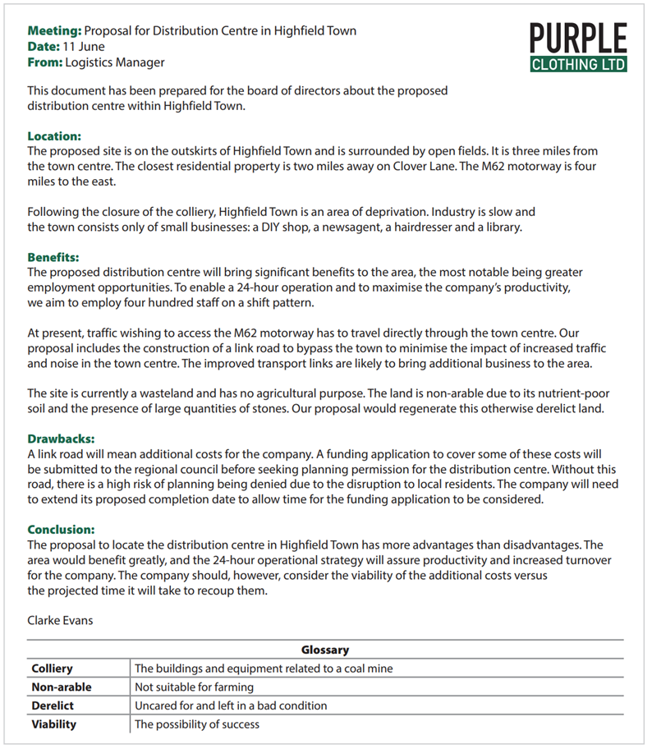

Date completed

Author’s name

Glossary

Subheadings

Image of company logo

**Examples of different types of text and documents**

**Emails and letters**

When you are writing a lot of detail in an email or letter, subheadings, bullet points or numbered lists can be used to help organise the information.

An example email has been provided below.

When writing emails and letters in your exam you will get marks for including organisational markers such as subheadings, bullet points, numbered lists or footnotes!

**Using the information provided on page 2, answer the following questions.**

**Question 1**

Using the following options, label the organisational markers on the text below.

Illustrations Text box Subheadings Bullet points Strapline

**Question 2**

Subheadings are one of the most common organisational markers used in a variety of texts.

Look at the article below and add appropriate subheadings in the spaces provided. The first one has been done for you.

**New course available: Woodworking Level 2**

**Course overview**

This is a full time, 2-year course delivered over 15 hours a week (Monday to Thursday). The course will be taught using a hybrid approach consisting of classroom delivery and practical lessons, which will be carried out in our purpose-built workshops.

**________________**This course is aimed at people considering a career in carpentry with opportunities to work in industry with real employers. You must be creative, organised and have a passion for woodwork.

**________________**

3 GCSEs at grade C or above or equivalent.

**________________**

When you sign up for the course, you will be welcomed into a life at college with many benefits. You’ll have access to state-of-the-art facilities, receive quality teaching and have the opportunity to forge long lasting friendships with your peers. For pastoral support, you can head over to out student’s union, where you’ll find all of the support and guidance you need. You’ll also have the chance to join a range of fantastic clubs and take part in some exciting extracurricular activities with your peers.

***So, what are you waiting for? Sign up today!***

The College Times

*The best place to get your up-to-date college info!*

Here’s a practice exam question. Write your answer on the next page and try to include some organisational markers.

**Exam question**

You write for the local newspaper and receive the following leaflet:



You can help us in our fight against poverty.

Did you know:

* Thousands of families are left with out access to food, water and adequate clothing
* Families are being hit with heavy tax rates, despite having low income
* Many families have been separated, their children going into foster care, leaving the parents homeless

Please help us in our fight to keep families together and end poverty.

To donate, call: 01234 567 890

For more information, visit: www.fightpoverty.org

Write an **article** for the newspaper highlighting the problem of poverty and encouraging readers to help with the fight against poverty.

You should write approximately **250-300 words**.

**Planning space:**

**Write your article here:**

**Summary**

Upon completion of this workbook, you should now understand:

* the format and layout of different types of texts~~.~~
* how to select relevant organisational markers for different types of text~~.~~
* how to ensure organisational markers are used to establish cohesion and convey a clear meaning~~.~~

**Your functional skills exam**

Your functional skills exams will consist of 2 papers.   
These papers will take place over the following time periods:

* Reading exam – 60 minutes
* Writing exam – 60 minutes

Further information on the format that your test will take can be obtained from your training provider.

**Hints and tips for writing**

* Find out what format your exam will be in. It may be paper-based or   
  on-screen.
* Plan what you are going to revise in advance. Do not leave it until the last minute.
* Do as many mock papers as you can so you are prepared for the day. If possible, try to complete the mock papers following the same format as the actual exam.
* Find a quiet place to study and revise. It helps to sit at a table or a desk.   
  Do not revise in bed.
* Do not stay up all night revising the night before your exam. It is important to have a good rest, so you feel refreshed and ready to go.
* Read the question 3 times. The first time to ensure you understand what is being asked, the second time to get an understanding of what you need to do and a third time to figure out exactly which English techniques you should be applying.
* If you are struggling with a question, skip it and come back to it later. Try not to sit getting stressed about a difficult question, it will only waste exam time. Move on and come back to it after you have answered the other questions.
* Take note of the number of marks available. 27 marks should give you an indication of how much information you should give in your answer.
* When you have finished the exam, go back and check your answers. If you still have time remaining, use it to check your answers and when you have checked your answers check them again.