**FUNCTIONAL SKILLS**

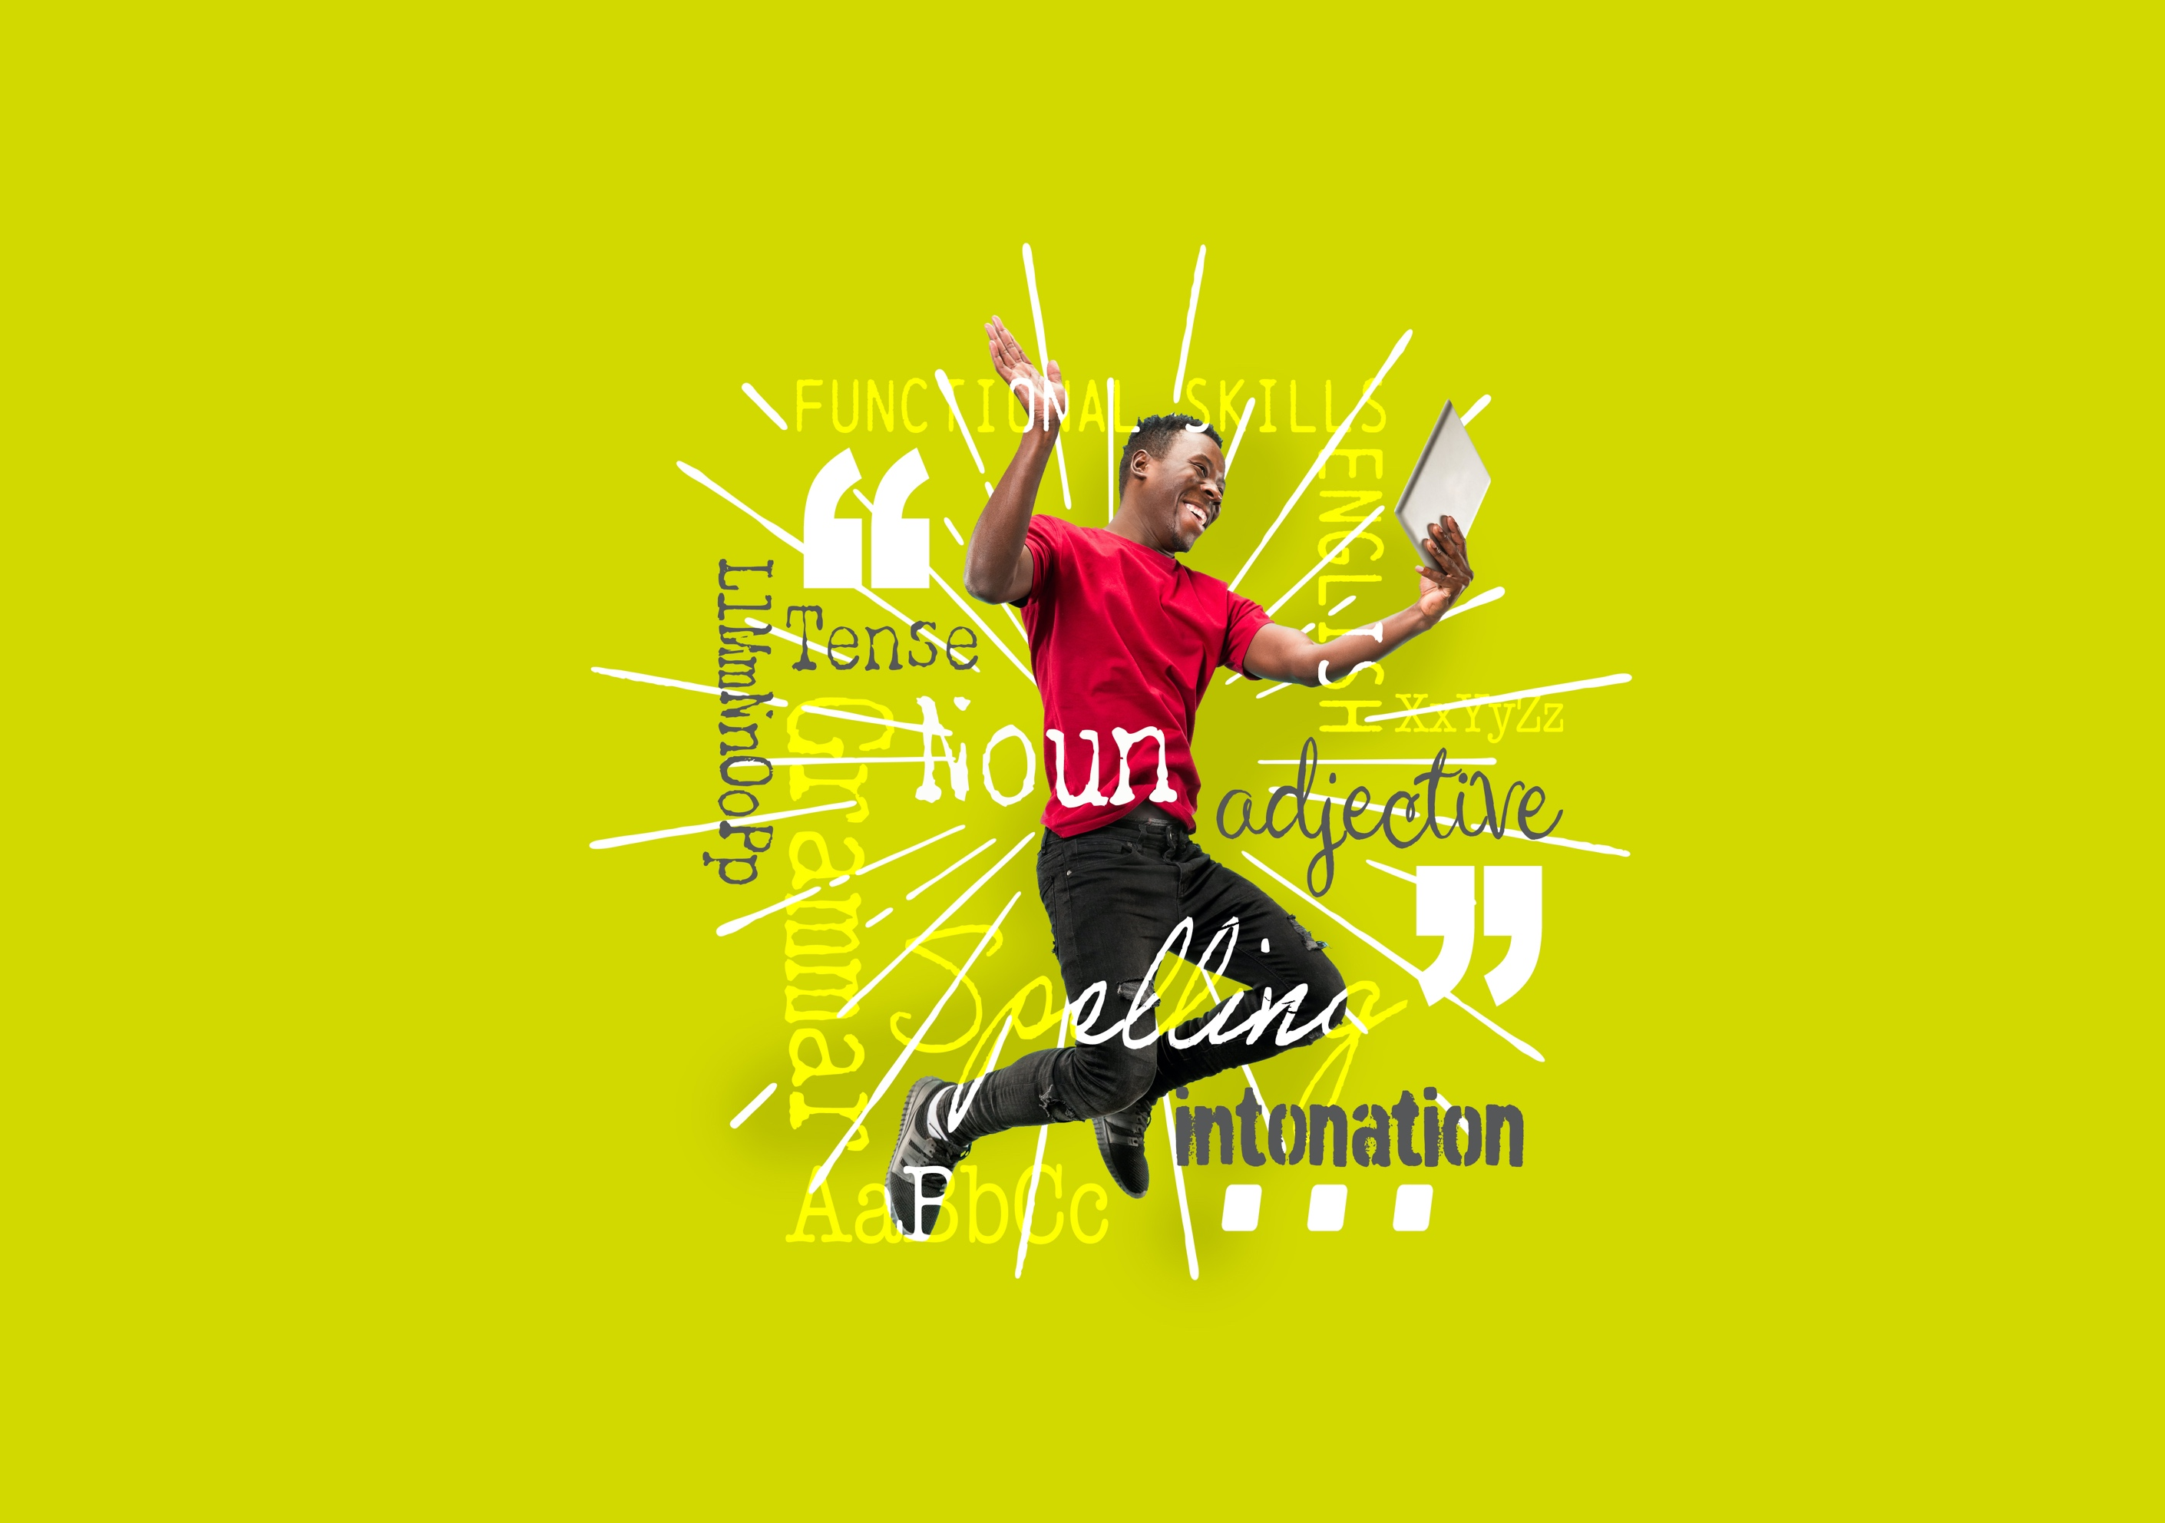English Level 2



**Area: Reading**

Criterion: Compare information, ideas and opinions in different texts, including how they are conveyed

**How information, ideas and opinions are conveyed**

This workbook will focus on the second part of the subject content: how information, ideas and opinions are conveyed.

Another way of saying conveyed is ‘how information, ideas and opinions are put across’.

Writers use different techniques to convey information to the reader. For example:

* humour may be used to entertain the reader.
* rhetorical questions may be used to make the reader think a certain way.
* the writer’s voice (or tone of voice) may be used to show how the writer is feeling. For example, in a letter of complaint the writer may use a frustrated or negative voice.

In your exam, you will be asked to identify how information, ideas and opinions have been put across in different texts.

Below is an example question on how information, ideas and opinions are conveyed.

Compare **two** ways the information has been conveyed in Text A and Text B.

In your answer, you could consider the use of:

• vocabulary

• style of writing

• tone of voice

(2 marks)

Although the question references vocabulary, style of writing and tone of voice, these are not the only answers. There are different ways that you can answer this question:

**Writing style**

Formal, informal, complex, straightforward, factual, informative and so on.

**Textual devices**

Facts, statistics, alliteration, rhetorical questions, emotive language, direct address and so on.

**Type of text**

Magazine article, government letter, report and so on.

**Writer’s voice**

Positive, negative, friendly, frustrated, and so on.

**Vocabulary**

Positive or negative, complex or simple and so on.

**Organisational features**

Bullet points, subheadings, textboxes, headlines or numbered lists and so on.

When answering a question about how information is conveyed, choose a topic from those listed above that you are more confident with.

**Read Text A below.**

How has the writer conveyed the information to the reader in Text A?

Heading

**Text A**

Negative voice

Statistics

Formal style

**Example answers**

**Organisational features**

The information has been conveyed using a headline to grab the reader’s attention.

**Textual devices**

The information has been conveyed using statistics to emphasise the points being made in the text.

**Style of writing**

The information has been conveyed using a formal style due to the important and serious nature of the topic.

**Writer’s voice**

The information has been conveyed using a negative voice to outline the serious consequences of not following a healthy lifestyle.

**Question 1**

How has the writer conveyed the information to the reader in Text B?

Using the options below, label the text with how the information has been conveyed.

**Options:**

Direct address Bullet points Informal style Positive voice

**Question 2**

Choose **one** of the above options to complete this statement.

In Text A, information has been conveyed using statistics to emphasise the points being made in the text.

However, in Text B, information has been conveyed using _______________ to talk directly to the reader and draw them in.

**Example answers**

Let’s look at how we can use the information as an answer to the exam question.

Compare **two** ways the information has been conveyed in Text A and Text B.

In your answer, you could consider the use of:

• vocabulary

• style of writing

• tone of voice

(2 marks)

Compare how the information has been conveyed in Text A and Text B.

**Comparison 1:**

The information in Text A has been conveyed using statistics to emphasise the points being made in the text.

In Text B, the information has been conveyed using second person pronouns (direct address) to talk directly to the reader. This draws the reader in and makes them take more notice of the advice being given.

**Comparison 2:**

Text A is formal. However, Text B uses an informal style to encourage people to keep healthy.

Rememberto read both texts very carefully.

Identify specific words and phrases in the text and make a comparison. If one text were to use first person perspective, does the second text also do this, or does it use second (or third) person perspective instead?

**Exam tips on how information, ideas and opinions are conveyed**

* Make it clear which text you are referring to (for example, Text A and Text B)
* You can refer to ‘both texts’ if you are giving a similarity (for example, both texts use a formal style)
* Make sure the information you are comparing is about the same topic
* Give two different similarities and/or differences
* Compare how the information has been conveyed in each text: consider the use of textual devices, writing style, writer’s voice, vocabulary or organisational features

**Text C**

**Text D**

**Exam practice 1**

Compare **two** ways the information has been conveyed in Text C and Text D.

In your answer, you could consider the use of:

• vocabulary

• style of writing

• tone of voice

(2 marks)

|  |
| --- |
|  |

**Answers**

**How information, ideas and opinions are conveyed**

Direct address

Informal style

Bullet points

Positive voice

**Question 2**

In text A, information has been conveyed using statistics to emphasise the points being made in the text.

However, in Text B, information has been conveyed using direct address to talk directly to the reader and draw them in.

**Exam practice 1**

Learners will receive 1 mark for each correct comparison of how ideas and opinions have been conveyed. Please note that there may be other answers that are not stated below.

Example answers include:

* Text C is formal, whereas Text D is informal
* Text C includes facts/factual statements, whereas Text D includes opinions with facts to support their arguments

**Your functional skills exam**

Your functional skills exams will consist of 2 papers.  
These papers will take place over the following time periods:

* Reading – 60 minutes
* Writing – 60 minutes

Further information on the format that your test will take can be obtained from your training provider.

**Hints and tips**

* Find out what format your exam will be in. It may be paper based   
  or on-screen.
* Plan what you are going to revise in advance. Don’t leave it until the last minute.
* Do as many past papers as you can so you are prepared for the day. If possible, try to complete the past papers following the same format as the actual exam.
* Find a quiet place to study and revise. It helps to sit at a table or a desk, don’t revise in bed.
* Don’t stay up all night revising the night before your exam. It’s important to have a good rest so you feel refreshed and ready to go.
* Read the question 3 times. The first time to ensure you understand what is being asked, the second time to get an understanding of what you need to do, and a third time to figure out exactly what maths techniques you should be applying.
* If you are struggling with a question, skip it and come back to it later. Try not to sit getting worked up about a difficult question, it will only waste exam time. Move on and come back to it after you have answered the other questions.
* Take note of the number of marks available. This will give you an indication of how much working out you must show. For example, 1 mark will need an answer only and more marks will need you to show your working out.
* When you’ve finished the exam, go back and check your answers. If you still have time remaining, use it to check your answers and when you have checked your answers check them again.