**FUNCTIONAL SKILLS**

English Level 2 - Reading

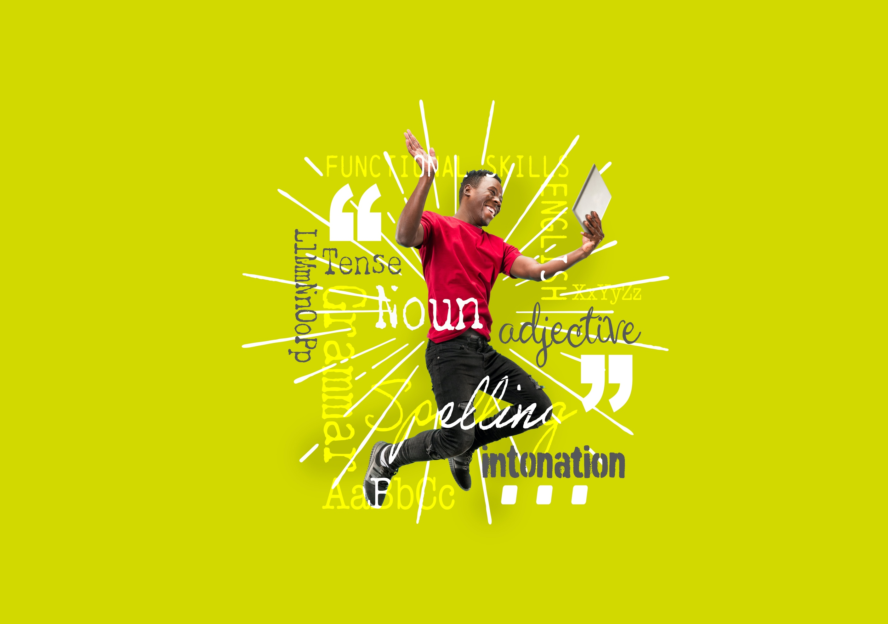

**.**

**12. Compare information, ideas and opinions in different texts, including how they are conveyed.**

This workbook will focus on the second part of the subject content: how information, ideas and opinions are conveyed.

Another way of saying conveyed is ‘how information, ideas and opinions are put across’.

Writers use different techniques to convey information to the reader. For example:

* humour may be used to entertain the reader.
* rhetorical questions may be used to make the reader think a certain way.
* the writer’s voice (or tone of voice) may be used to show how the writer is feeling. For example, in a letter of complaint the writer may use a frustrated or negative voice.

In your exam you will need to identify and compare some of the techniques used in different texts.



**How information, ideas and opinions are conveyed.**

Below is an example question on how information, ideas and opinions are conveyed that will form part of your reading level 2 functional skills exam:

**Example question**

1. Using Text A and Text B, compare two ideas or opinions about healthy living and explain how these are conveyed.

*(2 marks)*

There are different ways that you can answer the second part of this question: ‘explain how these are conveyed’.

**Writing Style**

Formal, informal, complex, straightforward, factual, informative, etc.

**Textual Devices**

Facts, statistics, alliteration, rhetorical questions, emotive language, direct address, etc.

**Type of Text**

Magazine article, government letter, report, etc.

**Writer’s Voice**

Positive, negative, friendly, frustrated, etc.

**Vocabulary**

Positive or negative, complex or simple, etc.

**Organisational Features**

Bullet points, subheadings, text boxes, headlines or numbered lists, etc.

In your exam choose a topic that you are most confident with or have revised the most.

**How information, ideas and opinions are conveyed**

Heading

**Read Text A below.**

**Example question.**

How has the writer conveyed the information to the reader in Text A?

Statistics

**Text A**

Negative voice

Formal style

**Example answers**

**Organisational features**

The information has been conveyed using a headline to grab the reader’s attention.

**Textual devices**

The information has been conveyed using statistics to emphasise the points being made in the text.

**Style of writing**

The information has been conveyed using a formal style due to the important and serious nature of the topic.

**Writer’s voice**

The information has been conveyed using a negative voice to outline the serious consequences of not following a healthy lifestyle.

**How information, ideas and opinions are conveyed**

**Question 1**

How has the writer conveyed the information to the reader in Text B?

Using the options below, label the text with how the information has been conveyed.

**Options:**

Direct address Bullet points Informal style Positive voice

**Question 2.**

Choose one of the above options to complete this statement.

**Textual devices**

The information has been conveyed using _______________ to talk directly to the reader and draw them in.

**How information, ideas and opinions are conveyed**

**Let’s look at how we can write this as an answer to the exam question.**

Exam Question

Compare how the information has been conveyed in Text A and Text B.

**Comparison 1:**

In text A, the information has been conveyed using statistics to emphasise the points being made in the text.

In text B, the information has been conveyed using 2nd person pronouns (direct address) to talk directly to the reader. This draws the reader in and makes the reader take more notice of the advice being given.

**Comparison 2:**

In Text A, the information has been conveyed using a formal style due to the serious topic.

In Text B, the information has been conveyed using an informal style to encourage people to keep healthy.



Read both texts very carefully.

Identify specific words and phrases in the text and make a comparison.

**Exam tips on how information, ideas and opinions are conveyed.**

* Make it clear which text you are referring to (e.g., Text A and Text B).
* You can refer to ‘both texts’ if you are giving a similarity (e.g., both texts use a formal style).
* Make sure the information you are comparing is on the same topic.
* Only give quotes that are relevant to your answer.
* Give two different similarities and/or differences.
* Compare how the information has been conveyed in each text: consider the use of textual devices, writing style, writer’s voice, vocabulary or organisational features.

**Exam Question**

Carefully read Texts A and B and then answer the questions about the texts.

**Text A**

**Text B**

1. Using Text A and Text B, compare the writers’ ideas and opinions on studying.

Provide two similarities or differences from the texts. *(2 marks)*

1. Compare how the information has been conveyed in Text A and Text B.

*(2 marks)*

**Your functional skills exam**

Your functional skills exams will consist of 2 papers.   
These papers will take place over the following time periods:

* Reading exam – 60 minutes
* Writing exam – 60 minutes

Further information on the format that your test will take can be obtained from your training provider.

**Hints and tips for reading**

* Find out what format your exam will be in. It may be paper-based or   
  on-screen.
* Plan what you are going to revise in advance. Do not leave it until the last minute.
* Do as many mock papers as you can so you are prepared for the day. If you gopossible, try to complete the mock papers following the same format as the actual exam.
* Find a quiet place to study and revise. It helps to sit at a table or a desk.   
  Do not revise in bed.
* Do not stay up all night revising the night before your exam. It is important to have a good rest, so you feel refreshed and ready to go.
* Read the question 3 times. The first time to ensure you understand what is being asked, the second time to get an understanding of what you need to do and a third time to figure out exactly which English techniques you should be applying.
* If you are struggling with a question, skip it and come back to it later. Try not to get stressed about a difficult question, it will only waste exam time. Move on and come back to it after you have answered the other questions.
* Take note of the number of marks available. This will give you an indication of how much information you should give in your answer.
* When you have finished the exam, go back and check your answers. If you still have time remaining, use it to check your answers and when you have checked your answers check them again.