# How to complete the Matchmaker Careers Quiz on Xello

Xello has hundreds of jobs to look through. Sometimes it can be overwhelming to think about what job would suit you.

This quiz helps gives you a better sense of what is out there or the job that suits your skills and personality.

Complete as many questions as you can! This will help you to narrow down options and show you what careers come back following the quiz.

Remember this is a guide. If you already have a career that you like, search for it in the top black box.



If you have any questions, contact your adviser.

1) Go to [Xello](https://login.xello.co.uk/) and type in your username and password.

**Login:** Check with your adviser but usually your email address

**Password:** Check with your adviser, but usually ‘Password1’

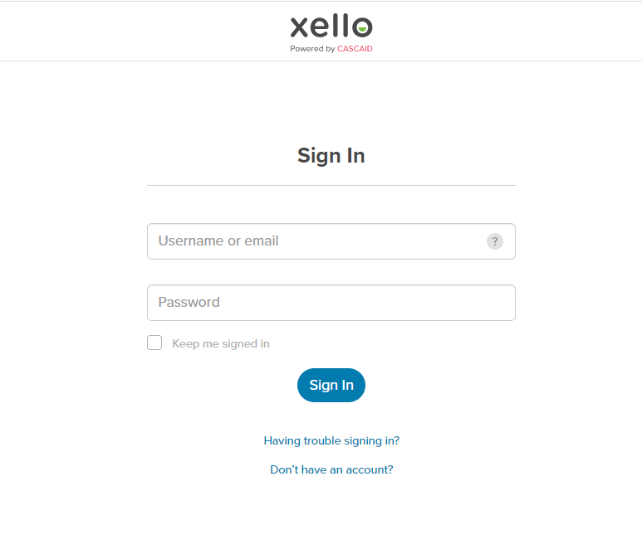

If you have lost your username or password, email your adviser to get a reminder or a reset.

2) This is the home screen where you can access everything on Xello. To explore different areas, such as careers or courses, click on the links on the right hand side. The ‘Matchmaker’ quiz is a questionnaire about your interests and skills. Click ‘Matchmaker’ and then ‘launch quiz’

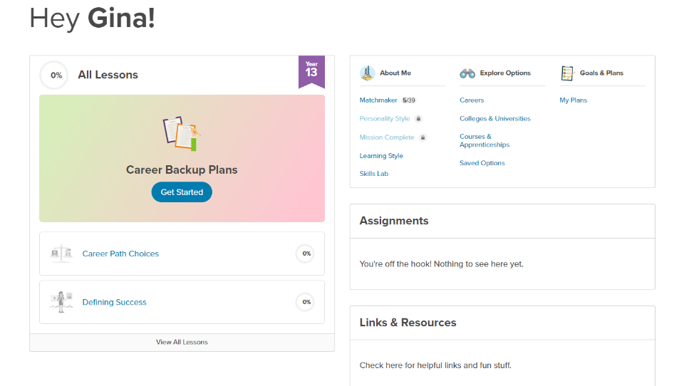

3) Complete each statement by clicking on the answer that most applies. You can press the question mark next to it to give you more information.

Try not to overthink your answers.

Try to pick 'like' or 'dislike' rather than ‘not sure’. This will help the website give the most accurate job suggestions!

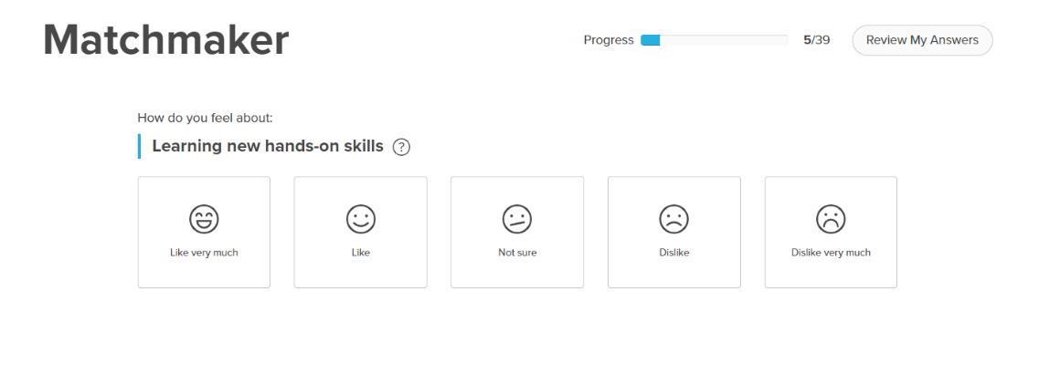

4) Once you have answered all the matchmaker questions, click ‘Your Personality Style’.



5) After completing this, click ‘Complete the mission’. You can then answer the last 50 questions to see the results!

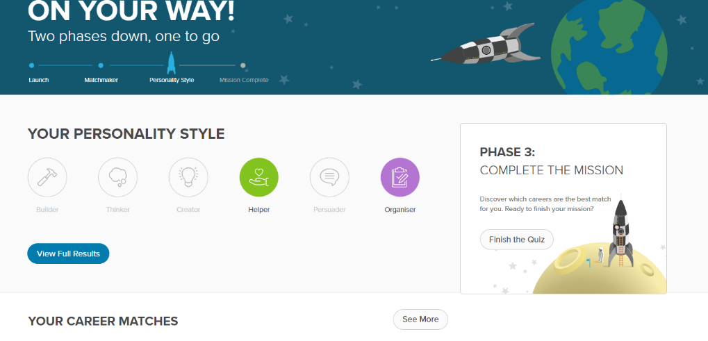

6) Once complete, click ‘View my matches’.



7) You can then look through different jobs and use the filters to change the results to see more or less.

Screenshot of Xello 'explore careers'.
There are a list of suggested jobs. There are a number of filters and list of roles with an arrow pointing towards 'data entry clerk'.

## Tips

* You can tick ‘School’ ‘College’ or ‘University’. If they are in blue, it means you need to have that level of education to do the job listed. You can unclick each box to match what level of education fits you best. Remember, this is not the highest achievement you have now, but the highest you want to have in the future.
* You can click on ‘filter’ and choose to see jobs from specific industries. You can also filter based on your personality style.
* When you see a job that you think is a good match, click the heart button to save it to your favourites. This will help in your next career session!

