

**Playbook: An inside look at inclusive playgrounds**

October 2022

**Contents**

**Introduction** 2

**What the data tells us** 2

**Stories from families with disabled children** 3

**Everyday experiences from parents and carers** 9

**How inclusive is your local playground for your child/children?** 9

**What impact would having a local inclusive, fully accessible playground have on you and your child/children?** 11

**Inclusive playground case studies** 13

**Inclusive play in other nations** 19

**Illustrations of dream playgrounds** 20

**What we’re asking governments to do** 25

**Appendices** 26

## **Introduction**

[Let’s Play Fair](https://www.scope.org.uk/campaigns/lets-play-fair/) is Scope’s campaign calling for disabled children to be given an equal chance to play. We’re asking governments in Westminster and Wales to invest in inclusive playgrounds [in England](https://campaigns.scope.org.uk/page/104758/action/1?chain) and [in Wales](https://campaigns.scope.org.uk/page/105255/action/1?chain).

Inclusive playgrounds nurture disabled children’s emotional, mental, and physical development. They create a sense of belonging for families with disabled children in their communities. And they enable disabled and non-disabled children to play together, breaking down barriers.

The question of what an inclusive playground looks like has come up repeatedly throughout the campaign. This Playbook provides an inside look at what makes a playground inclusive and the potential it offers for families with disabled children.

We’ve compiled polling data, stories from parent carers and case studies of inclusive playgrounds to demonstrate what can be made possible with the Government’s backing and why it must invest and support the creation of inclusive playgrounds.

## **What the data tells us**

**Playgrounds are popular.**

96% of parents with disabled children have used them in the past year. 69% use them at least once a week, 42% over twice a week, and 11% more than 4 times a week.

But they are not the most welcoming places for families with disabled children.

**Half (49%) of families with disabled children say there are accessibility problems with their local playground.**

**And one in ten (11%) have minimal or no access at all to their local playground.**

In addition,

* 11% said their disabled child hurt themselves because of inaccessible equipment
* 12% said their child didn’t feel safe using the equipment
* 16% said their disabled child felt upset and disappointed because they could not enjoy the playground
* 13% could not enjoy the playground as a family because siblings were unable to play together

Source: Opinium polling of 1,000 parents and carers of disabled children aged 12 or below in England and Wales. Fieldwork 25-31 March 2022.

## **Stories from families with disabled children**

During the campaign, parent carers of disabled children reached out to us about their everyday experiences of exclusion in playgrounds. These are their stories.

**Kiann, Redbridge**

Kiann is 4 years old and lives with his parents and 2-year-old sister. Kiann has got a genetic condition, epilepsy, and a learning disability. He wears glasses and has delayed development as a result. He crawls or uses a walking frame to get around, under his parents’ close supervision. He communicates using Makaton sign language and lots of gestures and sounds.

Although their local park is just 10 minutes from their house, mum Aanya feels unable to take Kiann and his sister to the playground unless there is an additional adult to support her. Each child needs 1:1 support, so going with more than one child isn’t an option if either parent is going alone. For example, Kiann can’t use swings that don’t have a back, but he’s also too heavy to use the toddler baby swings. Aanya has to have her hands swinging him the whole time to make sure he’s safe, meaning she can’t swing Kiann’s sister as well. If there was a safer swing, like a bucket seat with a harness in it, Aanya could push both her kids on the swing at the same time.

A few months ago, Aanya’s family travelled to an inclusive playground. There were safe swing seats that he could be strapped into, meaning he didn't need an adult to be holding him on the swing. There was also a zip line with a safe chair, so he could use the zip line. It was an entirely different experience for Kiann, who normally needs help on every single piece of equipment in their local playground.

Aanya feels inclusive playgrounds would be a game-changer for her, Kiann, and the rest of her family. Having an inclusive playground nearby would mean that the family could go and enjoy the playground without additional support. Both children could play together at the same time, while also having more fun and independence.

Aanya also feels that inclusive playgrounds would help normalize disability and inclusion from a young age.

“If we design with the most excluded in society in mind, and then work up from there, everyone's included.”

“I would want the people who design playgrounds to really spend time with disabled children. Or to have training and understand the impact of their design and really question that… What we would see is options for bigger kids that are safer.”

“Having inclusive playgrounds would mean that we’re not segregating disabled children to special areas. And it would mean that kids get to integrate at a younger age and normalise disability and inclusion. I think that it would just be huge, it would just spark conversation.”

**Emma, Scunthorpe**

Emma is 12 years old and lives in Scunthorpe with her parents and younger brother. Emma has a rare congenital condition called Baraitser-Winter syndrome and is a wheelchair user.

There is a local playground across the road from the family which has been recently renovated. Before the renovation, there was only a little seat with a net that spun round which Emma had to be physically lifted into from her wheelchair.

When the family went across the road the park one time, they had been there for 10 minutes when Emma’s younger brother wanted to stay for longer. The family stayed a few more minutes while she used the swing, the only equipment available for her to use. However, Emma couldn’t tell the family she was feeling dizzy. Her parents had to bring her home when they noticed that she was feeling unwell.

The same playground has since been renovated and advertised as being wheelchair accessible. However, the parents soon realised that they meant it was accessible for wheelchairs to move around. Emma still wasn’t able to use any of the equipment. In mum Helen’s words, “It was accessible, but it was not inclusive … if it was inclusive then she would have been able to play.”

“Not having inclusive playgrounds impacts on the whole family, it's not just her. It means that my son also cannot play for the amount of time that he would like to play, because there is nothing else for Emma to play on and she gets fed up.”

Despite their closest park being a one-minute walk across the road, the family now regularly drive to a playground 20 minutes away where there are more options for wheelchair-users.

The parents believe that Emma is missing out on experiences that could aid her development and give her the chance to make friends. They believe that by not making parks accessible, disabled children are disappearing from the community and are thus not able to help change attitudes towards disability for the future.

When asked what it would mean to have an inclusive playground, Emma’s mum Helen said:

“It would mean that my disabled daughter and non-disabled son can play together. It would mean that my disabled child is a visible member of her community. It means that she may be able to build relationships with other local children. Most importantly it would mean that she could have fun!”

**Samuel, Stoke-on-Trent**

Samuel is six years old and lives in Stoke-on-Trent with mum Victoria, dad James, and their pet dog. Samuel is autistic and has dyspraxia and sensory processing disorder.

The family’s local playground isn’t very accessible. The equipment is too challenging and unsafe for Samuel’s needs.

Samuel has a minimal sense of danger so he climbs to the top of big structures in the playground without recognising that it might be unsafe. As a result, James and Victoria have to keep a close eye on him to make sure he’s not going to injure himself. They often have to chase after him when he darts off, in case he runs into a road.

Samuel can also find the noise of playgrounds extremely overwhelming, which can lead to meltdowns. Other parents at the playground have shown a lack of understanding, which means Victoria and James avoid taking Samuel to busy spots where they might face negative attitudes.

Having an inclusive playground would mean Samuel could play more independently and safely. It. Small changes like having a quiet zone to go to when he’s overwhelmed or including more sensory equipment would make Samuel’s experience of play more enjoyable. It would also mean Victoria and James wouldn’t have to worry so much for his safety. Other changes like adding more signage for parents would mean other parents would be more aware of needs like Samuel’s, reducing the negative attitudes they experience.

**Lizzie, Solihull**

Lizzie is five years old and the youngest of five children. Lizzie has Down’s syndrome and several associated conditions. She’s non-verbal, her mobility was slow to develop, and she is registered as visually impaired.

Lizzie’s parents have become increasingly concerned about lifting her in and out of the swings at their local playground. One parent hurt their wrist, back and shoulders from this. The parents have to do a risk assessment when they go to playgrounds to identify potential dangerous equipment or hazards. They then have to try and navigate these to be able to play.

One of the parents emailed the parish council raising issues about the dangers in the playground, such as holes in the ground, and providing advice on the council’s legal obligations. They didn’t get a response.

The parent then volunteered to be involved with producing a neighbourhood plan which triggered a response to their previous email. The council stated that its legal team advised that it didn’t have to do anything. The parent wrote to the local MPs and the local paper. Contact from the journalist prompted the parish council to invite the parent to attend a parish council meeting. One of the members of the parish council realised they knew Lizzie and immediately said that they could have an accessible swing.

The family shared other examples. One local park has a disability swing that is three feet off the ground and takes two adults to lift one child into it. It has no harness, meaning that families must purchase the correct harness in advance. It costs £70.

The family visited another park three miles away in Warwickshire that had been beautifully done up but had no inclusive equipment. The family had a personal connection to the parish council so emailed them. The council responded apologising for the lack of inclusive equipment. It quickly identified some money it had left over from the development and are looking to purchase an accessible swing.

**Jac, Vale of Glamorgan**

Jac is 13 years old and has Muscular Dystrophy which affects his mobility and means he uses a wheelchair. He has two siblings.

When the family go to playgrounds, Jac has to sit and watch his siblings play because there is no accessible equipment. He finds that the focus on climbing equipment in playgrounds contributes to his exclusion because he’s unable to participate in any climbing jumping activities. This makes Jac feel left out. Other barriers around playgrounds are difficulties in finding parking with drop kerbs and a lack of accessible toilets at parks and playgrounds.

According to Jac’s mum:

“There's lots of emphasis on physical ability for park play. Jac always found climbing and jumping and those sorts of things quite difficult. It's just a real shame, because lots of children find the physical aspects of play difficult, and there's lots of different types of play.”

Jac’s dream playground would have accessible swings, roundabouts and slides with ramps. It would have a dedicated area for hide and seek and be inclusive for everyone. Even though he doesn’t really want to go to playgrounds anymore, he wants them to be accessible for other younger children or other people who just want to get outdoors more.

Jac says:

“I also want to think about people without disabilities, because I don't want to leave them out too. I’d want my dream park to be for everyone because parks right now are not for everyone. I hope in the future, that stuff will be more accessible.”

**Anonymous, Camarthen East and Dinefwr**

The closest park to this family isn’t inclusive at all, they say you have to be mobile and non-disabled to use it, apart from one ‘baby’ swing. The parents have to lift their child up onto the equipment if they want to use it or they have to use the equipment that is for very young children. The family finds other parks in the area slightly more inclusive as they have more interesting and contemporary Kompan play areas that are at ground level which suits their child better. However, there are no areas specifically designed for disabled children. There are never any Changing Places nearby unless it’s at a paid attraction.

It would mean so much to the family to have inclusive playgrounds. It would give their child independence in a public play setting, which is something they rarely get to have. It would help them, as parents, as they wouldn’t have to be on the slides and climbing frames themselves helping their child to climb up or get down. Their child would be able to play with their siblings and encourage inclusivity in play, especially as the local park is used by their nursery as a place to visit with the children.

**Anonymous, Ogmore**

A parent told us that Bridgend Council is developing a new playground but it isn’t inclusive. The Council has stated they are not making any inclusive playgrounds other than what Bryngarw Country Park has, which is only a wheelchair swing. It also isn’t close to the where the family life. Their son is very upset because he can't go and play like his friends can. He is particularly upset when his siblings are playing at the playground and he's sat in his chair.

The parent believes that an inclusive playground would make many disabled children ‘still feel like children’. It would also be safer for all children.

**Anonymous, Cynon Valley**

A parent told us that their village playground now has an accessible roundabout that is suitable for both disabled and non-disabled children. However, if they get to the park and there are children already on it, there is nothing else for her child to do. Other playgrounds now have an accessible roundabout but this seems like a token gesture so they can class the playground as accessible.

The parent would like to see sensory equipment, a wheelchair swing and ramps on the play structures (like wooden bridges and forts). Inclusive playgrounds would make their child feel equal and valued. It could also improve relations with other children. For example, the family went to a playground with a wheelchair swing and other children like to come and watch or help push which is great. The parent believes that all children need to play and feel equal and included. It helps form relationships and gives opportunities for non-disabled children to learn about disabled children and see disabled children as children who like to play and have fun too. It also means that their child could go to a park with other disabled children from school and they could all play together.

## **Everyday experiences from parents and carers**

During July and August 2022, Scope asked parents and carers:

### **How inclusive is your local playground for your child/children?**

Here’s what some of them had to say.

**England**

“No, my local park is not accessible. My son has spent his first 11 years never experiencing the joy of playing in his local park. He has felt completely ignored, unimportant and alienated. As a parent I am saddened that in 2022 we are having to fight for access and inclusion for our children”. **New Forest East**

“Our local playground is absolutely not accessible or inclusive… there isn’t a single piece that disabled children can play on. When we go past my little girl gets excited as she loves seeing the other children swing and make noise. It’s sad as she thinks parks are for others and not for her.” **Sefton Central**

“He is a thrill seeker and loves to have fun. Being in a wheelchair does not take away his want and need to play, but non inclusive playgrounds take away his ability to play (not his wheelchair). This is so wrong. My son gets so sad sitting on the sidelines that now we hardly ever go meaning not only does my son miss out on fun in the park, so do his sisters.” **Watford**

“Not inclusive. Not one thing in all our towns playgrounds is accessible for wheelchair users. The times I’ve cried watching one twin enjoy the playground whilst consoling my other twin who is isolated and can only watch! Heartbreaking!” **Harborough**

“We can’t even get into the playground with barriers erected to stop motorbikes and too narrow entrances. Plus wheelchairs and grass do not mix well. There is no equipment my son can use anyway. I feel like we don’t fit in and no one sees that or even cares.” **Wokingham**

“Absolutely appalling, token disabled swing & nothing else… the only way to access the slide is via a climbing wall - he is physically unable to do this, the slide is too high for me to lift him onto & now he is too heavy for me to lift… We avoid the park as he just gets upset. Seeing your child upset at not being able to play like other children is heartbreaking” **Sutton and Cheam**

**Wales**

“The playground most local to us has very typical play equipment - it is not completely accessible for disabled children with mobility issues. It worries me because it’s not enclosed, so my son (who is autistic and pre-verbal) could easily run onto a road if he becomes overwhelmed.” **Monmouth**

“There isn’t a single playground that has any equipment for my daughter who is a wheelchair user. She is 14 now but felt completely excluded from playgrounds, instead of going and watching her friends play which was too distressing we avoided such places.” **Ogmore**

“There is nothing worse than being told a park is inclusive [when it isn’t], my son can see children playing, and we have to walk away because there is nothing he can access… we are proving time and time again, that in reality disabled people don’t matter and don’t figure in planning or budgeting.” **Gower**

“Our local playground has nothing for my daughter to play with! We have recently travelled 20 miles to go to an accessible park which my daughter loved. Our local park is grass and very awkward to push my daughter’s adaptive chair.” **Clwyd South**

“It is only the roundabout that is sometimes accessible and it makes our profoundly disabled son feel very sad that he cannot be involved with the other children.” **Aberconwy**

“Our local playground had an inclusive roundabout then the area was refurbished and it was taken out. Now there’s none. That was the only one I have ever seen.” **Islwyn**

“Inclusion not exclusion should be the norm. Non-disabled kids should be playing side-by-side with disabled kids... My son could play alongside his siblings which should surely be a basic right of any child.” **Cardiff South and Penarth**

“My local parks only provide observation spaces for disabled and vulnerable wheelchair users instead of active participation spaces or apparatus!” **Rhondda**

“Our local park has no accessible equipment. It makes me feel sad that my oldest misses out on the same basic experience as my youngest child.” **Pontypridd**

We also asked:

### **What impact would having a local inclusive, fully accessible playground have on you and your child/children?**

**England**

“Huge impact… Being able to walk to a park with her would be respite for her and us during those times. Because this doesn’t exist we stay at home a lot and her social and emotional development is affected.” **Sefton Central**

It would be amazing and really make us feel like part of the community! My son could play and interact with other children… this would help to break down the stigma of being disabled and expose [non-disabled] children to kids like my son who have multiple disabilities and help integrate them in the community. **Surrey Heath**

“My children would be seen and known in their community, currently there is no opportunity for them to socialise locally.” **Mole Valley**

“It would be somewhere we could take the whole family to play together. These moments are precious as our daughter has a life limiting condition.” **Havant**

“It would be fantastic! There is a private charity nearby that has an accessible roundabout. Just seeing my disabled children playing with other, smiling, helping each other out there makes such a world of difference. It creates acceptance and understanding and gives all children the chance to just have fun and be kids, but we pay to get in there, if public playgrounds had that facility it would just be amazing” **Nottingham East**

“It would ease worry and fear over safety. It would be more inclusive for my daughter, relieve anxiety and upset.” **Epsom and Ewell**

“It would mean so much, to have a place to go and play with his brother too. It really would mean everything to see them both playing together and for my eldest to be playing like any other child.” **Leeds Central**

**Wales**

“My god where do I start? To have a playground accessible to our children would be massive! To see them smile, laugh, have fun is massive... Helping children interact and using their motor skills... amazing achievement.” **Newport East**

“[Having inclusive playgrounds] would mean my son wouldn’t be made to feel less than… he wants to feel included. I wouldn’t have to walk away defeated at yet another park he can’t access for fun, and the normal everyday things children do. Parents shouldn’t have to be reduced to tears and feel like they’ve failed their child.” **Gower**

“A local inclusive, fully accessible and safe playground would provide disabled children with the freedom to enjoy playing outdoors within their own community.” **Arfon**

“I think a lot more children of all abilities would access [inclusive] playgrounds and feel safer… To have a park close to home that features everything you need could not only save money, but it means you don't have to always plan things, you can just go to the park and have fun.” **Delyn**

“[Inclusive playgrounds] would give my daughter confidence and feel included. She gets frustrated because play equipment is not adapted and is too hard for her. She often plays in a puddle next to the playground, which is so unfair.” **Swansea East**

“[Inclusive playgrounds] would give my daughter a better quality of life meaning that she could play even when she's having a bad mobility day.” **Vale of Clwyd**

## **Inclusive playground case studies**

There is an urgent need for the Government to introduce guidance around making playgrounds inclusive. The below case studies model key components of inclusion in playgrounds and demonstrate what is possible with the right support.

**Russell Park, Bedford**

Bedford Borough Council worked with Bedford Borough Parent Carer Forum (BBPCF) to open inclusive playground Russell Park in August 2022. 75% of the equipment in the playground is wheelchair accessible and includes the following inclusive features:

* Roundabout (see **Appendix A**)
* See-saw (see **Appendix B**)
* Trampoline
* Short play tunnel or quiet space
* Interactive Play Panels
* Communication board for non-verbal children

Alongside the playground build, the council launched an awareness campaign to combat negative attitudes experienced by disabled children in playgrounds. They have incorporated signage (see **Appendix C**) into the playground raising awareness of different types of impairments that people at the playground may have.

**Since its opening, the inclusive playground has had a profoundly positive impact on the community:**

* Some families with disabled children have found themselves going to the playground most days over the holiday, where that wasn’t an option before
* Non-verbal children are communicating with other children using the communication board
* Parents were able to take more than one child to the playground at a time, as their children could play more safely and independently
* One family held a birthday party at the park and could bring the entire family together at the playground for the first time ever
* Parents reported improved wellbeing
* Bedford’s Parent Carer Forum has seen an increase in membership

Furthermore, the playground has created a new standard of inclusion for other playgrounds opening in the area, with two other playgrounds in Bedford having opened with wheelchair-accessible equipment.

The council anticipate that they will save money as a result of this inclusive playground. Many families with disabled children use direct payments to fund travel costs, accessible leisure activities, short breaks, and the employment of personal assistants. Having a free, local, accessible, and inclusive playground means that parents can meet the need for leisure activities with fewer travel costs and less need for additional care and support, thus reducing the need for council funding.

The inclusive playground came about following Bedford Borough Council’s ‘Shout out to SEND’ Pupil Voice conference. At this conference, a wheelchair user shared that they had to travel 20 minutes outside the borough to find an accessible playground. This prompted the council to work with BBPCF to run a number of focus groups on inclusive play with a diversity of families with disabled children in their community.

**The focus groups highlighted the following barriers:**

* Lack of access to playgrounds and equipment, particularly for wheelchair users
* Being unable to spend time together as a family
* Negative attitudes from other parents, particularly experienced by families with neurodivergent children
* Having to travel further out to find accessible play spaces
* The importance of playgrounds during lockdown

After securing a £100,000 grant from the Mayor’s Youth Empowerment fund, the council and BBPCF created a [specification](https://scopemdm-my.sharepoint.com/:w:/g/personal/ana-sofia_velasco_scope_org_uk/ERTpPpe0-WlHmpSGvAc0qmwBPYZrrdoJB6aWeu5CS3rPxw?e=Pr29aH) outlining specific measures of inclusion. The council saved money by keeping the existing fencing in Russell Park and completed the build of the playground in the summer of 2022.

Quote from Chris Morris, Acting Chief Officer of Education, SEND & School Infrastructure at Bedford Borough Council:

“An inclusive play park is for all children. It is amazing to see disabled children able to play on the same equipment as those who aren’t disabled. To see whole families able to attend the same park together and children to be on the trampoline with their brother or sister in a wheelchair. An inclusive play park benefits everyone, and an uninclusive play park marginalises. I know which one I would choose every time.”

**Victoria Recreation Ground, Barnet**

Victoria Recreation Ground is an upcoming mixed ability playground for children and adults in Barnet that is being designed by The Seneca Trust, Nathalie Esfandi and Angela Harding (the group). The project is spearheaded by a parent of a disabled child and professional Therapist OBE. Barnet Council is partnering with the group, and they are using equipment provider KOMPAN to design and build the playground. Together, they’ve created an initial specification of the playground. While subject to change, this has resulted in a specification that includes 30 pieces of inclusive equipment that meet a range of needs, including:

* Wheelchair accessible see saw, roundabout, and swings
* Sensory tactile and sound play panels
* Quiet zones
* Braille, sign language panels and a visual symbols communications panel which will have playground vocabulary and symbol pictures of each piece of equipment for nonverbal children and adults
* Communications boards placed in various locations around the playground

As part of their design process, the group are engaging with their community so they can incorporate feedback from families with disabled children, carers, teachers, support workers, and therapists. They are also producing a post development strategy to promote community engagement and inclusion in the local area.

The purpose of the playground is to model a flagship inclusive and accessible play space so that it can be replicated across the country by other councils and playground providers. It will act as a ‘shop window’ for councils that want to regenerate their playgrounds where equipment is falling into disrepair. Councils can look to Victoria Recreation Ground for inspiration as they replace their equipment, gradually making playgrounds across the country more inclusive.

Furthermore, the supply of inclusive equipment provision by equipment providers in the UK is currently lacking. It is the group’s hope that this playground and any subsequent builds will increase demand for better inclusive equipment provision, making inclusive play equipment more affordable for councils in the long run.

As a result of the specification designed by the group, councillors from nearby local authorities have expressed their interest in building inclusive, demonstrating that there is a desire to embed inclusive playgrounds in other areas.

Under the Public Services (Social Value) Act 2012, councils should ensure that public services contracts maximise social value. The Seneca Trust, Nathalie Esfandi, and Angela Harding say that making playgrounds inclusive increases their social value to the local community by enabling more people to play in them. Most importantly it brings a level of social equality lacking in our communities for disabled people, justifying increased investment at the local and national level.

“The need for inclusive playgrounds in our communities has long been hidden and neglected. Most disabled children have been excluded from playing with their siblings and neighbours in our parks by lack of accessibility, which has added to their isolation.

Quote from Deborah Gundle (Seneca Trust) and Nathalie Esfandi:

“The psychological and physical benefits of play should be available to all. Recognising the benefits of our diverse society and of what inclusion brings to our communities, making our playgrounds accessible for everyone reduces isolation, brings forward social equality and inclusion which is so important for all of us.”

**Coate Water Country Park, Swindon**

Mums on a Mission (MOAM) started campaigning around Changing Places in 2019 and then moved into inclusive play a year later. MOAM is working with Swindon Borough Council to design the playground in Coate Water Country Park.

The organisation produced an inclusive play information pack and gave the Council lots of examples of inclusive design that families liked. MOAM also ran a survey of the local community to get input and engaged with MP Robert Buckland, council officers and the Council’s Cabinet Member for Parks to talk about inclusive play at Coate.

Following determined and persistent communication with the Council, the plans for the playground now have inclusive equipment in them. However, they are still missing a wheelchair swing so MOAM is continuing to lobby for that.

There’s still more to do as the playground is yet to be built but MOAM says that overall, its positive work and they feel listened to. Most importantly, disabled children and their families can now enjoy the playground too. The little things can make a big difference.

Quote from Anna Bird, Mums on a Mission:

“Inclusive playgrounds mean that our children have the chance to do the most important thing in the world - to play! They mean our children can swing, spin and slide alongside their siblings and friends. And they mean that we can be part of the community, which helps to normalise disability and makes us feel so much more valued."

**Thames Valley Adventure Playground, Maidenhead**

[Thames Valley Adventure Playground](https://www.tvap.co.uk/) (TVAP) is a charity that supports disabled children and adults and their families to experience adventure play through its specialist indoor and outdoor play, recreation and learning facilities. It provides respite and advisory services as part of its Ofsted-registered, day-care facility built on a 2.5 acre site in the Royal Borough of Windsor and Maidenhead. The site includes roundabouts, swings, splash areas, a wacky woods area, a zip wire and lots more. Everything is adapted to be inclusive for all children. Families say that TVAP provides a safe, secure space for them where they don’t feel judged or threatened.

TVAP’s top principles for inclusive and accessible play spaces are:

* Play areas should be more about empowering people than just a collection of equipment.
* Play areas must feel like they belong to everyone regardless of ability.
* Inclusive playgrounds must encourage and enable children of all abilities to play together if they choose to do so but also allow space for individuality too.
* Inclusive Playgrounds must still be exciting and challenge the children to manage risks and gain confidence and skills.
* Accessibility is not just about physical access, areas must empower children and their families who may also have emotional, sensory, and cognitive needs.
* Playgrounds should be safe places for children and their families and ideally should include ‘safe spaces’ and adequate fencing in the design to promote independence and learning.

**Worlds End Recreation Ground, Burgess Hill**

[Mid Sussex District Council’s playground](https://www.midsussex.gov.uk/leisure-sport/parks/mid-sussex-parks/worlds-end-recreation-ground-play-area/) boasts many inclusive features (see **Appendix D**), including:

* A wheelchair accessible trampoline, roundabout and swing
* A multi-play unit with tactile elements and ramp access
* A quiet retreat area
* Sensory features
* A Changing Places toilet
* Car parking with accessible spaces

[New playground at Worlds End, Burgess Hill (YouTube)](https://www.youtube.com/watch?v=sUj-7cVjtcQ)

**Temple Newsam, Leeds**

[The playground at Temple Newsam](https://www.physcap.org/physcap-playground/) is said to be one of the largest of its type in the north of England as of 2011. It was designed by Leeds City Council and children's charity PhysCap. It includes a sensory maze and adventure area.

The playground also features the first "tactile map" at a Leeds play area. The map can be used by visually impaired children and children with learning difficulties to find and identify what equipment is available before entering the play area.

## **Inclusive play in other nations**

**Friendship Park, Ra’anana, Israel**

In 2005, Israeli disability services provider [Beit Issie Shapiro](https://en.beitissie.org.il/social-change/park/) developed an accessible and inclusive playground, [Park Chaverim (Friendship Park).](https://en.beitissie.org.il/social-change/park/) The large playground was the first of its kind in Israel and the model has since been replicated across over 30 Israeli municipalities, as well as internationally.

The playground plan was driven by two kinds of accessibility: physical and social. Physical accessibility should ensure the physical environment allows disabled people to move as independently as possible. Social accessibility should remove barriers that prevent disabled people from participating in the community, especially attitudes.

In terms of physical accessibility, the plan made the following considerations:

* **Surrounding environment**: Parking, public transportation, access paths, and entrance.
* **Accessible facilities**: Path, railing, placing of equipment, shading, seating areas, restrooms, signage promoting tolerance, and activity zones to enable children and their families to experience different activities in each zone.
* **Equipment:** The equipment should be good quality, safe, accessible, encouraging of independence, durable, vandalism-resistant, and should offer different levels of challenge.

To meet the criteria of social accessibility, the playground plan also included on-site activities that:

* Promoted integration and change attitudes
* Improved children’s functional, motor and social skills
* Raised awareness of playground for families with disabled children.

According to the [Friendship Park Booklet](https://www.beitissie.org.il/digital/friend-park-en/files/assets/basic-html/page-1.html), inclusive playgrounds should be used as a tool to advance integration and social inclusion:

“In the context of play environments, integration means that a child with disabilities and a child without disabilities play together at the same place and experience a positive connection, enabling them to get to know each other, leading to positive change in attitudes, to acceptance and understanding.”

Friendship Park inspired the build for Victoria Recreation Ground in Barnet.

[Israel’s First Accessible and Inclusive Park (YouTube)](https://www.youtube.com/watch?v=CNRwLXcUJ8Y)

**Communication boards initiative, Dublin**

In June 2021, Meath County Council passed an initiative to install communication boards in 26 playgrounds throughout County Meath in Dublin (see **Appendix E**). Communication boards are designed to break down communication barriers and are specific to the environment.

In a playground, a communication board will have pictures of things in the playground equipment, action words, feelings, and words that people can use to make requests. Communication boards can be used by anyone, whether they are disabled or not. However, they are particularly inclusive for people who don’t communicate verbally, have difficulty making speech sounds, or can’t understand what is being said.

[Tips for Communication Boards (Meath County Council)](https://www.meath.ie/system/files/media/file-uploads/2021-07/Tips%20for%20Communication%20Boards.pdf)

[Example of a communication board (Meath County Council)](https://www.meath.ie/system/files/media/file-uploads/2021-06/Trim%20Playground%20Communication%20Board.pdf)

## **Illustrations of dream playgrounds**

We asked families with disabled children to tell us what their dream playground would look like. We then commissioned artists to bring these visions to life. Here are the illustrations.

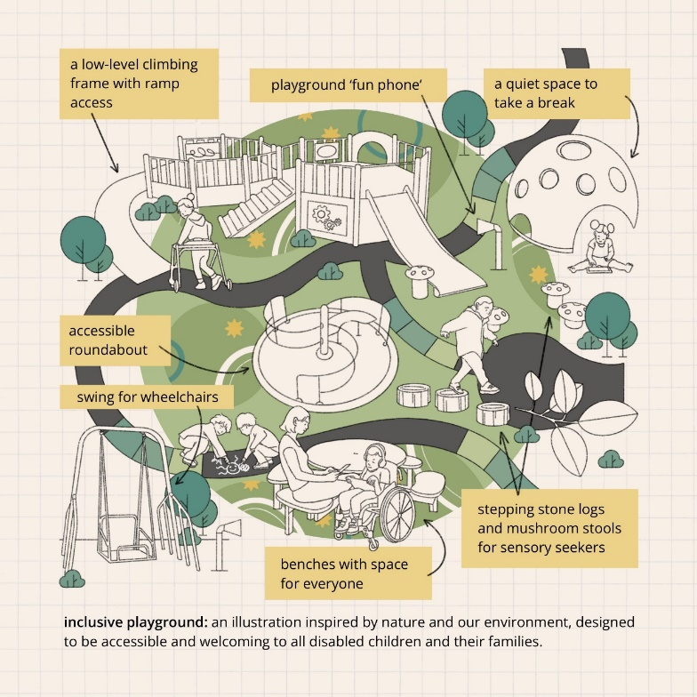

**Illustration 1: Nature’s Playspace by Megan Rhiannon**

**Nature’s Playspace image description:**

The background of the image is sepia-toned grid paper. There is lots of equipment and children and their families playing on it, all depicted as line drawings in black and white.

The playground is green with yellow stars and a dark grey path between the equipment. Two children are drawing a smiling sun using chalk on the path. Leaves and trees are illustrated across the piece.

Text labels point to each piece of equipment. They say: “a low-level climbing frame with ramp access”, “playground ‘fun phone’”, “a quiet space to take a break”, “accessible roundabout”, “swing for wheelchairs”, “benches with space for everyone”, “stepping stone logs and mushroom stools for sensory seekers”

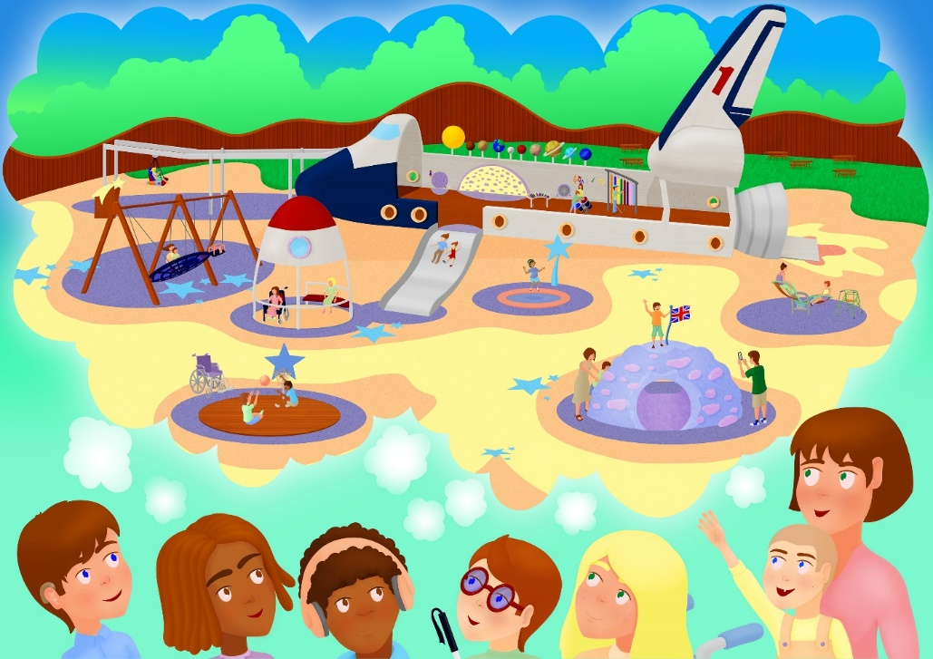

**Illustration 2: Space-Pirate Playground by Paul Miller**

**Space-Pirate Playground image description:**

The faces of 6 children and a parent at the bottom of the cartoon image have a collective thought bubble. One child is wearing a hearing aid, another has headphones on, one holds up a white cane and another’s wheelchair handles are popping into the frame.

In their thought bubble is a vibrant space-pirate-themed playground with a spaceship with an open roof in the centre. Inside the spaceship is a tall standing xylophone, a different xylophone to sit at, a sensory wall that looks like half a planet and a small maze.

The planets of the solar system are on top of the wall of the exterior of the ship. At the front of a ship, there's a slide with two people going down together. At the back of the spaceship, where the engine would be, is a ramp. On the ground of the playground are flames, so it looks like the rocket is taking off.

In the rest of the playground is a zip-wire with a seat like a chair, with a rocket on either side of the seat of the chair. There's a large swing set with a bucket swing that looks like a UFO and a rectangular swing seat next to it.

Two children, one of whom uses a wheelchair, are spinning on an accessible, ground-level roundabout. The roundabout has a roof that looks like the tip of a spaceship. Another child bounces on a trampoline that is set into the ground. A shooting star is coming out of the trampoline. Another two children are playing on an accessible see-saw with sides to grab on top. One of the children’s walkers is next to them as they play.

A half-moon with a tunnel going through it is emerging from the ground. A child is standing at the top, holding onto the Union Jack flag triumphantly. Their parent is taking a picture of them using their phone. Another parent is helping their small child climb up.

Two children are seated on a round court for seated basketball, one is about to get the basketball in the net and the other is trying to block them.

In the background are lots of accessible picnic benches, with spaces for wheelchair users to sit.

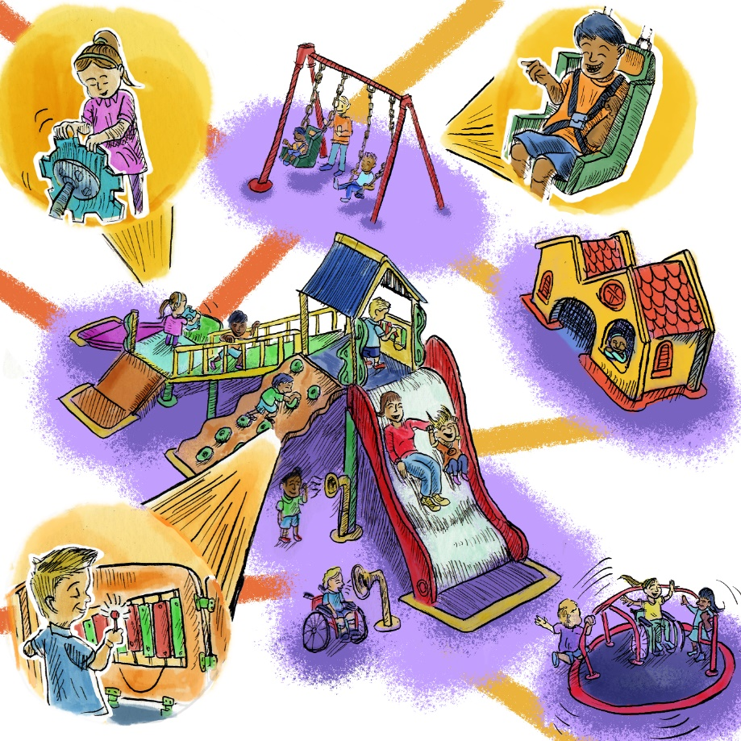

**Illustration 3: Family Fun Zone by Fred Campbell**

**Family Fun Zone image description:**

In pen and ink, children play across a playground. Two children are communicating with “fun phones” in front of a large play apparatus. It has a slide wide enough for a child and parent to slide down together. A climbing wall on a diagonal, with big chunky green hand-holds. It has a ramp up, from the ground, where at the first level a girl is spinning a big cog on the sides of the apparatus.

On the second level, connected by a ramp with railings, a boy is playing on a standing xylophone.

Besides the apparatus is a swing set with two children playing on it. One is sitting on a standard, rectangle-shaped swing seat. The other is on a swing seat shaped like a chair, with straps to keep the child secure.

Next to them is a yellow and orange playhouse, with a child chilling out with their arms crossed in the window. Three children are whizzing around on a ground-level roundabout, one of whom uses a wheelchair.

## **What we’re asking governments to do**

We want more disabled children and their families to be able to enjoy their local playgrounds. So, we’re calling on governments in Westminster and Wales to create dedicated, multi-million-pound inclusive playgrounds funds.

Local authorities across England and Wales could then apply for funding to refurbish existing playgrounds or create new ones. The fund criteria would ensure that inclusion and accessibility is at the heart of the playground design. It would also place a focus on the need to coproduce designs with disabled children and their families so that they meet the needs of local communities. Evaluation of the impact of the inclusive playgrounds would be built in so learning can be shared.

We’re also calling on Government to publish guidance that would promote the principles of inclusive design and share good practice to inspire local authorities, and other stakeholders, to create their own inclusive playgrounds. The guidance should be coproduced with sector experts and families with disabled children.

**To arrange a meeting or discuss anything included in the Let’s Play Fair Playbook, please get in touch with campaigns@scope.org.uk**

**Every child has an equal right to play.**

This document was produced by Hannah Dobbin.

## **Appendices**

1. Wheelchair accessible roundabout in Russell Park, Bedford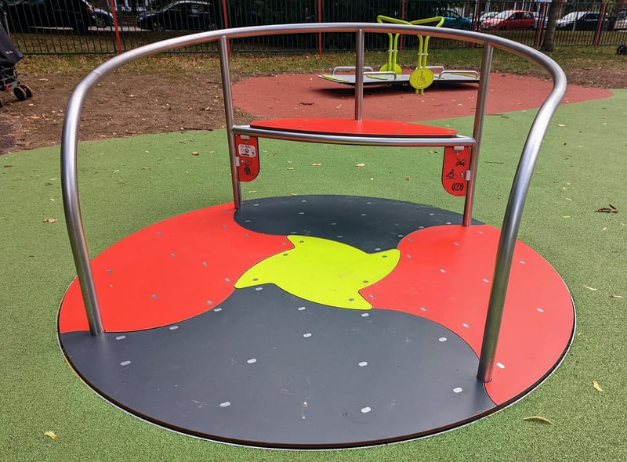
2. Wheelchair accessible see saw in Russell Park, Bedford 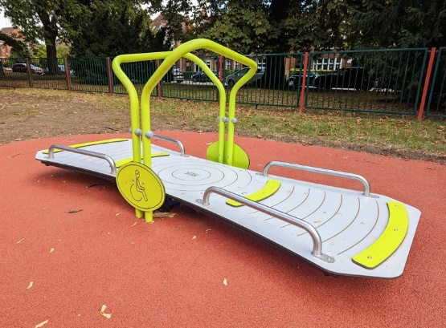
3. Disability awareness signage in Russell Park, Bedford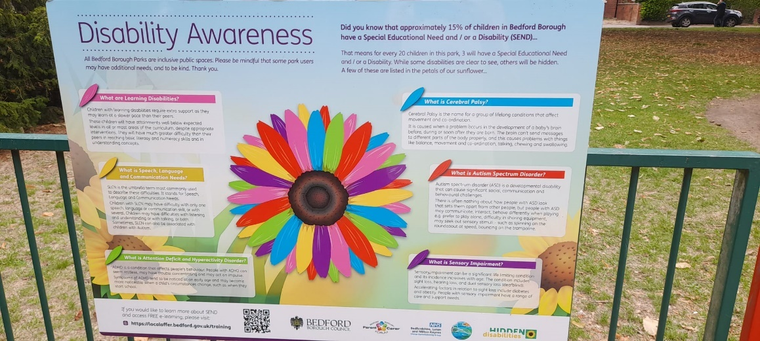
4. Worlds End Recreation Ground, Burgess Hill

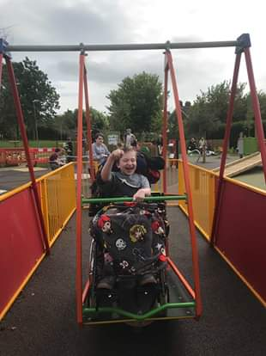 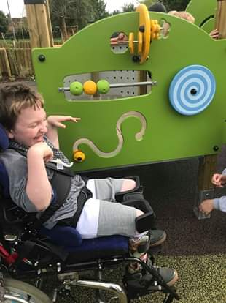

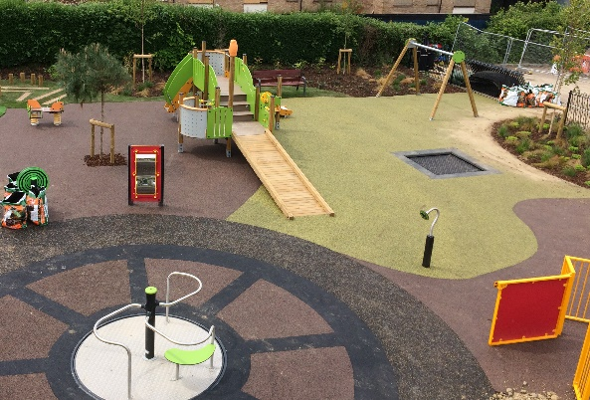

1. Communication boards in Meath County, Dublin

