# We’re raising money for Scope. Thank you for your support.

### How you can make a difference

Scope is here to provide practical information and emotional support for all disabled people and their families. But we can only do it with the help of amazing people like you.

By supporting Scope, you’re helping us answer more calls for help when it’s needed most. Here’s what your fundraising could achieve:

**could help pay for a 15-minute call to our Helpline.**   
It could mean an Adviser is there to listen to a mum who’s been desperately worried about her child and has no one else to turn to.

**could enable a Helpline Adviser to call 4 people back.**You could help us give them the time, support and understanding they need with more complex problems, which they can’t resolve on their own.

**could enable us to make life easier for 12 disabled families.**It could help them get the information they need to secure any extra benefits they’re entitled to. This could be a huge relief to someone who’s been lying awake at night worrying about their finances.

### How to pay in your fundraising

Please send us your completed sponsorship form and cheques to:

**Scope Fundraising Team**

**Here East Press Centre**

**14 East Bay Lane**

**London**

**E15 2GW**

If you require any additional information or alternative way to pay in the money you have raised, the team would be happy to help.

You can reach them on **020 7619 7270** or[**fundraise@scope.org.uk**](mailto:fundraise@scope.org.uk)

By giving your support you’re joining a movement, working together to create an equal future with disabled people.

**Name**

**Activity/Event**

**Date of Event**

|  |  |  |  |  |  |
| --- | --- | --- | --- | --- | --- |
| **Name** | **Home address** | **Full postcode** | **Amount donated** | **Paid date** | **Gift Aid it** |
|  |  |  |  |  |  |
|  |  |  |  |  |  |
|  |  |  |  |  |  |
|  |  |  |  |  |  |
|  |  |  |  |  |  |
|  |  |  |  |  |  |
|  |  |  |  |  |  |
|  |  |  |  |  |  |
|  |  |  |  |  |  |
|  |  |  |  |  |  |

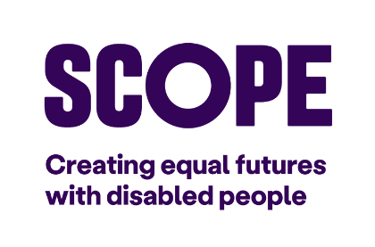**Using Gift Aid means that for every £1 you donate, Scope will receive a further 25p.**

If I have ticked the box headed ‘Gift Aid it’, I confirm that I want Scope to treat all qualifying donations over the last 4 years, today, and in the future as Gift Aid donations. Gift Aid allows Scope to reclaim 25p of tax on every £1 that I give. I am a UK taxpayer and understand that if I pay less Income Tax and/or Capital Gains Tax than the amount of Gift Aid claimed on all my donations in that tax year, it is my responsibility to pay the difference.