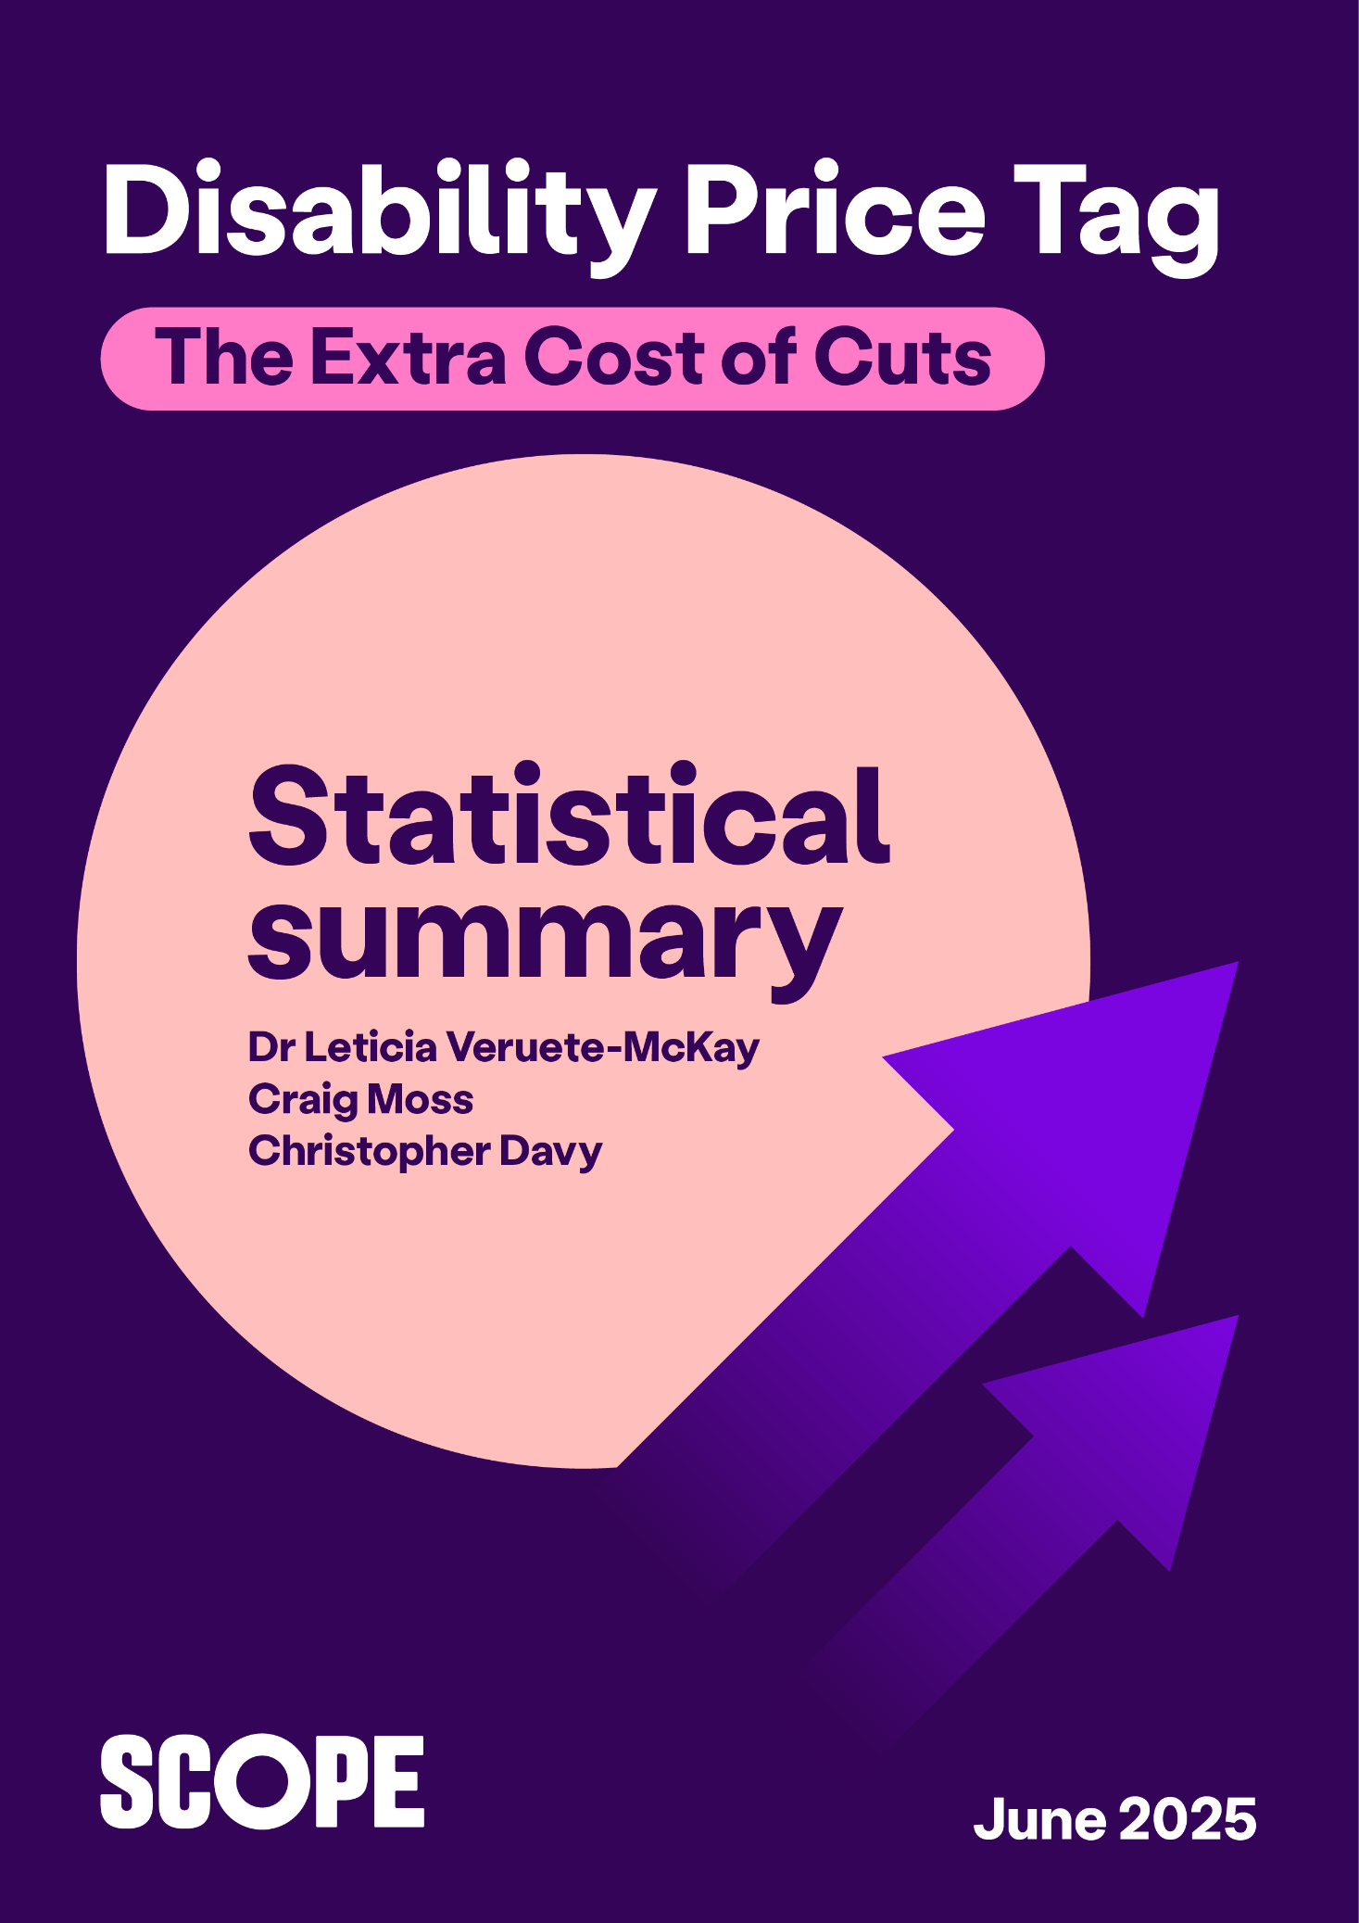

## The cost of cuts

In 2025, disability benefits are under the spotlight like never before. The government is making changes to Personal Independent Payments (PIP) and Universal Credit. These changes have the potential to leave many disabled people worse off in the future.  PIP is a lifeline for disabled people and their families. Losing these benefits will push many into poverty.[1]

We define ‘extra costs’ as the extra money a disabled household needs to have the same standard of living as a non-disabled household. We call this the Disability Price Tag.

To calculate the Disability Price Tag, we have uprated from our previous estimate of extra costs and have used OBR forecasts for inflation at Spring Statement 2025.[2]

Our estimates of extra costs account for disability benefit payments such as PIP as part of overall household income.

Our analysis shows:

* **For 2024 to 2025, disabled households need on average, an additional £1,095 a month to have the same standard of living as non-disabled households.[3]** This is 8% higher than our previous Disability Price Tag.
* By 2029 to 2030 financial year the price tag will be **£1,224** per month.
* The estimated average shortfall in disabled household income between extra costs and PIP benefit payments is **£630**.[4]
* For the 2029 to 2030 financial year, this average shortfall is estimated to rise to **£704**.**[5]**
* **On average, the extra cost of disability is now equivalent to 67% of household income**.

### The Cost of Cuts: impact on households

The UK Government has set out benefit reform in the ‘Pathways to Work: Reforming Benefits and Support to Get Britain Working’ Green Paper and in draft legislation.[6]

These include changes to Universal Credit health-related payments and to Personal Independence Payments. The average loss of benefit payments estimated at £4,500 a year.[7]

**Extra costs with little or no support**

For the estimated 400,000 disabled people set to lose their PIP benefit payments[8], we estimate the average loss of PIP income will be £520 per month[9], a total loss of £6,240 in the 2029 to 2030 financial year.

In the 2029 to 2030 financial year, on average, these disabled households stand to face **extra costs of £1,224 per month without any benefit support.**

### Rising extra costs

The Disability Price Tag is only set to rise in the years ahead.

Uprating extra costs and PIP payment benefits in line with inflation over the next 5 years, the average Disability Price Tag is forecast to be:

* £1,130 in the 2025 to 2026 financial year, with an average shortfall in income of £650 (assuming £480 average monthly PIP benefit payment)
* £1,153 in 2026 to 2027, with a shortfall of £664
* £1,176 in 2027 to 2028, with a shortfall of £667
* £1,200 in 2028 to 2029, with a shortfall of £690
* Rising to £1,224 by the 2029 to 2030 financial year, with an average shortfall of £704 (assuming £520 average monthly PIP benefit payment).

Should the Government’s proposed benefit changes happen, this shortfall is set to increase for thousands of disabled people and their families. With low-income families particularly facing big losses.[10]

Drastic changes to the benefits system will only further impact disabled households. As they face a future with growing extra costs.

### Variation across income groups

All disabled households face extra costs. There is variation in the extra costs across different income levels. Our analysis of household income quintiles estimates that:

* The poorest disabled households face extra costs equivalent to 202% of household income after housing costs, or £1,042 a month, on average, to have the same standard of living as equivalent non-disabled households.
* For lower to middle incomes, disabled households face additional extra costs as high as £1,649 a month, on average, to have the same standard of living as equivalent non-disabled households.
* Even for the highest income group, the extra cost of disability is estimated to be equivalent to 9% of household income after housing costs or £287 per month, on average.

**Fig 1: Average monthly extra costs and disability benefits by household income.** Source: Scope calculation based on Family Resources Survey 2022 to 2023.

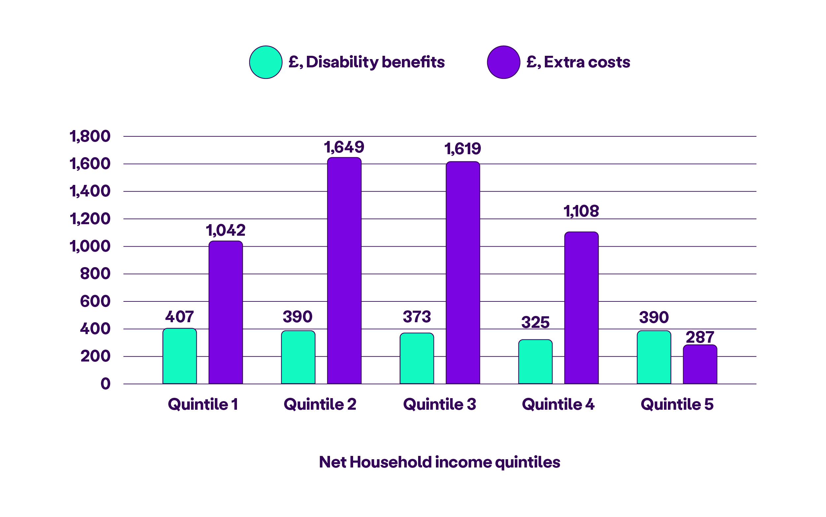

### Impact of age on extra costs

Disabled people of all ages face extra costs. There is variation in the level of extra costs across different age groups.

Our analysis shows that:

* For individuals 45 to 54 years old, extra costs can be as high as £1,235 a month, on average.
* For individuals 25 to 35 years old, they face the highest extra costs of £1,463 a month, on average. The shortfall for this group is also the highest at £1,151 per month. This is based on an average PIP benefit payment of £312.

**Fig.2: Average monthly extra costs and disability benefits by age group.** Source: Scope calculation based on Family Resources Survey 2022 to 2023.

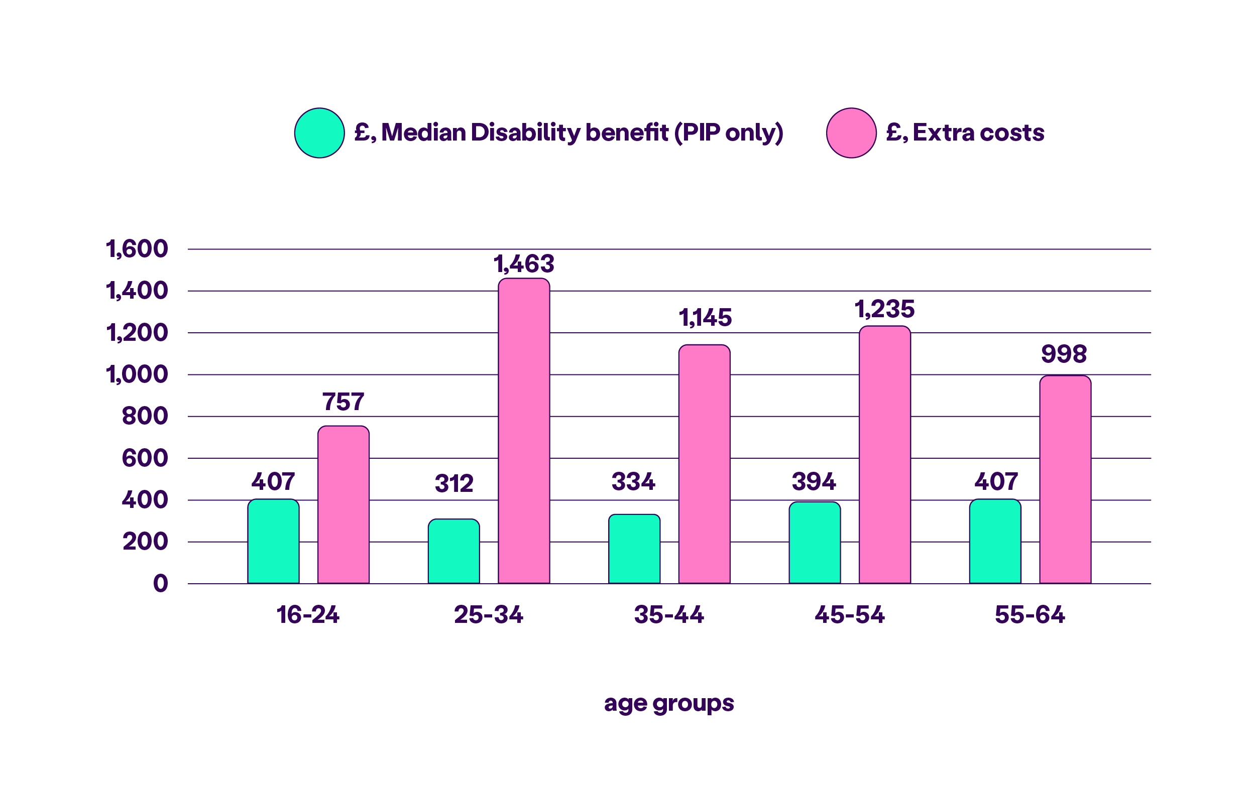

## About this research

To calculate the extra cost of disability, we follow a Standard of Living approach. This is consistent with academic and previous Scope’s Disability Price Tag research. Please refer [Disability Price Tag 2024](https://www.scope.org.uk/campaigns/disability-price-tag-2024) and [Disability Price Tag Technical Report 2023](https://www.scope.org.uk/campaigns/extra-costs/disability-price-tag-2023) for further details.

The extra cost of disability is measured by comparing the difference in the standard of living between disabled and non-disabled households at any given income level. The standard of living of each household was calculated on whether important goods or services could be afforded. As well as on the ability of each household to conduct essential household tasks and manage finances.

To estimate the latest figure, we highlight some important features of the analysis:

* Due to the new way the Office for National Statistics is measuring material deprivation, only 25% of the survey participants in 2023 and 2024 financial year have completed the original material deprivation variables that Scope has used in previous publications. This has affected our ability to calculate the Standard of Living index for all survey participants.
* As such, we uprated the previous Disability Price Tag 2024 estimates to current and future prices in line with Consumer Price Index (CPI) and the Office of Budget Responsibility (OBR) forecasts up to the 2029 to 2030 financial year. We believe uprating our previous calculations will provide a more robust estimation of the extra costs for disabled household for this financial year.
* Our analysis did not account for the reduction of household income following the withdrawal PIP benefit payment in proposed the Government reforms to change PIP benefit payment eligibility. The main reason for this was due to a difficulty in identifying those disabled household members in FRS microdata who may potentially lose their PIP benefit payments.
* The figures presented are expressed as prices of the current 2024 to 2025 financial year. To uprate from the 2022 to 2023 financial year to the current 2024 to 2025 financial year, the Consumer Price Index (CPI) inflation rate of 5.7% was used for 2023 to 2024. A further 2.5% was applied following the Office of Budget Responsibility (OBR) forecast for the 2024 to 2025 financial year.
* We continue to use equivalised household income which was calculated using the Department for Work and Pensions equivalence scales. This means we can account for the size and composition of different households.
* Organisation and cleaning of the dataset. Such as eliminating extreme values (top 1% percentile) in household income.
* To calculate the variation of extra costs across income groups (page 5), the equivalised household income (deducting housing costs) was sorted from low to high household income groups. Each of the 5 income groups (or quintiles) were interacted with disability status. And they were included in a regression of the standard of living and the household income, while controlling for other demographic household characteristics.
* To calculate the impact of age on extra costs (page 6), a similar regression as above was calculated for each age group interacted with disability status, but without including income quintile terms.

**End notes**

1. [Scope (2025) Cost of Cuts campaign](https://www.scope.org.uk/campaigns/the-cost-of-cuts)
2. There are limitations with the latest Family Resources Survey 2023 to 2024 dataset currently available. Please see ‘About this research’ at the end of this document for more details.
3. The Disability Price Tag and benefit shortfall figures are expressed as prices of the current 2024 to 2025 financial year. To uprate from the 2022 to 2023 financial year to the current 2024 to 2025 financial year, the Consumer Price Index (CPI) inflation rate of 5.7% was used for 2023 to 2024. A further 2.5% was applied following the Office of Budget Responsibility (OBR) forecast for the 2024 to 2025 financial year.
4. Using the FRS microdata, the difference between the Disability Price Tag estimate and the average household income was calculated for PIP claimants, for each financial year up to the 2029 to 2030 financial year. When this is a positive figure, this difference (or gap) indicates a shortfall of income for disabled households claiming PIP benefit payments. Our analysis did not account for the reduction of household income following the withdrawal PIP benefit payments.
5. The estimated average shortfall of income for the 2029 to 2030 financial year was calculated by uprating the average shortfall from 2024 to 2025 financial year by using the OBR forecasts of inflation.
6. [UK Government (2025) Pathways to Work Green Paper](https://www.gov.uk/government/consultations/pathways-to-work-reforming-benefits-and-support-to-get-britain-working-green-paper)
7. [UK Parliament (2025) Research Briefing: Changes to benefits for disabled people.](https://commonslibrary.parliament.uk/research-briefings/cbp-10283/)
8. [Resolution Foundation (2025) No workaround](https://www.resolutionfoundation.org/publications/no-workaround/)
9. Using FRS microdata, we estimated the average equivalised household disability benefits income (for those claiming PIP only) across different type of households in 2022 to 2023 financial year. This is equal to £429 per month. This figure was uprated to the 2029 to 2030 financial year using the current Consumer Price Index inflation and Office for Budget Responsibility forecasts of inflation.
10. [Resolution Foundation (2025) Britain’s new safety net](https://www.resolutionfoundation.org/events/britains-new-safety-net/)