Requesting data from the Netherlands Autism Register
The Netherlands Autism Register has been collecting data since 2013. Here you will find an explanation of the data we have and how it is structured.

NAR surveys
When a participant registers, they complete the registration questionnaire (also known as T0). In this list, all kinds of basic data are requested, mainly information that will not change (such as: country of birth of the parents or date of autism diagnosis).
Since 2015, all registered participants receive an invitation every year (in springtime Feb-Apr) to participate in the annual NAR survey. In 2015, this started with the T01, in 2016 the T02, etc. Participation in the annual survey is always optional, not every participant participates every year.
Annual surveys contain questions that are repeated every year, such as questions about current diagnoses, physical complaints or use of treatments. In addition, extra questions are added each year (such as a screener for anxiety complaints or insomnia, or questions about health habits). In the file ‘NAR surveys per wave’ you will find an overview of the topics per year.
In addition to the annual surveys, projects are sometimes carried out where additional data is collected. These can be surveys such as additional questionnaires during the Corona period.

NAR data
The NAR has a lot of data and thus we have a strict procedure for naming our variables.
We use a format for variables as follows: xXXX##x##XX_???(x)
(Legend: x = lowercase character; X = uppercase character; # = number; ? = number of lower case character; final element between brackets is optional)

x XXX ## x ## XX _ ??? (x)
Element(s) | Mask | Description | Example 1 (dASQ15t01SP_015r) | Example 2 (dSDQ00m99PG_hyp)
01 | x | The domain of the variable. This character is generally the first letter of the domain | d = Diagnoses | d = Diagnoses
02 – 04 | XXX | The subdomain of the variable. These characters are generally an acronym of the subdomain | ASQ = Autism Spectrum Quotient | SDQ = Strengths and Difficulties Questionnaire
05 – 06 | ## | The year the associated question was introduced in the questionnaire. Note that this does not mean this question is only available for this year in the case of the intake T0 questionnaire | 15 = 2015 | 00 = unique code to indicate no associated year
07 | x | The type of questionnaire the variable appeared in | t = yearly wave or T# | m = most recent variable based on all available waves
08 – 09 | ## | The wavenumber of the questionnaire type | 01 = wave 01; combined with previous element this would be T01 | 99 = unique code to indicate no associated wave
10 – 11 | XX | A code representing the informant(s) of this variables; see below for all the current codes | SP = Self report and Parents | PG = Parents and Guardians
11 | _ | Filler. Has no function other than aesthetics.
12 – 14 | ??? | This can be either: (1) A number to indicate the question number in the questionnaire with (generally) a hierarchy between the first and last two numbers. Or (2) An acronym to describe a (calculated) scale or subscale or often used descriptive such as age or gender | 015 = item 15 of block 0 | hyp = Hyperactivity subscale
15 | (x) | (Optional) Mostly used to expand on the base variable | r = Recoded item | Base variable, left empty

ParticipantCode | ParticipantDescription | RZ | RO | RW | CNT
AL | All | 1 | 1 | 1 | 1
AA | All persons with autism | 1 | 1 | 1 | 0
CP | Parents + control | 0 | 1 | 0 | 1
SP | Self + parents | 1 | 1 | 0 | 0
CG | Self + guardians + control | 1 | 0 | 1 | 1
SG | Self + guardians | 1 | 0 | 1 | 0
CS | Self + control | 1 | 0 | 0 | 1
AS | Self (adult with autism) | 1 | 0 | 0 | 0
ID | Parents and guardians of persons with an intellectual disability | 0 | 1 | 1 | 0
PG | Parents + guardians | 0 | 1 | 1 | 0
AP | Parents (children with autism) | 0 | 1 | 0 | 0
AG | Guardians (adults with autism) | 0 | 0 | 1 | 0
CN | Control (adults without autism) | 0 | 0 | 0 | 1
NG | Self + parents + control | 1 | 1 | 0 | 1
(Legend: RZ= Self-report, 16+; RO = Parent report, 16-; RW = Guardian report, 16+; CNT = Control).
You can find an overview of available data at topic level in the ‘NAR questionoverview 2024’ file. If you want a full overview of all available variables, you can look at the ‘Codebook’.

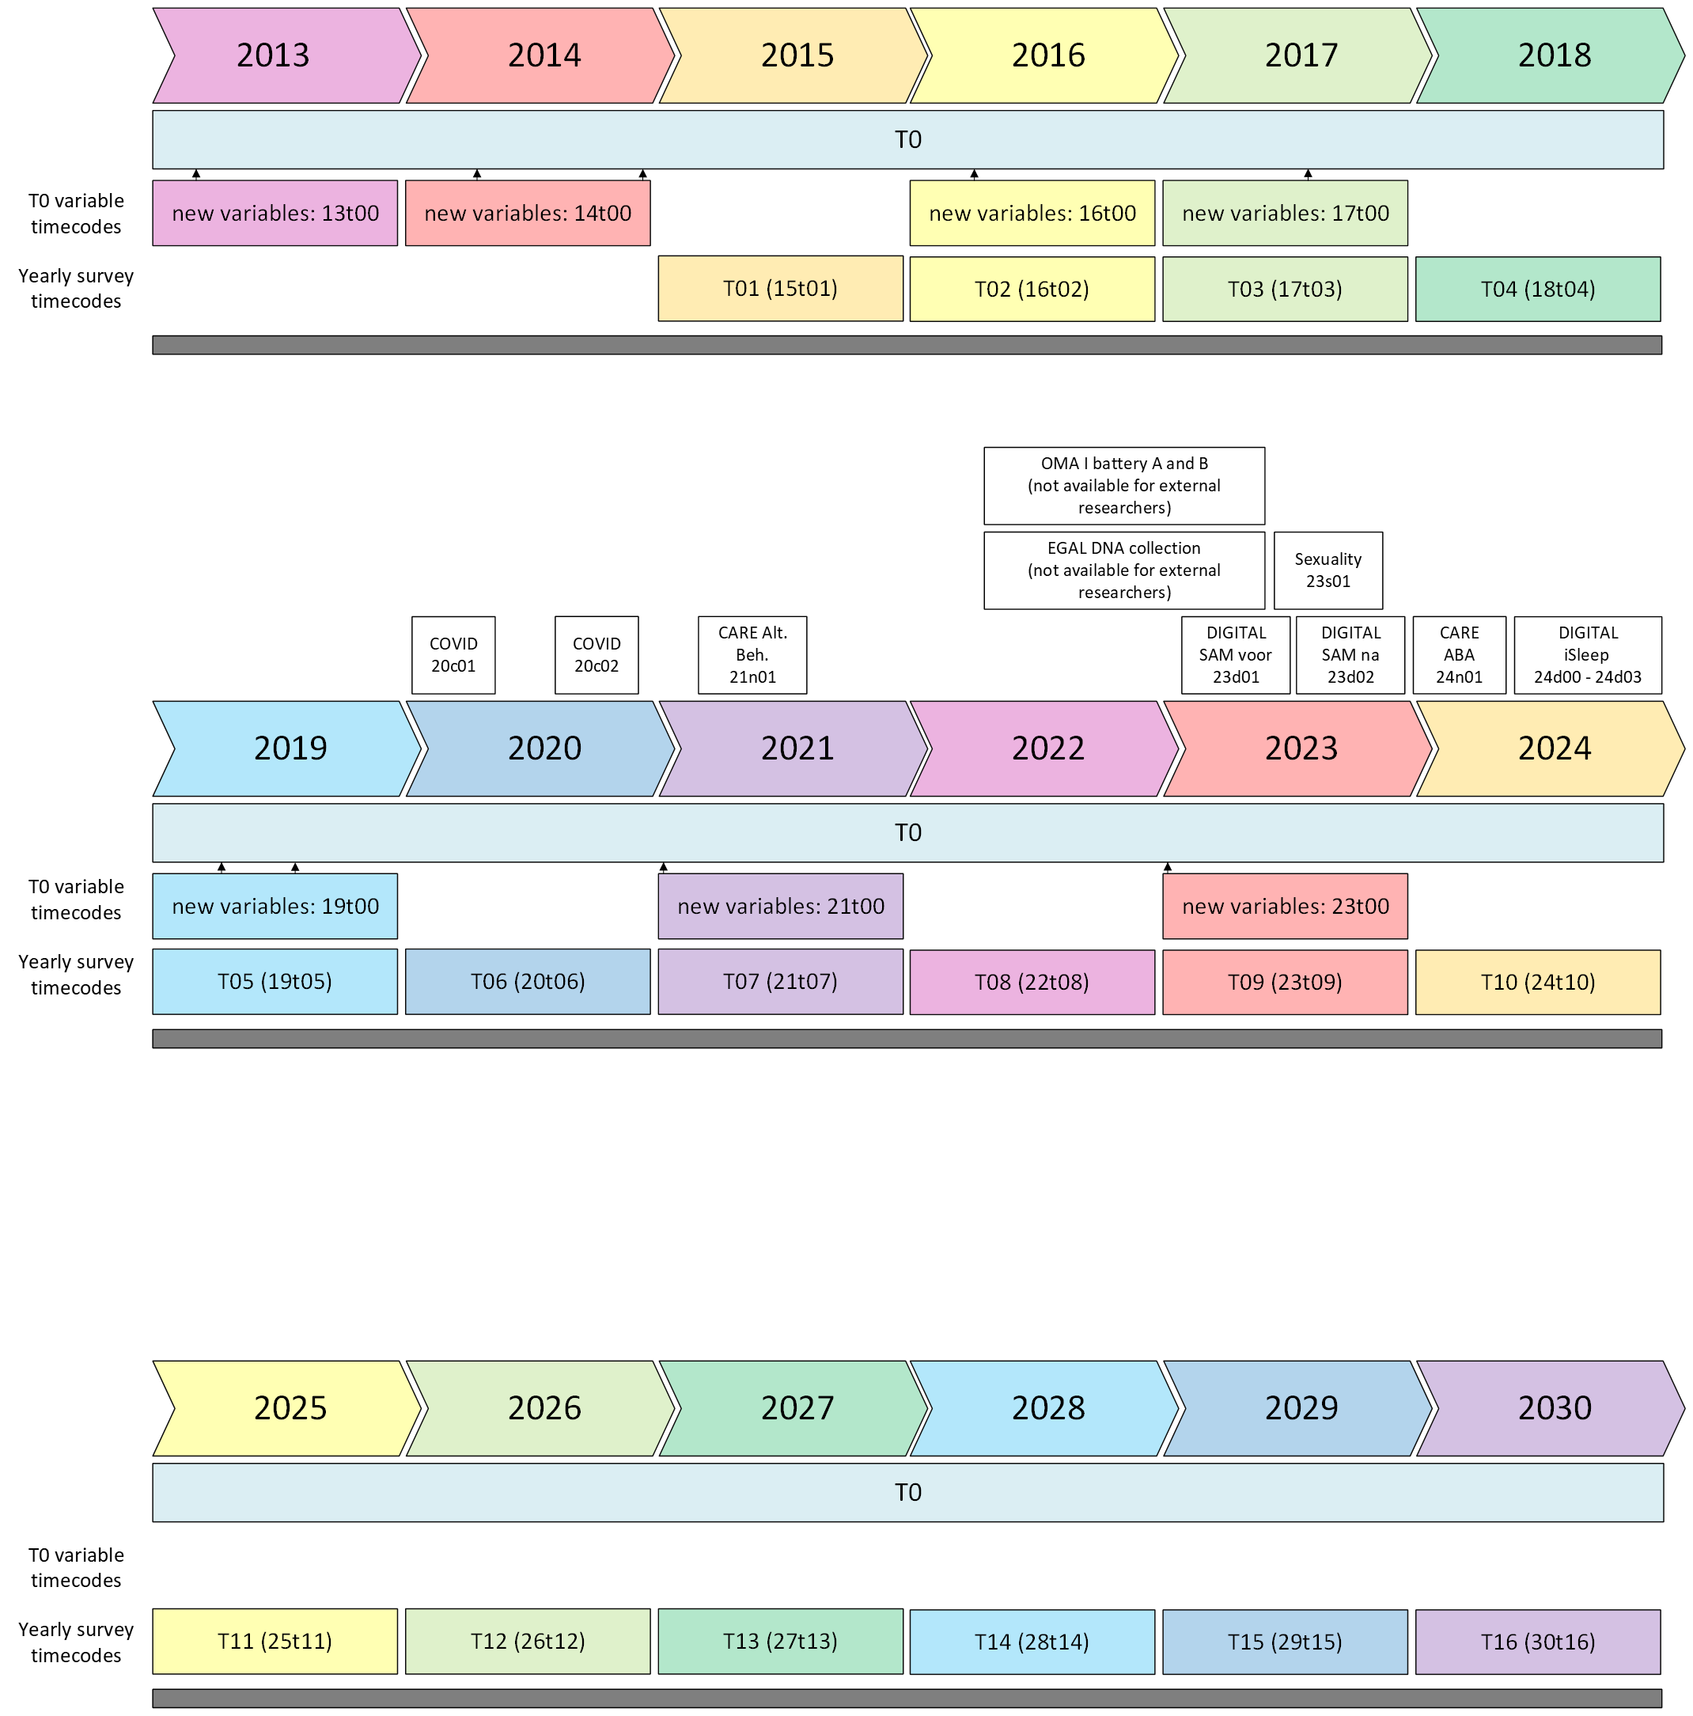
You can find an overview of the wave numbers and years here:
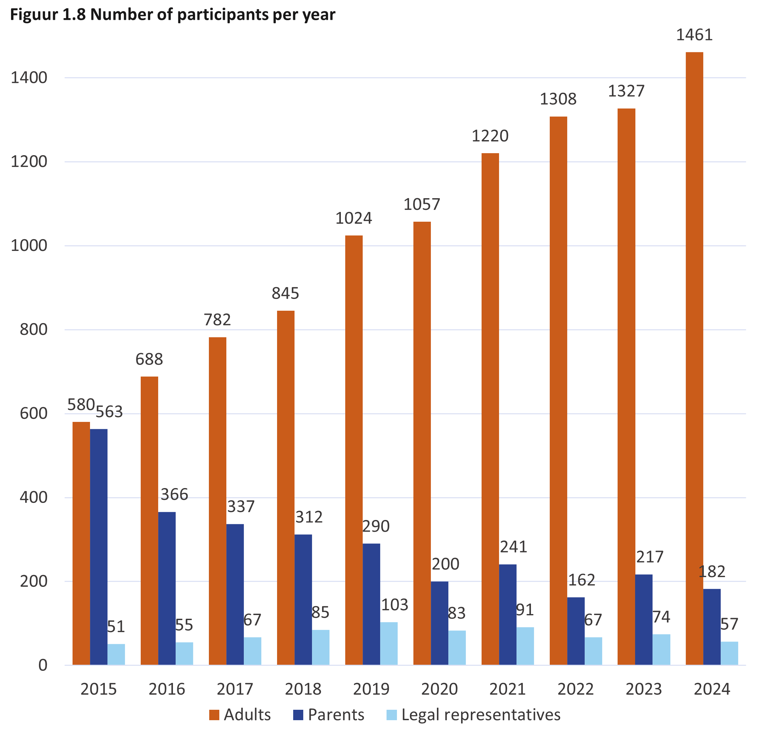

Changes in the T0
The content of the T0 survey has changed a bit over the years. The most important changes are:
2015 NAR survey is disconnected from NVA survey
2017 Control participants are added and can now also register and fill in surveys
2023 Updates on the core questions (in T0 and yearly waves)
2025 Autism and control participants are merged into 1 survey (no consequences for the data) and the T0 is shortened (questions are deleted)

Requesting data
Researchers who want to collaborate with the Netherlands Autism Register can fill out this form and send it to s.begeer@vu.nl, or contact the NAR via info@nederlandsautismeregister.nl. Your data request will be reviewed by the NAR-team. Once the NAR-team has reviewed your request (typically within 2 weeks) you will be informed of the outcome. If the request is not approved, you may be requested to revise the proposal and resubmit.
Once your data request is approved, you will be asked to sign a data sharing agreement (DSA). Once we receive your signed data sharing agreement, data management will prepare your dataset. A typical data request takes approximately 2 weeks to prepare. If your request is particularly complex or if your request comes at a very busy time, more time may be needed. If this is the case, you will be informed of this by NAR data management.
If you have any questions that have not been answered, feel free to contact the NAR team via info@nederlandsautismeregister.nl.

