DOWNLOAD THIS TEMPLATE FROM panmacmillan.com/AnnCleeves
[insert your logo here]
** PRESS RELEASE **
XXXX XXXXX to host a MURDER MYSTERY to
celebrate Ann Cleeves’ 30th book in 30 years.
The new and exclusive script, Blood on the Bannocks, is based on Cold Earth, the new Shetland novel by the award-winning crime writer.
On [insert date] at [insert time] XXXX will host an evening of witness statements, forensic reports and, of course, guessing whodunnit! A prize will be awarded to the audience member closest to solving the murder and copies of Cleeves’ books will be available on the night.
As part of her 30th book celebrations, Cleeves hopes the murder mystery parties will help libraries, bookshops and community groups continue to hold events that engage new readers, she said: 'I am so lucky to have been supported by so many passionate librarians and booksellers in my 30 years as an author, writing this murder mystery script is my small way of saying thank you, and I hope everyone has fun trying to unravel the mystery!'
With over 1.5 million copies sold worldwide, Cleeves is one of Britain’s most successful crime fiction novelists. Her bestselling books are loved in print and on screen: both the Vera Stanhope and Shetland series are now major TV adaptations on ITV and BBC One respectively.
[Info about bookshop/ group- are you using volunteers? Will there be drinks? We suggest you charge a small entry fee, perhaps redeemable against a copy of Ann’s book, so list this here]
Sunday Times bestseller, Ann Cleeves, has written 30 novels and is translated into as many languages. Before her writing career took off, Ann worked as a probation officer, bird observatory cook and auxiliary coastguard.

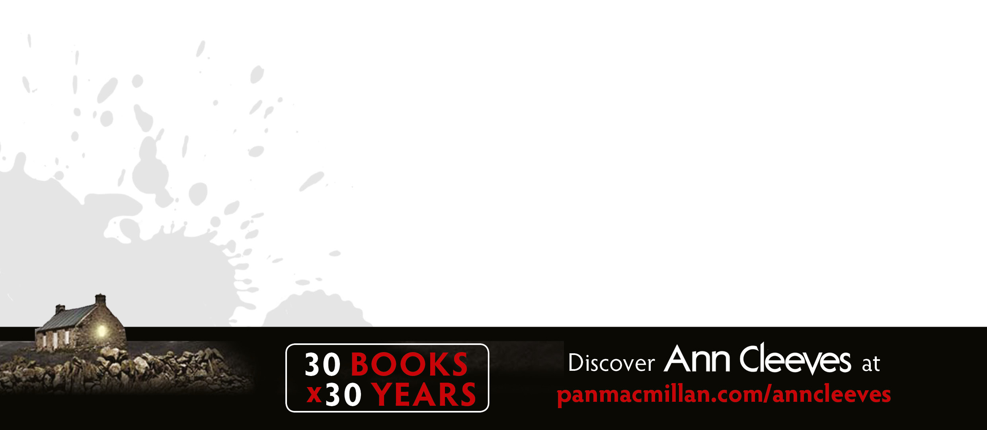
In 2016, Ann was chosen to be Ambassador for National Libraries Day, in 2015, Thin Air, was nominated for the Scottish Crime Novel of the Year and Cleeves was shortlisted for the prestigious Crime Writers Association Dagger in the Library award. In 2006, Cleeves’ novel, Raven Black, was awarded the Duncan Lawrie Dagger (CWA Gold Dagger) for Best Crime Novel, and in 2012, she was inducted into the CWA Crime Thriller Awards Hall of Fame.

As well as fiction Ann has written a non-fiction title about Shetland and, in November 2015, she hosted the inaugural Shetland Noir festival on the Shetland Islands.

The script has been provided by publishers PanMacmillan
For more information contact XXXX on XXXXXXX or e-mail XXXXXXX
XXX YOUR WEBSITE HERE XXX
AnnCleeves.com

