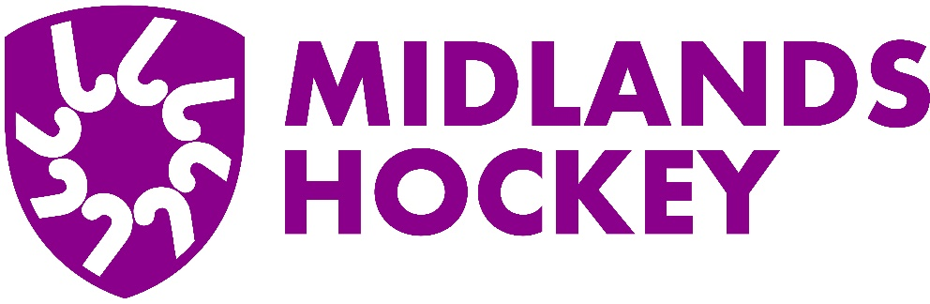

# Midlands Area Officiating Committee

# Club Cluster Lead (CCL)

Purpose

The CCL will be responsible for a cluster of hockey clubs within a defined area, to help drive the strategy of the Midlands Area Officiating Committe (MAOC). The CCL will be a local point of contact for clubs within the cluster which, through closer knowledge and relationships, will improve the support, communication and messaging outreach from MHOC.

**Key Tasks of the Role**

Support the MAOC Club Engagement Lead through a variety of communication channels (email, WhatsApp, in-person) to drive the strategic initiatives within their cluster.

Act a point of contact for clubs, umpires and individuals who may need help with any aspects of officiating and to be a gateway to the wider support MAOC can provide (e.g. umpire development, young umpire development, coaching, CUTE and many more offerings).

Cluster Leads can take as much of an active role in providing support, that their time allows. The Club Engagement Lead will either support the CCL’s in executing activities or can take them on entirely if the CCL doesn’t have capacity.

Using WhatsApp, CCL’s should create a group of key contacts at clubs within their cluster and to broadcast news and updates that are relevant.

CCL’s are asked to like/share and promote positive news, including success within their own cluster on Midlands social media sites, working in conjunction with the Midlands social media manager.

Support the Club Engagement Lead with driving participation and reviewing the responses from the annual “Umpire Health Check” survey, which enables MAOC to have a RAG status of clubs, enabling those clubs within the cluster who need the most support to receive it.

Attend a once a quarter Club Cluster Lead meeting (remote) to provide an update on the Red and Amber clubs within their regions and any initiatives and successes that have been achieved.

Attend the start of season and end of season Officiating Club Update where MAOC will tell clubs about the; Officiating strategy, update on the Cluster Leads, RAG clubs and any changes, such as to umpiring rules, that clubs may need to be aware of.

Attend some initial training and upskilling events relating to the products and services that MAOC offer so that CCL’s can talk competently to clubs about what can be provided.

Support the Club Engagement Lead working with Clubs in their cluster, who have provided feedback on Umpires or, Umpires who have provided feedback on clubs, that requires action and follow up.

Input ideas and guidance on what is working well within their Clusters and where the MAOC and Club Engagement Lead should continue to focus our efforts

**Is this Role for you?**

Skills required:

Passionate about the quality and growth of officiating within their club and across the Midlands

Good working knowledge of a Club environment with connections across a range of local clubs

Working knowledge of umpiring and the current England Hockey Umpire Developer and Umpire Development pathways

Excellent communicator of verbal and written communication

Competent user of email and computer applications such as word/excel or similar applications