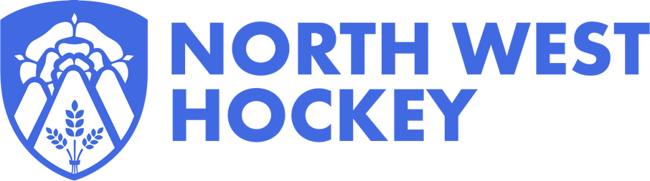

NORTH WEST HOCKEY 2023 ANNUAL GENERAL MEETING
CALLING NOTICE
Notice is hereby given that the Annual General Meeting of North West Hockey Limited will be held on Thursday 6 July 2023 at 7:30pm By Video Conference. The link to access the meeting will be sent to your Club Chair/Secretary and or eligible members who register to attend prior to the meeting.
Agenda
- Welcome and Introductions
- Apologies for absence
- Chair’s Remarks
- Announcement of Postholder election results

- Minutes of the last AGM held on 7 July 2022 (draft attached)
4.1 Approved as a true and accurate record of the meeting
  - Matters arising not covered by the Agenda

- Review of North West Hockey Ltd 2022-23 (attached)
6.1 Overview of 2022-23
6.2 Questions

- North West Hockey Limited Financial Report
7.1 Financial Summary of operation income and expenditure for the period up to 30th April 2023
  - Report to Directors and Unaudited Financial Statements for the period 1st May 2022 to 30th April 2023 (attached)
  - Receipt of the The Independent Scrutineer’s report on the North West Hockey Ltd (attached)

- Resolutions to be voted on at the meeting
  - Proposed Club Membership Subscription Fees for 2022-23
  - Proposed Entry Fees for North West Hockey Competitions and Leagues for 2023-24

- Appointed Umpire Fees: (Information)
- Update on the Adult League Structure 2023-24
- Any Other Business
(of which due notice of 14 days has been given by written notice of the issue)

There are a number of actions required to attend and vote at the AGM, please see the action list below for ease.
Action required | Deadline for completion | Forms Links | Instructions
Register for the meeting (as an individual or club) | Deadline by –19:30 hours 4 July 2023 | Link here | In addition, a Link will also be sent directly to Club nominated Officer to register to attend
Register your proxy / duly authorised representative | Deadline by –19:30 hours 4 July 2023 | Link here | Only need to complete this if Chair/Secretary or nominated club officer is not attending.  This must be received by 19:30 hours 4 July 2023 or your votes will not be counted.
Eligible voting members submit your vote for Postholders | Deadline by –19:30 hours 4 July 2023 | Link here | This must be received by 19:30 hours 4 July 2023 or your votes will not be counted.
Remaining items, if required |  | Vote on night, if required | Vote the on night if required. Voting instructions will be included with meeting link.
Any Other Business | Matter for consideration under AOB should be submitted 14 days prior to the AGM:  21st June 2023. | Email to the Chair  Chair@northwesthockey.co.uk

Agenda Item 8 - Resolutions to be put to the AGM and voted on at the meeting
8.1 Proposed Club Membership Subscription Fees for 2023-24
North West Hockey Ltd Board and Management Committee propose that:
For full voting Member Clubs that the annual Subscription for 2023-24 to be a member of North West Hockey Ltd shall be £17.50 per senior team (a 30% reduction on 2022-23 the Subscription)
For Counties (Sub-Areas) and other Organisations, the proposal for Subscriptions for 2023-24 shall be set at zero (no change to 2022-23)

8.2 Proposed Entry Fees for North West Hockey Competitions and Leagues for 2023-24
North West Hockey Ltd Board and Management Committee propose that:
For Clubs entering North West Hockey Adult Competitions and Leagues the annual entry fee shall be £10.50 per senior team (a 30% reduction 2022-23 Entry Fees)
Entry fees for all other competitions (including Juniors and Masters) shall be set by the Directors on the recommendation of the relevant Committee and if required informal consultation with member clubs

- Appointed Umpire Fees: (Information)
Note the Appointed Umpire Fees to be paid by Clubs for 2023-2024
North West Hockey Ltd Board and Management Committee propose that:
The fee paid by Clubs where Umpires are appointed by North West Hockey shall be £26.50 per appointment (same as 2022-23 Fees)

Kind regards,
Chris Reece (Chair) Director
North West Hockey Limited

