Checklist of key information you need to have before completing the online Red Card Report Form
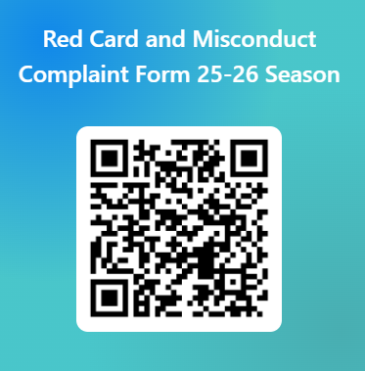
- You
  - Name
  - Umpiring qualification
  - Contact details

- Your colleague
  - Name

- Offender and Club details*
  - Name of Offender
  - Shirt number of offender
  - Over/ under 18 years old
  - Club**
  - Team
*the Offender’s club is obliged to provide you with this information.
**there are pre-populated options for Club name; if this is, for instance, a Schools or representative match, select “Other” and include the details there.
- Competition/ Match details
  - Date of match
  - Area
  - League and division
  - Fixture, e.g. ABC Open/ Men’s 1s vs. XYZ Open/ Men’s 2s

- Details of offence
For more information on how to complete the Red Card Form see the England Hockey and/ or your Area website or contact your Area Disciplinary Administrator (see contact details via this England Hockey Committees)

