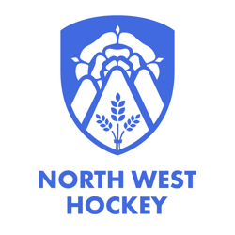
Northwest Hockey Officiating

NORTH WEST HOCKEY – LEVEL 2 UMPIRE CANDIDATE REGISTRATION FORM 2025-26
Name:
Email Address:
Postal Address:
Postcode:
Tel No: | (H) | (M) | (W)
Date of Birth
Preference: Men’s, Women’s or Both Matches – please indicate:
Minimum Requirement for Application. LEVEL ONE ASSESSED.
England Hockey Registration No. __________________
Umpiring Record – Last 12 months, Club, Team, Division

Nominated/Endorsed by:
Club:
Name:
Position: Chair, Secretary, Club Umpire Developer (please indicate)
Phone No:
Email:
Signature:
Date:

Signature |  | Date

*Please complete all sections.
You agree to accept a minimum of 6 NW Premier League appointments per season.
Form MUST be returned to: NW AOC:
Email: Appointmentslead@northwesthockey.co.uk

