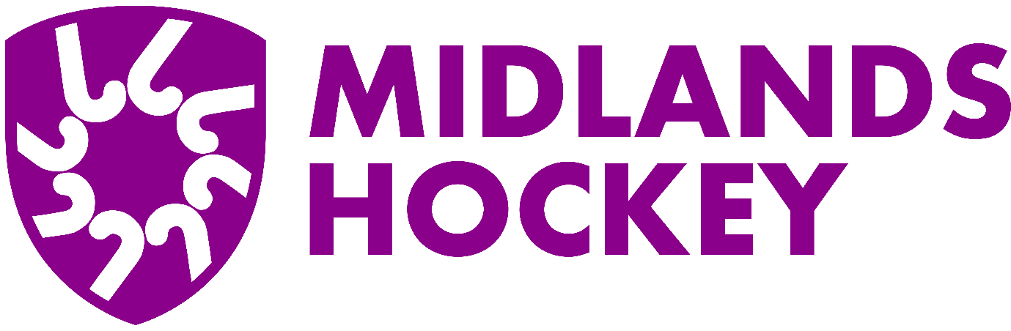

**MIDLANDS HOCKEY YOUTH SUPPORT TRUST**

**APPLICATION FORM**

|  |  |
| --- | --- |
| **Name of Club:** |  |
| **Details of proposed project including expenditure and how the project will be funded:** |  |
| **Amount requested**  **From £300-£1000:** |  |

|  |  |
| --- | --- |
| Club Bank Account Details: | |
| Name of Account: |  |
| Sort Code: |  |
| Account Number: |  |

|  |  |
| --- | --- |
| We agree to adhere to the rules and regulations of the Midlands Youth Hockey Trust as set out on the Midlands website | |
| Signed: |  |
| Name: |  |
| Date: |  |
| Email: |  |
| Position in club: |  |
| Authority to sign: |  |

Please include with this application:

1. Copy of England Hockey Club Mark Accreditation form
2. Copy of your latest financial statement

Please email the above documents and your completed application form and any additional information to: areaadmin@midlands.hockey

MIdlands Hockey will aim to acknowledge receipt of your application within 5 working days and confirm its decision within 6 weeks. Please do not start your project until you have had confirmation of the decision.