What an interesting season and this is not to say that everything has gone the way in which we would have hoped.

We were kept waiting for the Game Management System to go on line until the very last minute leaving us with no umpires registered and therefore with no knowledge of the numbers let alone the availability of the officials who would decide to join with us.

APPOINTMENTS (Appointments Lead: Chris Butler)

It is to the huge credit of the appointments team that so many appointments were made in the first fortnight and have continued to be throughout the season.

As the appointments team have come to know their officials so the appointments system has become smoother and it has been possible to plan much further ahead.

To date we have made the following appointments;

Premier & Division 1: (Chris Butler)

790 fixtures were appointed to with only two, at the beginning of the season not receiving appointments

One difficulty that we have had to overcome is that the geographical location of umpires does not fit with the location of games and thus we have had greater movement and travelling distances than we might have expected.

Invicta League (Brian Miller)

We have only been able to make appointments to 24 games.

This has been because most of the umpires have been engaged in higher level games away from Kent and has therefore made it almost impossible for them to accept two games on a Saturday

Oaks League (Surinder Bodwal)

Appointments have been made to 77 games throughout the season.

Availability and having many umpires away from the county has impacted on the number of umpires that have been able to umpire two games on match days

Martlets League (Robin Lush)

75 matches have received two appointments with a further 16 receiving one appointment.

We have been fortunate that due to the number of Sussex based umpires taking two appointments we have been able to cover that number of games

Across the South East Area there has been highlighted a shortage of umpires and that active recruitment will be necessary for the appointments system to cope more easily with the number of games to which they are asked to appoint.

South East Hockey Indoor Report Season 2021-22 (Lead: Julian Warburton)

The inaugural indoor season was completed successfully despite many initial obstacles, such as venue availability and lack of GMS support, so the appointments were planned and executed old school style on spreadsheets and emails

Twenty different umpires supported the eleven events that we officiated at, which included the schools and clubs U16 and U18 regional qualifiers and the women’s senior regional finals.

We were blighted by late drop outs by some teams and we didn’t have a men’s regional finals tournament due to a series of late withdrawals.

Nevertheless, we always had sufficient umpires to support each event as well as having Debbie Garner and Jackie Gibbs offering their valuable coaching expertise to the umpiring teams.

We have been working hard with the schools in terms of planning the indoor events for the next season, so there will be better notice of dates and venues. The GMS system should be fully functional for the indoor appointments process, so everything will be a lot smoother.

Congratulations are due to some of our team :

- Graeme Cooke for progressing to Level 3 indoor
- James Rollins for umpiring the National U18 Schools Boys Final and getting to Level 3 indoor
- Campbell Reeman for getting to Level 3 indoor and progressing straight to the NPUA A Panel in his first season of indoor hockey

Thank you to those umpires that dropped in at late notice and showed great flexibility, enthusiasm and talent in the first indoor season under the new structure.

Special thanks are due to Debbie Garner and Jackie Gibbs for working so hard with me to share the burden of selection, appointments, admin and sourcing venues.

We wouldn’t have had an indoor season without them.

DEVELOPMENT (Development Lead: John Moss)

An astonishing 154 assessments and a further 89 coaching watchings have been carried out during the season. We have also carried out two coaches and assessors days.

By now most appointed umpires, at least those who have been on the panels for the whole season, will have been assessed and/or coached. We published this early in the season, so we thought it worth repeating. This picture shows the key attributes we are looking for.
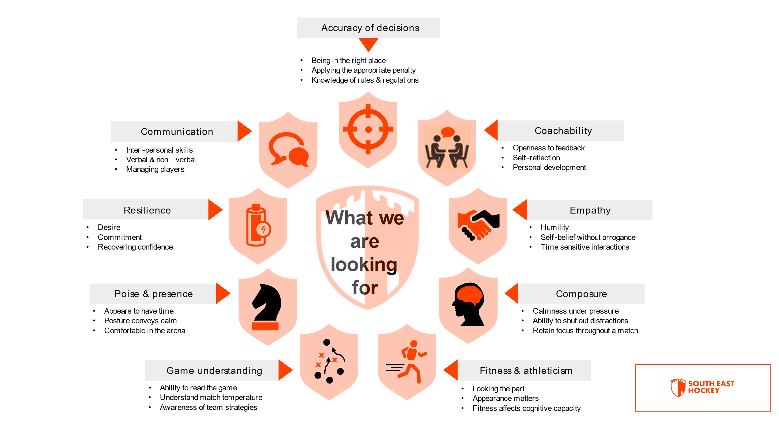

We have a small core team of Jane Binner, Gary Stent, John Moss, Philip Hook and Sarah Chapman. Philip & Sarah are taking the lead on the day-to-day management of umpires. Philip is responsible for Level 1 and Sarah for Level 2. Gary is responsible for developing the skills of all our coaches and assessors.
The Development team continue with their program of Coaching and Assessing of ALL our SE Umpires. At the start of 21/22 season we set out an ambitious plan to carry out 2 watching’s per umpire (Coaching and/or Assessment). So far, a total of 204 watchings have been made (120 Assessments and 84 Coaching’s) which is a huge achievement. We are extremely grateful to our dedicated Assessor and Coaching team who have made all this possible.
For the umpires still waiting for their assessment, these should be carried out over the remaining weeks of the season. Thank you for your patience.
We do hope you find that helpful. If you have not been assessed/coached and you want to be please let us know on dev.umpires@southeast.hockey
We are pleased to report that 10 promotions have been made so far; we have 4 umpires on the NPUA reserve list and 1 umpire has been promoted to NPUA. Congratulations to them all as they progress with their Umpire pathway.
Congratulations to the following Umpires

NPUA panel*
Annette Golding
Panel A – Level 2 Ladies
Karen Stevenson
Michael Coates
Anthony Schweitzer
Paul Meehan
Panel B* Level 2 Ladies
Gihan Thabrew
Panel A Level 2 Men
Malcolm Wain
Richard Gibson Brown
Panel B* Level 2 Men
Adrian Russell-Smith
Tom Spinks
We have also been working closely with Clubs to review their L1 unassessed umpires. So far 15 Club Umpires have passed their L1 assessments and are now Level 1 assessed umpires, with 2 club umpires taking SE Hockey neutral appointments. Our congratulations to the Umpires who have passed and a big thank you to the Clubs for the support they have given.

CLUBS (Club Lead: Alex Bandurak)
Report on 2021-2022 Season
Engagement between SE Officiating and Clubs in SE Region has not gone to plan this season. Before the beginning of the season all 77 clubs, encompassing 268 mens and 205 womens teams, were “clustered” into 9 distinct groups, of broadly equal size. The intention was for each cluster to have a direct way into SE Officiating, either with a representative from the component clubs acting as spokesperson for that cluster, or for SE Officiating to appoint a Club liaison for each of the clusters. Each club would then use the cluster as the gateway to SE Officiating.

Unfortunately, functionality on GMS to enable outreach to clubs wasn’t enabled until February. This meant for the first half of the season I was unable to proactively reach out to clubs, and had to rely solely on “receive mode”. This was supplemented by articles in every SE Officiating newsletter, but without the ability to reach out directly to clubs, we suffered with a lack of communication and understanding.

The enquiries I have received this season can be grouped in to two distinct asks:
Assistance with finding umpires for matches, received from small clubs
Assistance with organising level 1 assessments
For the first ask, we have attempted to link small clubs up with their larger neighbouring clubs, in the hope that they could assist. We have however had to be firm in that we can’t supply umpires for their games, and it is on them to find their umpires, whilst also offering assistance with getting umpires through Level 1 assessment. With the Development team, we have formulated a good conveyor mechanism for Level 1 assessment requests, and this has enabled us to get assessors to multiple clubs over the season, with 18 umpires passing Level 1 assessment.

Having the ability to outreach to clubs at the beginning of February was far too late for this season. As such, I took the decision to continue with the “Reactive” approach for the remanding few weeks of the season, rather than change things up for those final few weeks. I have however used the outreach ability to share information re upcoming opportunities for Young Umpires, which received some positive responses, which have been passed to appointments.

Overall though, I think we are disconnected from the majority of clubs in the region. As Clubs rep I had no knowledge of the letter sent in on behalf of some of them re payment of fees until it was raised at the meeting – this is something I had hoped clubs would come to the Club Lead for.

Looking forward to next season I would like to move to a Proactive stance. My next step is to send a survey out to clubs at the end of this season with a “what do you want from us, what can we best do to help you” style approach. In September I propose SE Officiating host a call for all clubs in the region to get together, and share updates and procedures for the coming season. This can range from process for getting their umpires assessed at level 1, to fees, to how to raise complaints. If required, the clustering approach can be explored again – it was not implemented this year purely because of the low number of enquiries (circa 5 per week) from the lack of system access which were easily handled by one person.

TECHNICAL OFFICIATING (Lead: Simon Begg)

- Answering queries on interest and GMS and associated transition issues?
- Connecting with other areas TAPs (consistent approach)
- Liaising with EH reps for Technical Officiating
- Attending and supporting Tech Officials for deep understanding of activities (Outdoor and Indoor)
- Supporting TO awareness training
- Deliberately kept arms distance and taken a reactive approach with clubs, simply responsive to date as they were pretty overwhelmed with transition issues

Balance of this Season
Planning to utilise junior and County events to promote TO function
Utilise access to systems to target candidate TO’s
Work with Senior Clubs who provide TO’s to hone targeting
Run Online Intro to TO workshops (previous not fit for purpose)
Supporting TO awareness training
Next Season
Aim to recruit up to ten new TOs to fulfil Conference games
If able to recruit more than ten start on SE Prem teams both genders

EHO (Lead: Philip Hook)

Primarily the aim has been to support members in whatever manner we are able.

Help with understanding GMS and claiming expenses have been two things that have taken much of the time and the support has been welcomed by many members

Well Being

A notable success has been the establishment of a “Well Being service for our officials.

This is designed primarily to help to support officials whether in a time of personal difficulty, following a difficult event or even after a difficult game.

The aim is to let people know that we are there and thinking about them with some limited practical steps that we can undertake.

Equality, Diversity and Inclusion

With the publication of a report from England Hockey we are committed to looking at the organisation, identifying opportunities and making improvements in whatever ways we can.

This is a new venture for us and hopefully we will be able to report on our progress during the next season

JUNIOR UMPIRES (Lead: Vacant)

This is the one area in which we have not been able to show any progress.

In spite of much canvassing by England Hockey and our own efforts to recruit a Junior Umpire Lead we have met with no success.

This is an important area of our work that we need to develop, and it is to be hoped that someone will step forward at the AGM to take on this responsibility.

In the meanwhile, we are grateful to Chris O’Hagan for overseeing the role for us.

KIT

We are still awaiting final decisions from England Hockey regarding the sourcing of umpire kit and information regarding prices.

It is hoped that this issue will be resolved quickly so that new kit will be able to be worn by all our umpires in time for the start of the next season.

COMMUNICATION

We are very aware of the need for effective communication within South East Hockey

We have produced seven newsletters during this season in order to keep members up to date with not just what is happening in South East Hockey but also the wider hockey world.

We have both Facebook and Twitter accounts and although these are beginning to be used we do still need to further develop and widen the usage.

It would be good if we were to have a volunteer who would oversee these accounts and be a conduit for information to be passed through for it to be posted.

CONCLUSION

This has been a challenging year and I am conscious of what still needs to be done to meet the expectations that our members have.

At the same time when I look at the huge amount of hard work that has been put in by the volunteers who make up the committee and those working behind the scenes I am hugely grateful for all their efforts and thank them for everything that they have given to getting South East Hockey up and running and for the progress their hard work has enabled us to achieve.

Paul Shackman

Chair, South East Officiating

March 2022

