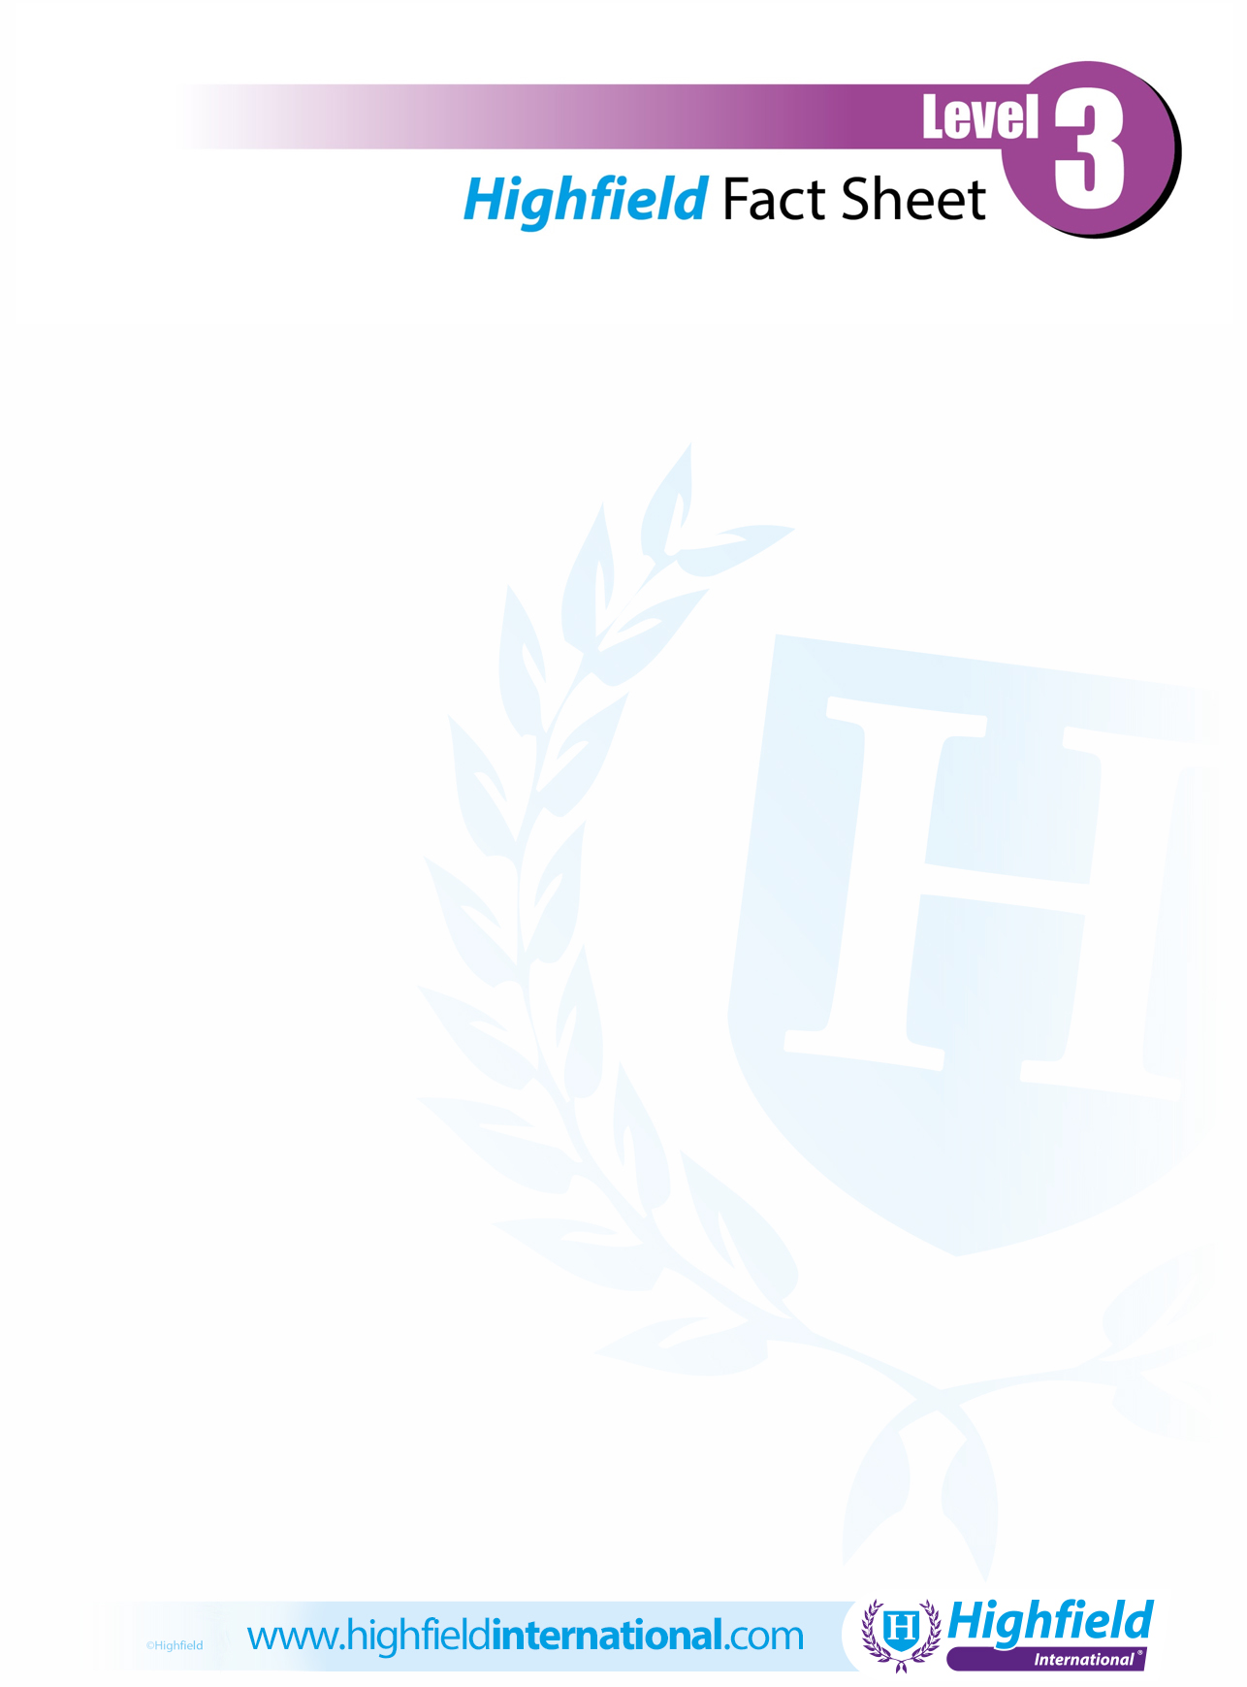

***You can use this space to add your logo/contact details.  If you prefer to leave the space blank, please delete this text prior to printing.***

**Security**

**Highfield Level 3 International Certificate in Close Protection**

The Highfield Level 3 International Certificate in Close Protection is a qualification developed by Highfield, the Middle East’s leading supplier of compliance-based qualifications. The qualification has been designed with sector experts specifically for international learners who wish to become close protection operatives. It has taken into account recognised best-practice principles of close protection. The qualification provides an excellent basis for international learners who may wish to undertake further security qualifications.

**How long will it take me to achieve this qualification?**

This qualification is usually achieved by completing approximately 138 hours of learning.

**How is the qualification assessed?**

This qualification is assessed in two parts:

**Part 1:** Assessed by a multiple-choice examination of 60 questions and a duration of 2 hours.

**Part 2:** Assessed through completing of a portfolio of evidence by learners.

**What next?**

Individuals achieving this qualification can progress onto the following:

Highfield Level 2 International Award in CCTV Operations (Public Space Surveillance)

Highfield Level 3 International Certificate in Security Guarding

**Where can this course be taken?**

Through any Highfield approved training centre.