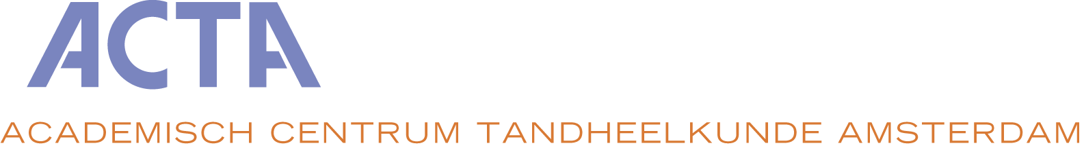
APPLICATION FORM

POSTGRADUATE MASTER’S PROGRAMME IN ORAL HEALTH SCIENCES
for the course starting in September 2023

Graduation profiles of the Oral Health Sciences, MSc

Please choose one (or max two) graduation profiles:
- Endodontology
- Orofacial Pain and Dysfunction
- Paediatric Dentistry
- Periodontology
- Prosthodontics and Oral Implantology

Personal details and contact information:

First name : ___________________________ Family name : ____________________________

Mobile phone : ___________________________ E-mail address : ___________________________

Please answer these questions so we can assess your eligibility for the programme:

- Do you have a BIG registration number?
- If yes, what is your BIG registration number? ___________________________________________
- If no, please explain your situation.
For instance, describe whether you have already started the process of registration, or whether you still have to start. ___________________________________________

- Where and when did you obtain your dental degree? ___________________________________________

- How well do you speak and understand the Dutch language? Please elaborate. ________________________________________________

- How well do you speak and understand the English language? Please elaborate. ________________________________________________

- Who will be sending a letter of reference on your behalf? (minimum 2)

- _______________________________________________________________________________________
- _______________________________________________________________________________________
- _______________________________________________________________________________________

Application documents

Please include the documents listed below with your application by 1 December 2022.

- Personal motivation for your application and future plans
- Curriculum vitae, including your home address
- Proof of experience in a general dentistry after graduation (minimum of 1 year)
- Copy of dental diploma obtained in one of the countries within the European Union
- Copy of Radiology certificate

Please note that if you are accepted into the MSc programme you have to hand in the following documents by 1 July 2023:

- Legalised copy of the dental diploma obtained in one of the countries within the European Union
- Copy of hepatitis-B vaccination, together with titer determination (provide a certified translation if document is not made out in English or Dutch)
- Copy of Reanimation or CPR certificate (not older than 2 years)

Submission of your application:

This fully filled out application form plus all required documentation should be received at our office on December 1, 2022 at the latest. Please send by email to: onderwijsbureau@acta.nl with subject ‘PG OHS Application + name(s) of graduation profile'.

Letters of recommendation:
The letters of recommendation (minimum 2) should be sent directly by the referee to the appropriate profile director by email or by post to the following address:

Postgraduate Master’s programme in Oral Health Sciences
ACTA - Academic Centre for Dentistry Amsterdam
Gustav Mahlerlaan 3004, 1081 LA Amsterdam, The Netherlands

Endodontology | Dr S. van de Waal, Dept. of Endodontology | s.vd.waal@acta.nl
Orofacial Pain and Dysfunction | Dr P. Wetselaar, Dept. of Oral Kinesiology | p.wetselaar@acta.nl
Periodontology | Dr M.M. Danser, Dept. of Periodontology | m.danser@acta.nl
Paediatric Dentistry | Dr. C.C. Bonifácio, Dept. of Paediatric Dentistry | c.bonifacio@acta.nl
Prosthodontics and Oral Implantology | Prof. A.J. Feilzer | a.feilzer@acta.nl

STATEMENT

I, . . . . . . . . . . . . . . . . . . . . . . . . . (name of applicant) would like to apply for the postgraduate Master’s programme in Oral Health Sciences at ACTA, starting September 2023. I have included all documents as mentioned above under the header Application documents.
I understand that an interview in Amsterdam may be part of the admission procedure. I appreciate that this is a 3-year programme which requires at least 40 study hours per week and which charges an annual tuition fee.

City: Date:

Signature applicant:

