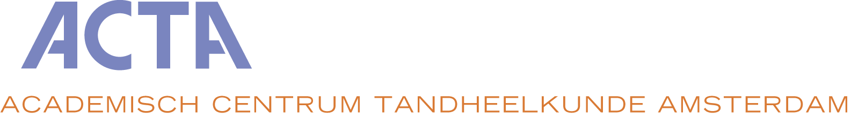

APPLICATION FORM

POSTGRADUATE MASTER’S PROGRAM IN ORAL HEALTH SCIENCES
for the course starting in September 2022

Graduation profile Prosthodontics and Oral Implantology

Personal details:
Family name : ____________________________ First name : ___________________________

Initials : _____________________________ Telephone : ___________________________

Address : ____________________________ Mobile phone : ___________________________

Postal code : _____________________________ E-mail address : ___________________________

City : _____________________________ Fax : ___________________________

Country : _____________________________ Date of birth : ___________________________

Passport number: _____________________ Country where issued: _______________ Valid until: __________

BSN number (if already in your possession): _________________________________________________________

BIG. registration number (if already in your possession): _____________________________________________

Academic credentials:
University where dental degree was obtained: _______________________________________________________

Date of graduation from dental school : _____________________________________________________________

Additional degrees (where and when obtained): ______________________________________________________

Names of persons who will send letters of recommendation (see Appendix; minimum 2 letters):

- _______________________________________________________________________________________

- _______________________________________________________________________________________

- _______________________________________________________________________________________
I, . . . . . . . . . . . . . . . . . . . . . . . . . (name of applicant) hereby formally apply for the Postgraduate Master’s Program in Oral Health Sciences at ACTA, graduation profile Prosthodontics and Oral Implantology, starting September 2020. I have included all documents as requested in the enclosed Appendix. I understand that an online interview is part of the admission procedure, and that the annual tuition fee is €25.000. I appreciate that this is a 3-year program which requires at least 42 study hours per week.

Signature applicant:

City: Date:

Appendix
to the Application Form of the postgraduate Master’s Program in Oral Health Sciences

Documents to be submitted with your application:

The following items are to be enclosed in your application package (please check and include this page):

- copy of passport
- personal motivation for application and future plans
- curriculum vitae
- proof of experience in general dentistry after graduation (minimum of 1 year)
- legally certified copy of the dental diploma obtained in one of the countries within the European Union
- English language test report: TOEFL, IELTS or Cambridge English (necessary both for dentists with a Dutch dental diploma and an international dental degree)
- copy of hepatitis-B vaccination, together with titer determination, officially translated into English or Dutch
- certified copy of B.I.G. registration document of the Netherlands. Please note that your B.I.G. registration needs to be effective by 1 September 2022 at the latest unless you have permission from the respective profile director to start the program without.
- copy of Reanimation course (not older than 2 years)
- copy of Radiology certificate

Submission of your application:

Please send this two-sided application form plus all required documentation to:

Prof. dr. A.J. Feilzer, Head ad interim Department of Reconstructive Oral Care, a.feilzer@acta.nl

Letters of recommendation:

The letters of recommendation (minimum 2) should be sent directly by the referee to the profile director at: a.feilzer@acta.nl

